Chapter 11

Optimal Portfolio Choice

- Let be the number of share in stock I, then

The new value of the portfolio is

- Return

- The portfolio weight are the fraction of value invested in each stock

  - Both calculations of expected return of a portfolio give the same answer.

  - If the price of one stock goes up, the other stock price always goes up as well.

11-5.
- The mean for KO is 2.02%; the mean for XOM is 0.79%.
The standard deviation (i.e., volatility) for KO is 8.24%; the standard deviation for XOM is 4.25%.

- The covariance is 0.00213.

- The correlation is 60.83%.

11-6.

11-7.

11-8. All three methods result have the same result: The standard deviation (i.e., volatility) is 5.90%.

11-9.
(see spreadsheet application)

11-10. First calculate the standard deviation of each stock and multiply this by the stock’s portfolio weight and by the stock’s correlation with the whole portfolio. The sum of these products is the portfolio’s volatility.

  - Volatility of a very large portfolio is

11-12.
- If the two stocks are perfectly negatively correlated, they fluctuate due to the same risks, but in opposite directions. Because Intel is twice as volatile as Coke, we will need to hold twice as much Coke stock as Intel in order to offset Intel’s risk. That is, our portfolio should be 2/3 Coke and 1/3 Intel.

We can check this using Eq. 11.9:

- From Eq. 11.3, the expect return of the portfolio is

Because this portfolio has no risk, the risk-free interest rate must also be 12.67%.

11-13. In this case, the portfolio weights are x_{j} = x_{w} = 0.50. From Eq. 11.3,
We can use Eq. 11.9

11-14. In this case, the total investment is $10,000 – 2,000 = $8,000, so the portfolio weights are x_{j} = 10,000 / 8,000 = 1.25, x_{w} = −2,000 / 8,000 = −0.25. From Eq. 11.3,
We can use Eq. 11.9

11-15. The set of efficient portfolio’s is approximately those portfolios with no more than 65% invested in J&J (this is the portfolio with the lowest possible volatility, as shown in the chart).

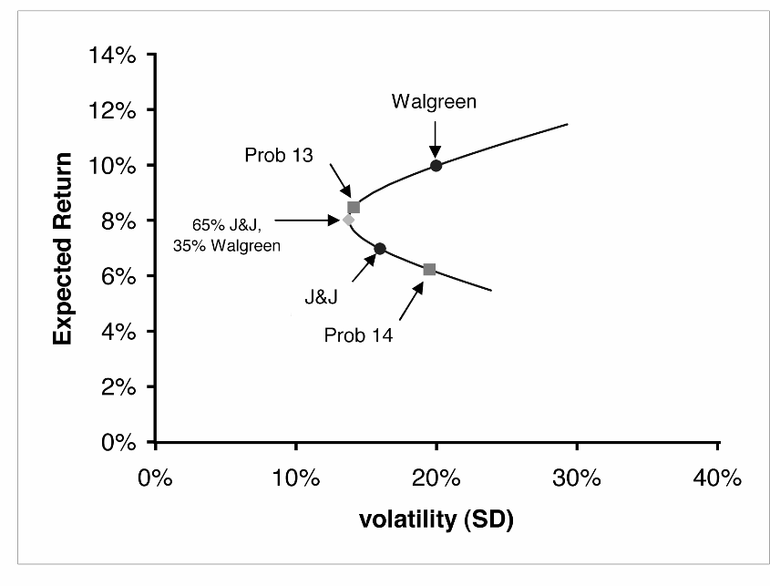

11-16.
a.

b.

c.

11-17. Investors who want to maximize their expected return for a given level of volatility will pick portfolios which maximize their Sharpe ratio. The set of portfolios that do this is a combination of a risk free asset a single portfolio of risk assets --- the tangential portfolio.

11-18.

You should add some of the venture fund to your portfolio because it has an expected return that exceeds the required return.

11-19. Your current portfolio is not efficient.

11-20.

