**Classroom/Bauer 3 Notes, Questions and Comments**

**Version 9 – May 4, 2011**

**For plans on Floors 3,4 and 5 received May 3, 2011**

1. 4th Floor GPP Office Suite/Clinical Office **swap space functions**
   1. Moved three breakout rooms from the SE corner back to the

GPP suite corridor

* 1. Removed the long storage space Room 424 (108 sq ft).
  2. For the resulting six interior spaces -- each becomes slightly wider.
  3. The fact that breakout room 422 is bigger is OK (it could seat 10 at 20 sq feet for each person)

The count of breakout rooms is still 16.

See image on the next page

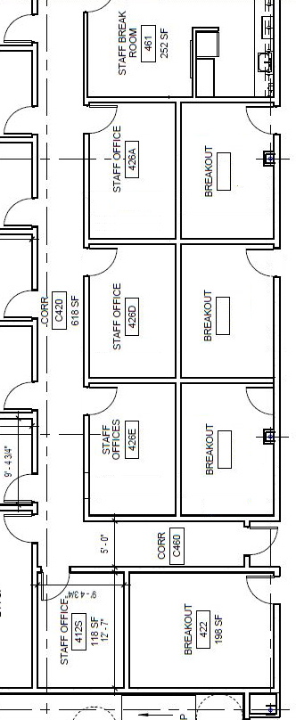

1. Corresponding correction in the SE corner Clinical Suite
   1. Return all the offices in the SE corner suite to “Clinical Office “ functionality.

See image on the next page.

* 1. Added two office on the east wall – but the window opening

alignment is off by several inches

So, “make it fit” even though the two offices may be smaller than others than the program specifies, I would rather have “office count” rather than a few extra square feet in the offices (e.g., these two offices may be single rather than double occupancy)

1.3 The corner office is now larger.

1.4 In the central island of six clinical offices, equalize the widths.

It is OK if they are slightly smaller than the program spec.

The Clinical Office count on the 4th floor is 17

(Confirm that there are still there are 2 on the 2nd floor)

