Classroom/Bauer 3 Notes, Questions and Comments
Version 8 – April 26, 2011
For plans on Floors 3,4 and 5 received April 25, 2011

- 4th Floor Northwest/Southeast Corners Swap
We wish to swap the two GPP tiered classrooms in the SE corner and the Clinical Office Suite in the NW corner.
1.1 In the NW corner, the two classrooms fit snugly in the corner. The rooms have been flipped vertically and horizontally from their original position – but internally left unchanged.
Corridor C246 is left intact partially intact. Two clinical offices remain east along this corridor with different wall layouts. The red line on the image shown on the next page defines the wall changes limits.
1.2 In the SE corner, a separate room has been added for 2 aisles of lockers to the east side of the GPP Lounge. In the remaining space to the east are “some of” the components in the NW corner “entirely rearranged”.
The red line shows the limits of the wall change limits.
The 18 Clinical offices as shown below shown are a reduction to:
11 in the SE corner + 2 remaining in the NW corner = 13
This is a net loss of 5 Clinical Offices.
The exterior Clinical Offices are NOT shown with equal width on the south wall – equalize these room widths.
Additionally, four breakout rooms formerly in the NW corridor are now shown in the SW corridor. They are shown now as six person rooms instead of eight person rooms. The total number of breakout rooms remains the same (18)

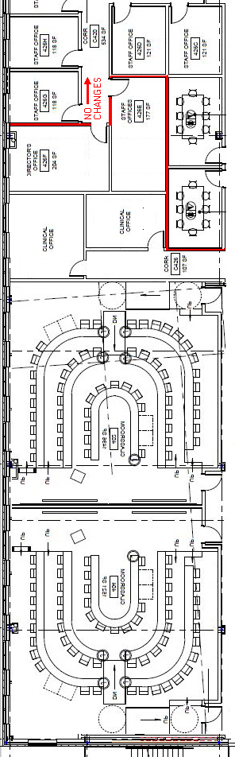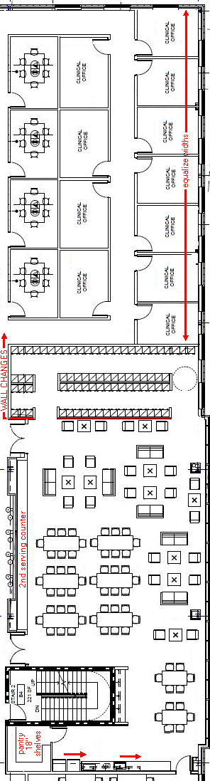

- 4th Floor – GPP Lounge

  - Return the internal storeroom to the kitchen area. Shown as “pantry”, it should open into the kitchen area and contain open 18” shelving.
  - The entire kitchen east wall is slid south as far possible with the loss of cabinet space.
  - The sink should be as close to the refrigerators as possible.
  - The lockers have been moved to a separate room (without doors) to the east. The north wall of the lounge has a serving counter WITH cabinet doors below.

- 4th Floor GPP Administrative Suite (NE Corner)
Move the breakroom to the west of the archival space.

From this:
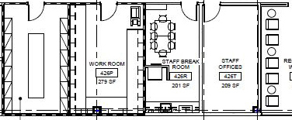
To this:
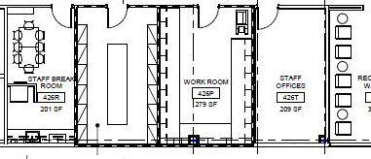
- 3rd Floor Room 300 MBA Commons

  - Remove carrels and replace with soft furniture.\

  - Kitchen Area 300A

Show kitchen detail ( asked as “Item 4.1” from previous version 7). This should outfitted be like the GPP lounge on the 4th floor.

NO VENDING MACHINES

- 3rd Floor Telcon Services Room 314
The server island shown in the center of the room should abut to the wall on the east side.
Change dimensions of the raised server raised flooring to 8’ 9” wide (east to west) and 7’ 0” tall (north to south).
See images below.
ELECTRICAL NOTE: IT has informed me that instead of individual circuits to the servers and san. The entire server island will be power from: a single 100 AMP 5 wire 3 phase 120/208 circuit.
(This circuit feeds directly into a UPS bypass switch, which feeds a single UPS that powers all the racked equipment).
A/C QUESTION: I wish to get a forced air ducts (for AC) to blow upwards from the floor below into the raised server island raised floor. Is this a issue for now?

From this:  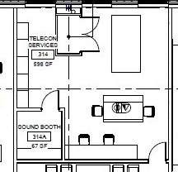 | To This:  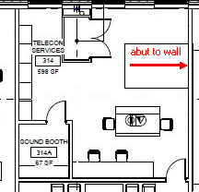

- 3rd and 4th Floor Break Rooms wiring clarification.
What is the wiring configuration in these rooms? We assume there is:
Power to the table – from the floor?
Data to the table -- from the floor?
Connectivity to the flat screen -- from the table?

