Classroom/Bauer 3 Notes, Questions and Comments
Version 7 – April 18, 2011
For plans on Floors 3,4 and 5 received April 15, 2011

- 3rd Floor – Teleconferencing (northwest corner suite -- east side small gallery room) -- the arrangement generally is correct except for the space in back of the wall where the flat screens are attached (west side). The objective of the space behind the wall is to facilitate access to the rear of the flat screen panels and to align/connect cameras. It should be finished on the seating side and open on the “back” side (west) to allow cables and power to be easily accessible when the hardware configuration changes.
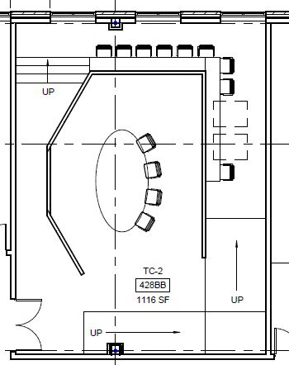 | 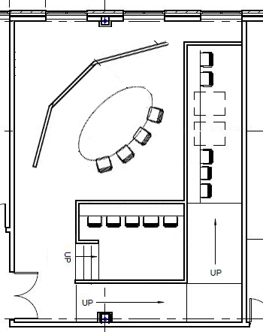

Compare the above (original on the left, revised on the right): (a) rotating the room clockwise 45 degrees to hide the rear of the flat screen wall; (b) disconnecting the flat screen wall (which is full ceiling height) and the gallery wall (which is bank customer counter height). Thus, the “back” side should NOT be visible to anyone entering or viewing in the room.
- 3rd Floor – 428X -- Northwestern Classroom – nice!

- 3rd floor –Events/Dining Center – nice all around!

  - Extend the counters in the kitchen north-south on both sides to the maximum
  - Equalize the “pass-thru window” length with the façade counter length

- 3rd Floor – MBA Lounge 306

  - Does the kitchen area (M-4) not have a sink? refrigerator? Cabinets above the counters?

  - In M-3 there are no details. Isn’t this print/copy? Needs cabinets (top and bottom on both sides, assumes desktop ptr, desktop cpy instead of freestanding)

- 3rd Floor – Southwest Suite – Room counts and functions are OK. (Realizing the loss of 2 director offices in the eastern-most suite -- which are now smaller offices).

  - Western Suite:
5.1.1 Room R156 -- should be renamed “break room” -- show a small table/chairs/sink/counter/cabinet

5.1.2 Room R171 -- is only copier/ptr/storage room – counters and cabinets on one side, space for cpy/ptr (as shown), full shelving on the other side

  - Eastern Suite:

    - Room R173 is a “combination” breakroom, copier/ptr, storage. Show table/sink/cabinet/cpy/ptr/shelving. Small parts all around.

- 4th Floor – Graduate and Professional Programs (formerly called EMBA)

  - Room 426 is listed as a “breakout room”. This room and 420Q will both be multi-occupant staff offices

  - Room 420N needs to show the center workspace island made from lateral files as the base. See image and item 2.7 in previous version (document: UHCBB_variances_version_6.docx). Or is this just furniture?

  - Classrooms 410, 402, 404 – the layouts work well. In counting seats -- I find 55 chairs drawn and space allowance for 4 HC seats. My understanding is that the desk height is the same throughout. The allowance for HC is about 1.5 regular chairs. So I could -- in theory -- move chairs. I could use three extra chairs in both the top and bottom tiers – if there were NO handicap students.

So, I want to BUY 61 chairs for each of these three classrooms!

  - Room 406 (R189) Kitchen Area in the GPP Lounge (notice I am changing the words hereafter from “EMBA” to “GPP”) – move the sink north to be adjacent to the refrigerator to make more continuous counter space. I assume:

(a) Cabinets above the counter for microwaves and storage; and
(b) I will get millwork elevations to approve.

  - The cpy/ptr counter south of the stairwell should be cabinet above
and below. Desktop copier/printer.

- 4th Floor -- Clinical Offices

  - Remove the small closet (428U) at the east end of the interior corridor of the Clinical Office Suite. The original (left) and the revised (right) is shown below:

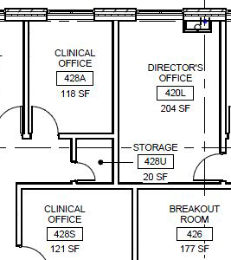 | 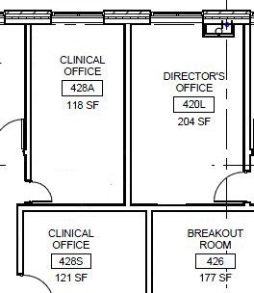

Show this office a single occupancy for furniture purposes. We need a “visiting dignitary” office (has a small conference table)

- 5th Floor

  - Quiet Hall 540 (note the name change—not “Great” just “Quiet”)

    - Furniture – tables to the maximum interior to the column grids. Use north-south aisles. Soft seating on the west wall ONLY. Sparse soft seating against the exterior windows – I do not wish to obstruct the 2 exterior views by blocking the entire outside view with too much furniture. Like using soft seats that back up to on the sides of the freestanding columns.

Desks should have power.

    - Acoustics – with 3 glass walls I am concerned about the issues involved in creating a “quiet room”

    - Lighting – I am hoping for individual lighting (e.g., banker’s or library lamps) at each table seat – mostly to make group work difficult. See:

http://www.visitingdc.com/new-york/new-york-public-library-reading-room
“Partitioning the tables would also be an option”. Like this:
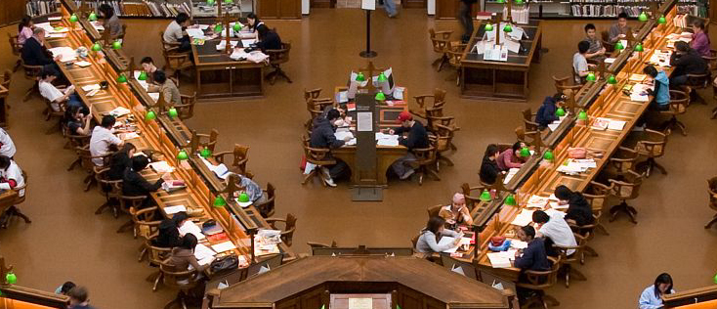

Individual lighting for the soft seats against the walls also.

8.2 The 5th Floor is nice all around!

