Classroom/Bauer 3 Notes, Questions and Comments
Version 6 – April 1, 2011
For plans on Floors 3,4 and 5 received Mar 22, 2011

- Wolf Center for Entrepreneurship 5th Floor Revision to the Version 5
The following diagram shows the revisions to the previous document:
1.1 Room 531 -- expanded slightly to the east (about +2 feet)
1.2 Room 532 --- moved (slide) to the east, added a door, add space (about +2 feet)
1.3 Room 536 – narrowed slightly (about -4 feet)
1.4 Room 538 – changed from double to a single door

Changes like this:

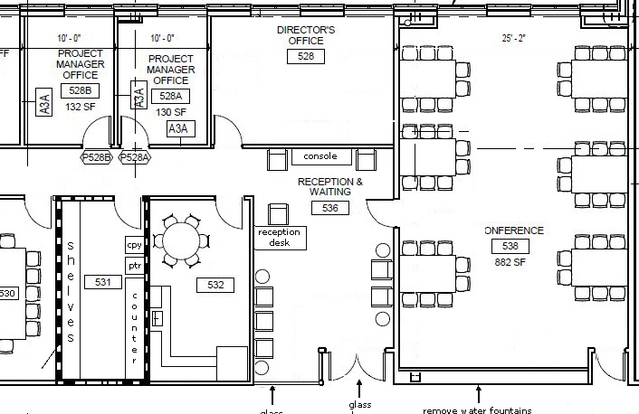

New:
1.5 Room 522 -- Capture the column and make a continuous surface on the south wall. Remove the glass. This is the whiteboard/projector wall.
These 5 changes shown below:

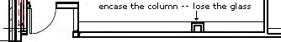

- EMBA suite – 4th floor northeast corner

  - Room 420J -- Records – make smaller. Contents is all tall lateral files (furniture only – no built-ins). East and west walls have full height lateral files, center aisle of 2 back-bacl full height lateral files. Two 3 foot wide aisles.

  - Room 420K –Work room 36” cabinets west, south and half of the east walls (cabinets above); copier, printer on the northeast wall. Work/Assembly space. Large pedestal atop a rectangle of lateral files 36” tall)

  - Room 420N – width to the column.
  - Room 420P -- removed this staff office
  - Room 420J – remove door inset
  - Room414 – center door on the corridor
  - Room 412 – Double glass doors and glass sidelights. Add walls to corridor as shown. Add furniture (double station; bank counter height; counter/workspace on three sides.
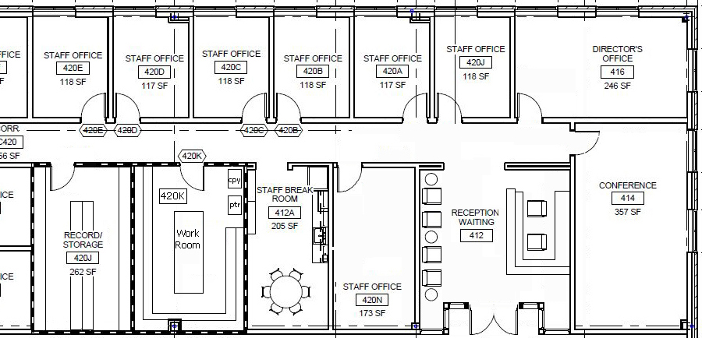
- EMBA/Clinical Suites – 4th Floor northwest corner

3.01 Removed Room 428A

3.02 Slide Room 418 (Director Office) to the west into the space previously occupied by 428A

3.03 Added a Staff office to the east where Room 418 (Director Office) was located

3.04 Storage Room 428U has been slide to the west to be adjacent to Room 428B

3.05 Reconfigued the northeast-most (interior) breakout room into a large staff office

3.06 Reconfigured the northwest-most (interior) breakout room to a clinical office

3.07 Moved the corrdiror C426 (which formerly separated the breakout rooms to the west

3.08 Moved All Breakout Rooms to the corridor – there are still six

3.09 Removed Two Clinical Offices from the main corridor (Rooms 440 and 488) BTW – I don’t understand this original numbering scheme – Room 488 lies between 440 and 436 in the original drawings?

3.10 Kill the vending area 443, and slide Clinical Room 442 west to the corridor

3.11 Please equalize the four western-most contiguous breakout room sizes. These four will be slightly smaller

Changes to the northwest corner of the fourth floor are shown on the next page.
The NET effect of these changes on the north wall of the fourth floor are:
- Loss of TWO clinical offices

- In the EMBA Suite:
2.1 Gain of one exterior (windowed Staff Office)
2.2 Expanded Room 420N size
2.3 Loss of one interior staff office (Room 420 adjacent to the reception area)
2.4 Gained a large interior staff office south of the director’s office (418)

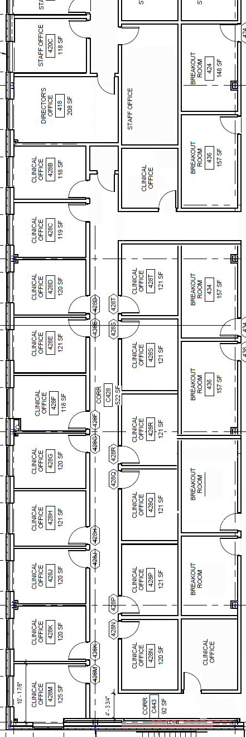
- Student Manager Office – Fifth Floor

  - Move the Student Manager Office to the south windowed wall
  - Move the two “extra offices” to the interior lobby as shown below:
  - The two extra offices are now:
    - Assistant Student org Manager
    - Storage – 18 shelves, cabinetry (36” cabinets with 12” shelves above that have doors), and a tall stoage space
The changes appear as:

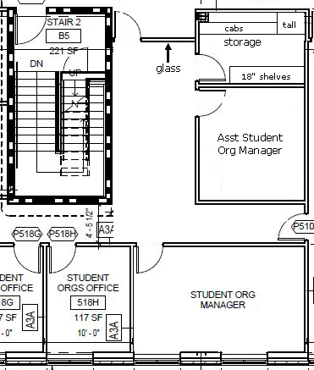

- Great Hall Room 540 – Fifth Floor
We wish to enhance the corridor Wall for this room. As much Glass as possible. Particularly between the two columns that face the elevator lobby 501.

- Third Floor Main elevator lobby
We wish to enhance the wall treatment (make it glass) on the two rooms that empty into the main elevator lobby on the Third Floor. Both of these rooms (the MBA Lounge – 428MMM?) and the Reception Area for the Events/Dining Center (428 EE) need some glass frontage and double glass doors.

- Conference Room in the Third Floor Events/Dining Area (428DD)
Can we make the east and south walls of this conference room glass?

- What is the function of the open space west of the two MBA breakout rooms (these two rooms are west of the main elevators labeled 428SSS and 428 TTT). Is it for seating?

- What is the function of the two interior spaces on the north wall of the MBA lounge on the third floor? They are labeled R152 and R 153 but their purpose is not clear.

