**Classroom/Bauer 3 Notes, Questions and Comments**

**Version 5**

**For plans on Floors 3,4 and 5 received Mar 22, 2011**

1. Room 410

Details on seats, ramps, steps, handrails is missing. Assume more details to follow

2. Rooms 402 and 404

Same as 410, I assume.

3. Room 406 contents

3a. Lounge seating 406B -- program (from UH-CBB-ProgrmStdy-02Feb2010.pdf) says:

(25) Upholstered chairs

(5) Side Tables

(8) Armless chairs

(2) Movable tables

...currently shown as 9 - 6 person tables

...what we want is a mixed use lounge -- not a eating area

...the doors to 408 allows accees to that room for overflow eating area (if needed)

...the meeting/dining facility on the 3rd floor will normally be used for the EMBA

...so this space should have maybe two 6 person tables

...the rest are arm chairs, 2 person sofas, coffee table groupings

...like a british men's club

3b. Kitchen area

...my email to Hickson of 3/15/2011 says:

"(ii) get rid of the "archival store room" [now named 406D] currently adjacent to the south 4th

floor stairwell and provide a hallway entrance to the kitchen side of the lounge."

...the doors to 408 allows accees to that room for overflow eating area (if needed)

...the meeting/dining facility on the 3rd floor will normally be used for the EMBA

...so this space should have lots of counter space (for serving if necessary), sinks, refrigs, microwaves

4.0 Wolf Center for Entrepreneurship 5th Floor

The following diagram shows the revisions to the Mar 2011 floor plans.

4.1 Students Lounge Room 522 – We wish to reconfigure this room to be the same as 538. It will have 48 seats in 6 tables with 8 seats each. Hide the column and make the south wall continuous white board (this is not show below). This is to take care of the new graduate entrepreneurship classes. Other changes shown below

4.2 Rooms 526C and 526D are to be reconfigured as small 8 person conference rooms – no walls are moved and the square footage is the same. Changes shown below

4.3 Rooms 530 is now a 12 person conference room. Note this was the storage room. It has been widened. Changes shown below

4.4 Room 531 was the copy/print room is now the “combined storage/opier/print room. It has deep shelves on the west wall; space for the printer and copier on the east wall; and a counter on the east wall with open shelving above (not shown). It is narrower than the original. Changes shown below

4.5 Room 532 has been reconfigured and made smaller. It has a table (pushed up against the west wall, refrigerator, sink, and cabinetry on the west and south walls. Changes shown below

Why is there NO door on this room?

4.6 Room 536 has been expanded considerably to provide a more spacious reception room. We wish to a double pedestal wooden reception desk; more reception chairs and side tables; console table and chairs on the north wall. This must be ELEGANT (like leather wing back chairs, hard floor surface; wainscoting, NON-acoustical tile ceiling treatment). The wall on the corridor should be glass, The doors should be glass. Changes shown below

4.7 Room 528 – move the south wall to align with the hallway. This Director’s office should have a six person conference table. Changes shown below

4.8 Room 538 – Move the west side door to the middle of the wall. REMOVE the exterior water fountains -- anywhere but here!

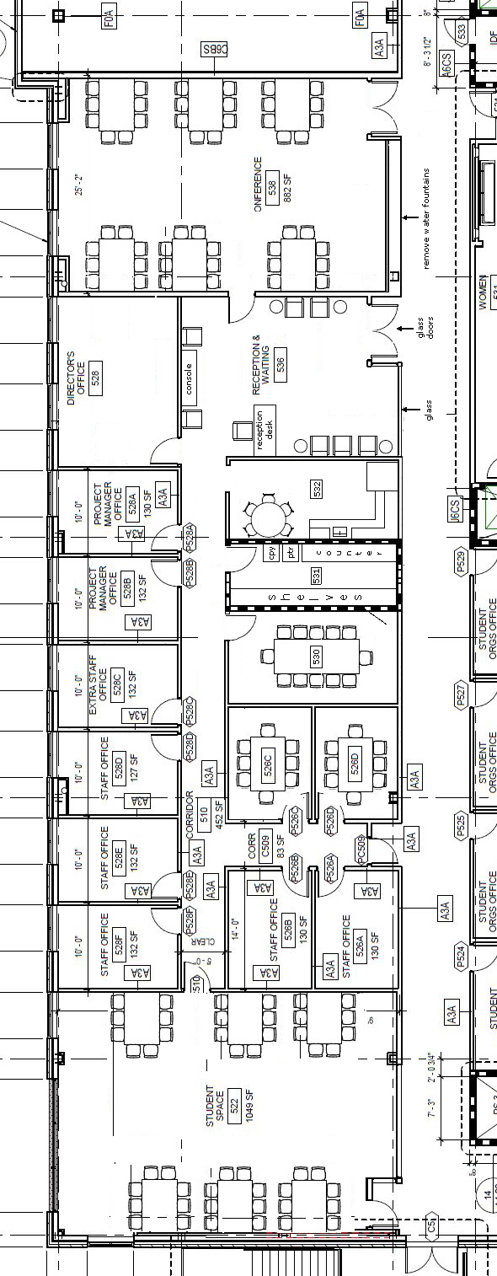

5.0 Teleconferencing Suite

From the 3rd Floor specs (document: Additional_Floor _5_detauils_version_2.doc dated 6/25/2010)

(see also the proposal sketch at: http://www.bauer.uh.edu/parks/newcba/cisco_proposal.htm)

5.1 Teleconferencing Lobby

Move the south wall to create a simple long rectangular lobby. Add: a console table; one side table; 8 chairs. Encase the column and add a mirror image column with floor to ceiling glass (this is for the naming opportunity).

5.2 Teleconference Service Room

5.2.1 Server Rack Space

8” raised floor 5’x10’, Twenty 30 amp circuits

5.2.2 Sound Booth

Counter only, no furniture, acoustically isolated, no fluorescent lights, window facing the work desk side

5.2.3 Tall Equipment Closet (east wall)

First shelf at 5’

5.2.4 Open Shelving

On the west wall – 24” deep

5.2.5 Two person work desk

Power strip on the counter, 4 flat screens on the south wall

5.2.6 Prep Island

36” tall large pedestal, 6” deep drawers on one side below, open shelving below on the

other side; power at the center of the work space AND inside the open shelving (for battery recharge)

More details on the classroom (TC-1) and Gallery (TC-2) needed

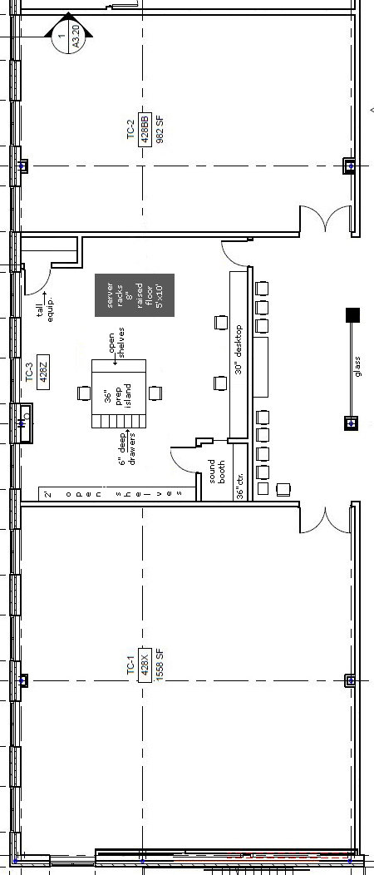

6.0 Lobby of the 3rd Floor

On both rooms that open onto the Elevator Lobby (i.e., the Reception Room of the Events/Dining Center AND the MBA Lounge, make:

the corridor walls glass AND make the doors glass

These sound be mirror images of one another

7.0 Centers for Excellence

7.1 Make the main to western suite have double glass doors (this is the middle entrance to the suite)

Move the doors to the two interior office to the interior corridor to make space for reception seating

Like this:

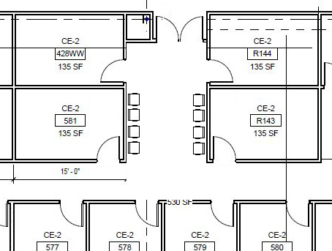

7.2 Suite Intersections

There is a mismatch on the rooms counts between the large suites and the three combined smaller suite.

South of the stairwell make the following changes:

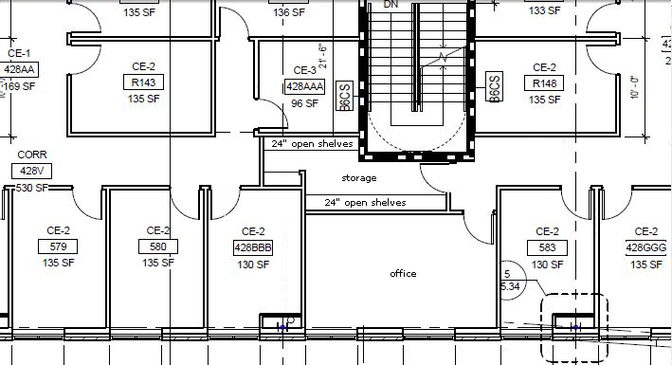

This creates a single windowed office into the east side suite and makes a long storeroom with 24” shelving as shown above.

7.3 Centers for Excellence (east suite)

7.3.1 Convert to 100 sq ft store room on the east wall to a break room. Add a refrigerator, sink and a 5 person table. Also cheat the north wall up a little -- about 1 ft – shown below)

7.3.2 Move the door to the south east office in the lobby (shown below) to the interior corridor. This is to allow wall space for reception seating.

7.3.3 Center double glass doors on the suite entrance with glass side lights.

7.3.4 Recept ion counter and seating shown below

