UH Classroom Business Building
Program Variances & Suggestions Floors 4 and 5
Version 4, Jan 7, 2011
Bauer Program Committee
Michael S. Parks
713 743 4729
parks@uh.edu
Using the original program specification document:
- "Program Study"
University of Houston
Classroom and Business Building
January 2010
Document filename: UH-CBB-ProgrmStdy-02Feb2010.pdf
compared to:
- "Drawings"
CBB_JAN_2011_1 – Sheet – A1 – 24 – CONSTRUCTION PLAN – LEVEL 4.pdf
12-10-2011 Volume 2
CBB_JAN_2011_1 – Sheet – A1 – 25 – CONSTRUCTION PLAN – LEVEL 5.pdf
12-10-2011 Volume 2

- East-West Swap of North exterior suites of the 4th Floor
In order to make the entry to the EMBA Suite (214) adjacent to the elevator we wish to swap the north wall of the 4th floor functionality.
This places even numbered rooms 412 through 422 (the entire EMBA suite) on the east side of the building. This is a left-right inversion – not a shift (i.e., the conference room 416 will be in the north east corner of the building as opposed to the northwest corner of the building. Similarly, 428M will move from the northeast corner to the northwest corner.
Thus the entrance to the MBA suite will be adjacent to the elevators.
This will necessitate a renumbering of the rooms
- Current Room 412 -- EMBA Reception Waiting Room needs a grandiose glass exterior
The corridor wall of 412 needs to be glass floor-to-ceiling and instead of the single doorway should be double doors of glass -- flush to the corridor wall.
- Current Room 536 –Wolff Center Reception Waiting Room needs a grandiose glass exterior
The corridor wall of 536 needs to be glass floor-to-ceiling and instead of a single doorway there should be double doors of glass -- flush to the corridor wall.
- EMBA Suite Tiered Classroom Seating Issues (Rooms 402,404, 408)
The "fixed chairs" in the First Floor 80 person classroom (C-1 and C-2) are drawn with approximately 23.1 sq. ft. per student (1848/80) and an approximate 2.5 ft interdesk distance (as near as I can measure this).
Compare to the "moveable chairs" in the EMBA ES-2 classrooms with 25 sq. ft. per student (1500/60) and approximate 3.5 ft. interdesk distance (as near as I can measure this).
Our issues (dean and associate dean) are:
  - Long and Linear Rows -- the layout does not provide for the "horseshoe" shape that places the instructor "inside" the horseshoe. This is well-handled in the First Floor 80 person rooms. It is absent in the three EMBA ES-2 rooms.
  - No rear entry -- the layout forces students to enter the room from the front. As the students will spend all day in the rooms, there will be much entry and exit thus creating distractions.
Below is a sketch of what we want the three ES-2 rooms to look like (i.e., side entrances, deep horseshoe). Assumptions:
    - From the "Drawings" ES-2 I get:
      - 5 ft inter-desktop distance
      - 18" x 24" seats (60)
      - 12" between seats
      - 18" desktop depth
    - Key to the sketch below:
      - top is north
      - three tiers (black is corridor level; dark gray second tier; light gray third tier)
the desktop is white; the chairs are blue.
      - the red dot (radial center) is 20' 4" from the western wall and 18' 9' from the southern wall
      - radial distance between desktops is 4.5 ft.
      - chairs are shown partial under the desktop
See image (a) below
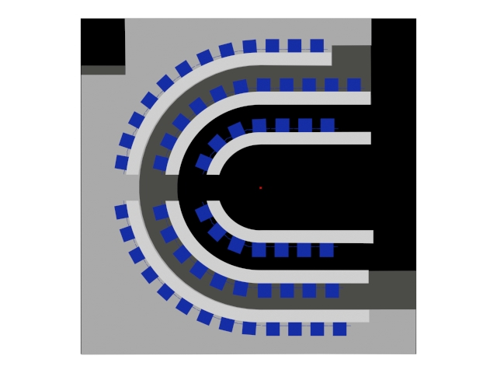
Image (a)
- Fourth Floor -- Combined EMBA Lounge (Room 406).
The third entrance door at the northwest corner where a print/copy area has been located is kludgy. It makes a third entrance and is way too tight to be useable as an operating lounge and is dead-end circulation space. I suggest:
        - Close off the dead end and make an “Archival Storage Room”
        - move the copy/print area to the south of the stairwell. This is just cabinetry with copiers and prints on the counter with storage above and below
        - create the kitchen/coffee service area on the west wall. This would hide the sink, microwaves and ref. in the alcove. Continue lower cabinets to the south wall.
        - Add door to adjacent classroom
See (revised image (b) below:
Image (b)
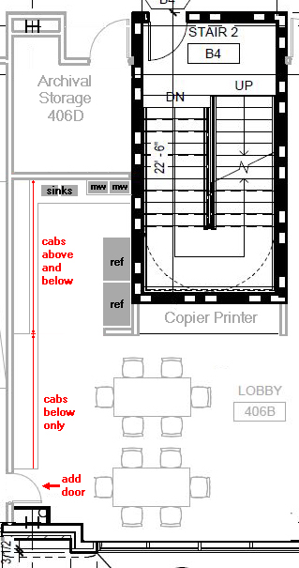
- Swap Classroom Layouts 408 and 410
We wish the flat classroom currently shown as 410 to be adjacent to the 406 lounge area. In the previous item notice the additional door connecting the 406 lounge with the classroom to the west. This is for overflow dining needs. Catering can be set up in 406 and actually dining in the adjacent flat classroom.
- Fourth Floor -- Classroom (410)
The classroom as shown doesn't conform to the programmatic specifications regarding room layout.
The furniture shown in "6 person tables" arranged in three rows. The "Program Study" says: "Classroom space with tables and chairs arranged in (10) pods of six students. Each pod will have a table that seats (6) students near an LCD screen." [This 'pod' arrangement also appears in the Wolff Center (Room 538)]. The revised image below shows ten square tables. Each pod will use desktop mounted flatscreen mounted above the end of the square table where there are no seats.
Additionally – the “front” of the room has a column that will break the plane of the whiteboards. Add this wall.
(see original image (c1) and revised image (c2) below)

Image (c1)  From THIS | Image (c2)  To THIS
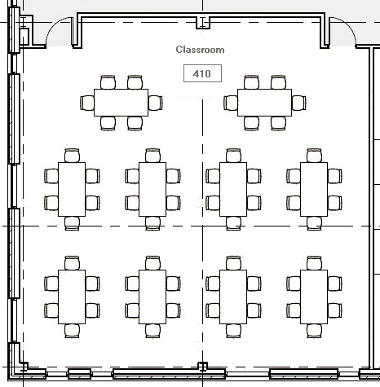 | 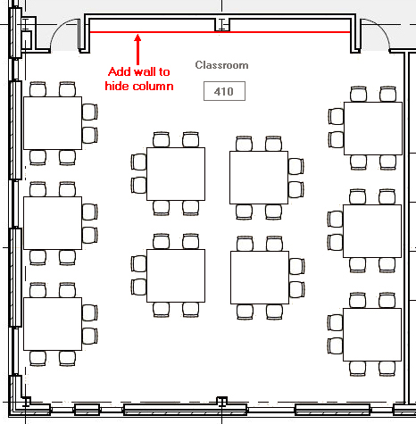
Impact on the Program:
Furniture and A/V Change only
- Fifth Floor, Wolff Center, Conference Room 538
The "Program Study" says: "General purpose meeting space used for group learning in (4) pods of ten students. Each pod has flat screen per table controlled by lectern. I am suggesting the revised 6 pods of eight as shown below. This does changes the occupancy to 48 [This 'pod' arrangement also appears in the EMBA (ES-1)]. Each pod will use desktop mounted flats screen mounted above the end of the square table where there are no seats.
The south wall of this has a column that protrudes into the room that reduced the whiteboard at the front of the room.
  - Encase the column inside the existing wall
OR
  - hide the column behind a new wall
(see original image (d1) and revised image (d2) below)
Image (d1)  From THIS | Image (d2)  To THIS
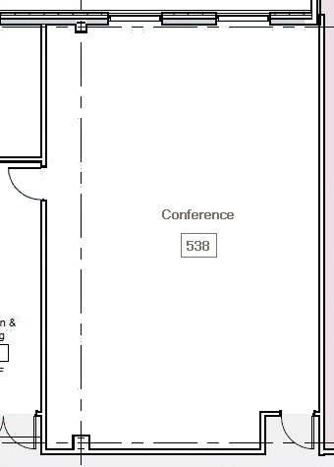 | 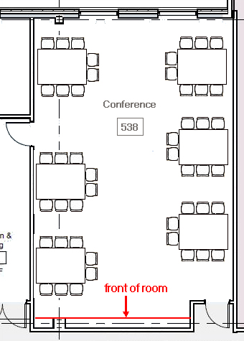
Impact on the Program:
Add wall at the front to hide the column. Furniture and A/V need changing.

- Fifth Floor, Seminar Reception 504
Reception area has a "free standing column" visually in the middle of the hallway. I suggest moving the center seminar room doors to conform and align with the eastern and western seminar rooms (i.e., a hallway with a door at the end) which can "capture" the isolated column.
I also wish to extend the southern wall of 504/506 approximately five feet southward in order to recover the space to make the reception area 300 Sq ft as per the "Program Study".
(see original image (e1) and revised image (e2) below)

Image (e1)
From THIS
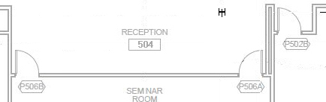
Image (e2)
To THIS
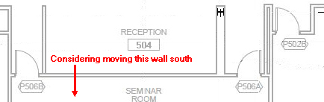
Impact on the Program:
Adds 30 feet of wall
- Fifth Floor Student Organization Meeting Rooms 510 and 520
Both of the meeting rooms have a "front" with a column protruding into the space. The "front" wall is not a single plane and would preclude a continuous whiteboard. This applies to the north wall in both Student Organization Meeting Rooms (510 and 520).
  - Encase the column inside the existing wall
OR
  - hide the column behind a new wall
Image (f1)  From THIS | Image (f2)  To THIS
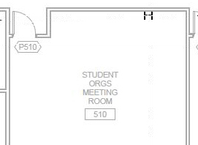 | 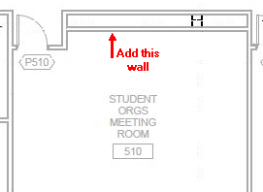
Impact on Program:

Adds wall space

- First floor lobby -- has a Print/Copy room and a Clinical Office. Put a door between these two rooms and label the current CO-1 as "Technology Support". This would allow our technology group to: be centrally located; have access to the copiers/printers; and be adjacent to the IT-MDF.
Image (g1)  From THIS | Image (g2)  To THIS
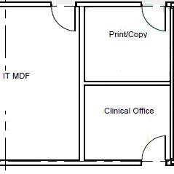 | 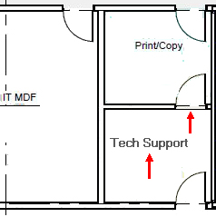
Impact on the Program:
Adds 1 door
- Fourth Floor EMBA Administrative Suite. -- "program study calls for 3 200 sq ft (total 600 sq ft) records and storage rooms (EA-3 on page 63, 4.38). "Drawings" show only 2 with a total of only 443 sq ft. "Program Study" says:
General file storage for the following functions:
(1) archival storage (file room for MBA records -- location is flexible)
(2) current storage (file room near advisors who have applications and current student records) (3) storage/assembly --
File storage should be directly accessible from the open office area.
QUANTITY: (3)
Are these functions combined into two rooms? (a) One for storage/assembly (cabinets with work surfaces on the perimeter, cabinet storage above and assembly space (counter-height) in the center (b) One for archival storage (floor to ceiling shelving on the perimeter and file storage furniture in the center)
Advise intent or program modification.

- Remove Dead-end Corridor and extend office 420 H
Revise corridor to enclose and expand room 420H as below.
Image (h1)  From THIS | Image (h2)  To THIS
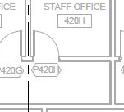 | 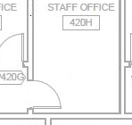
Impact on the Program:
Removes some wall space
- Replace Dead-end Corridor with a small closet in corridor of 428A
Revise corridor to enclose and expand room 428A as below.
Image (i1)  From THIS | Image (i2)  To THIS
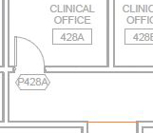 | 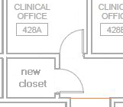
Impact on the Program:
Adds a door

- Create a Student Organization Manager Office by combining Rooms 519 and 523 into a single office
Image (j1)  From THIS | Image (j2)  To THIS
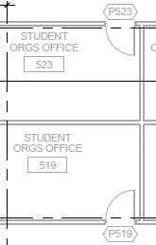 | 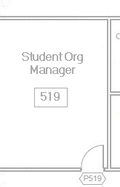
Impact on the Program:
loss of one door and some wall add a door

- Over-Under Suite Lockers in 406
There is a need for personal locker space for the EMBA students in 406. We suggest single hallway on the northern corridor side with lockers facing both way (north and south). There are 18” deep and 12” wide (two high). This will allow for about 240 lockers.
These are suite lockers and double height.
See revised image k1 below.

Image (k1)
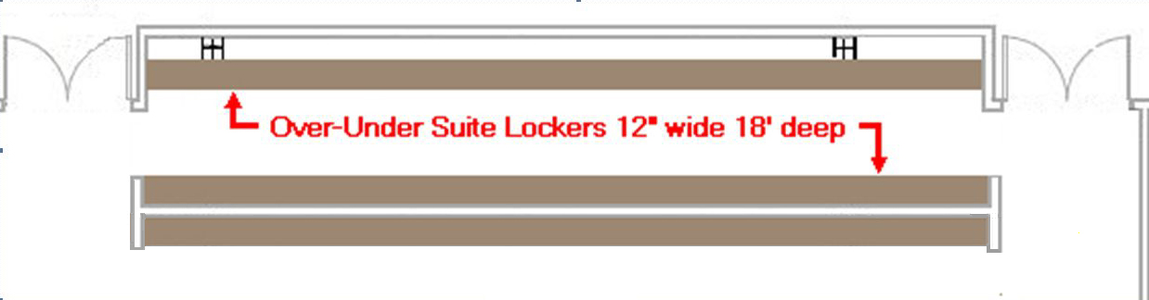
Impact on Program:

Adds 80 (or 120) feet of wall space

- Archival Storage on the first floor – return to the two-room version.
In our previous meeting, we requested that the two unclaimed storage rooms on the first florr be converted to one large room.
It has been requested by the Dean’s office to return these spaces to twp rooms as the originally appeared. One will be storage and one will be for our College maintenance personnel.

