Classroom/Bauer 3 Notes, Questions and Comments
Version 11 – Aug 2, 2011

Functional Changes:
- First Floor Bauer Staff 113 and 129

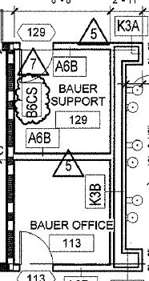 | 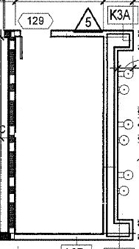

Remove wall between 113 and 129; Remove Door from 113. Furniture is: two desk, one file cabinet and the rest 18” industrial shelves. Double up on electrical outlets. This space will be used by Bauer’s maintenance people for storing tools and materials. They need extra outlets for battery chargers.
- First Floor Rooms 139 and 107
Remove connecting door
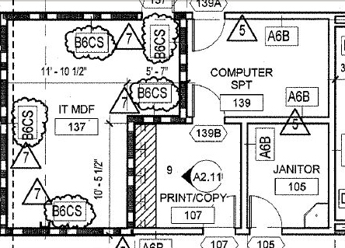
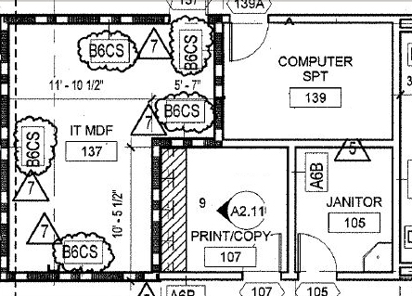

- Lecture Capture removal in the AV program

Confirm that lecture capture has been removed from the two 2nd floor general purpose classrooms and the four EMBA 4th floor classrooms:

  - Classrooms 212 and 214

  - Classrooms 410, 412, 414 and 416

Note: Owner said:
“We have a portable system now. I've been interested in using it but a great
many faculty are hostile to it. We don't need it. I wouldn't spend a penny on
it. Please save some money for a decent quality table tennis table.”

