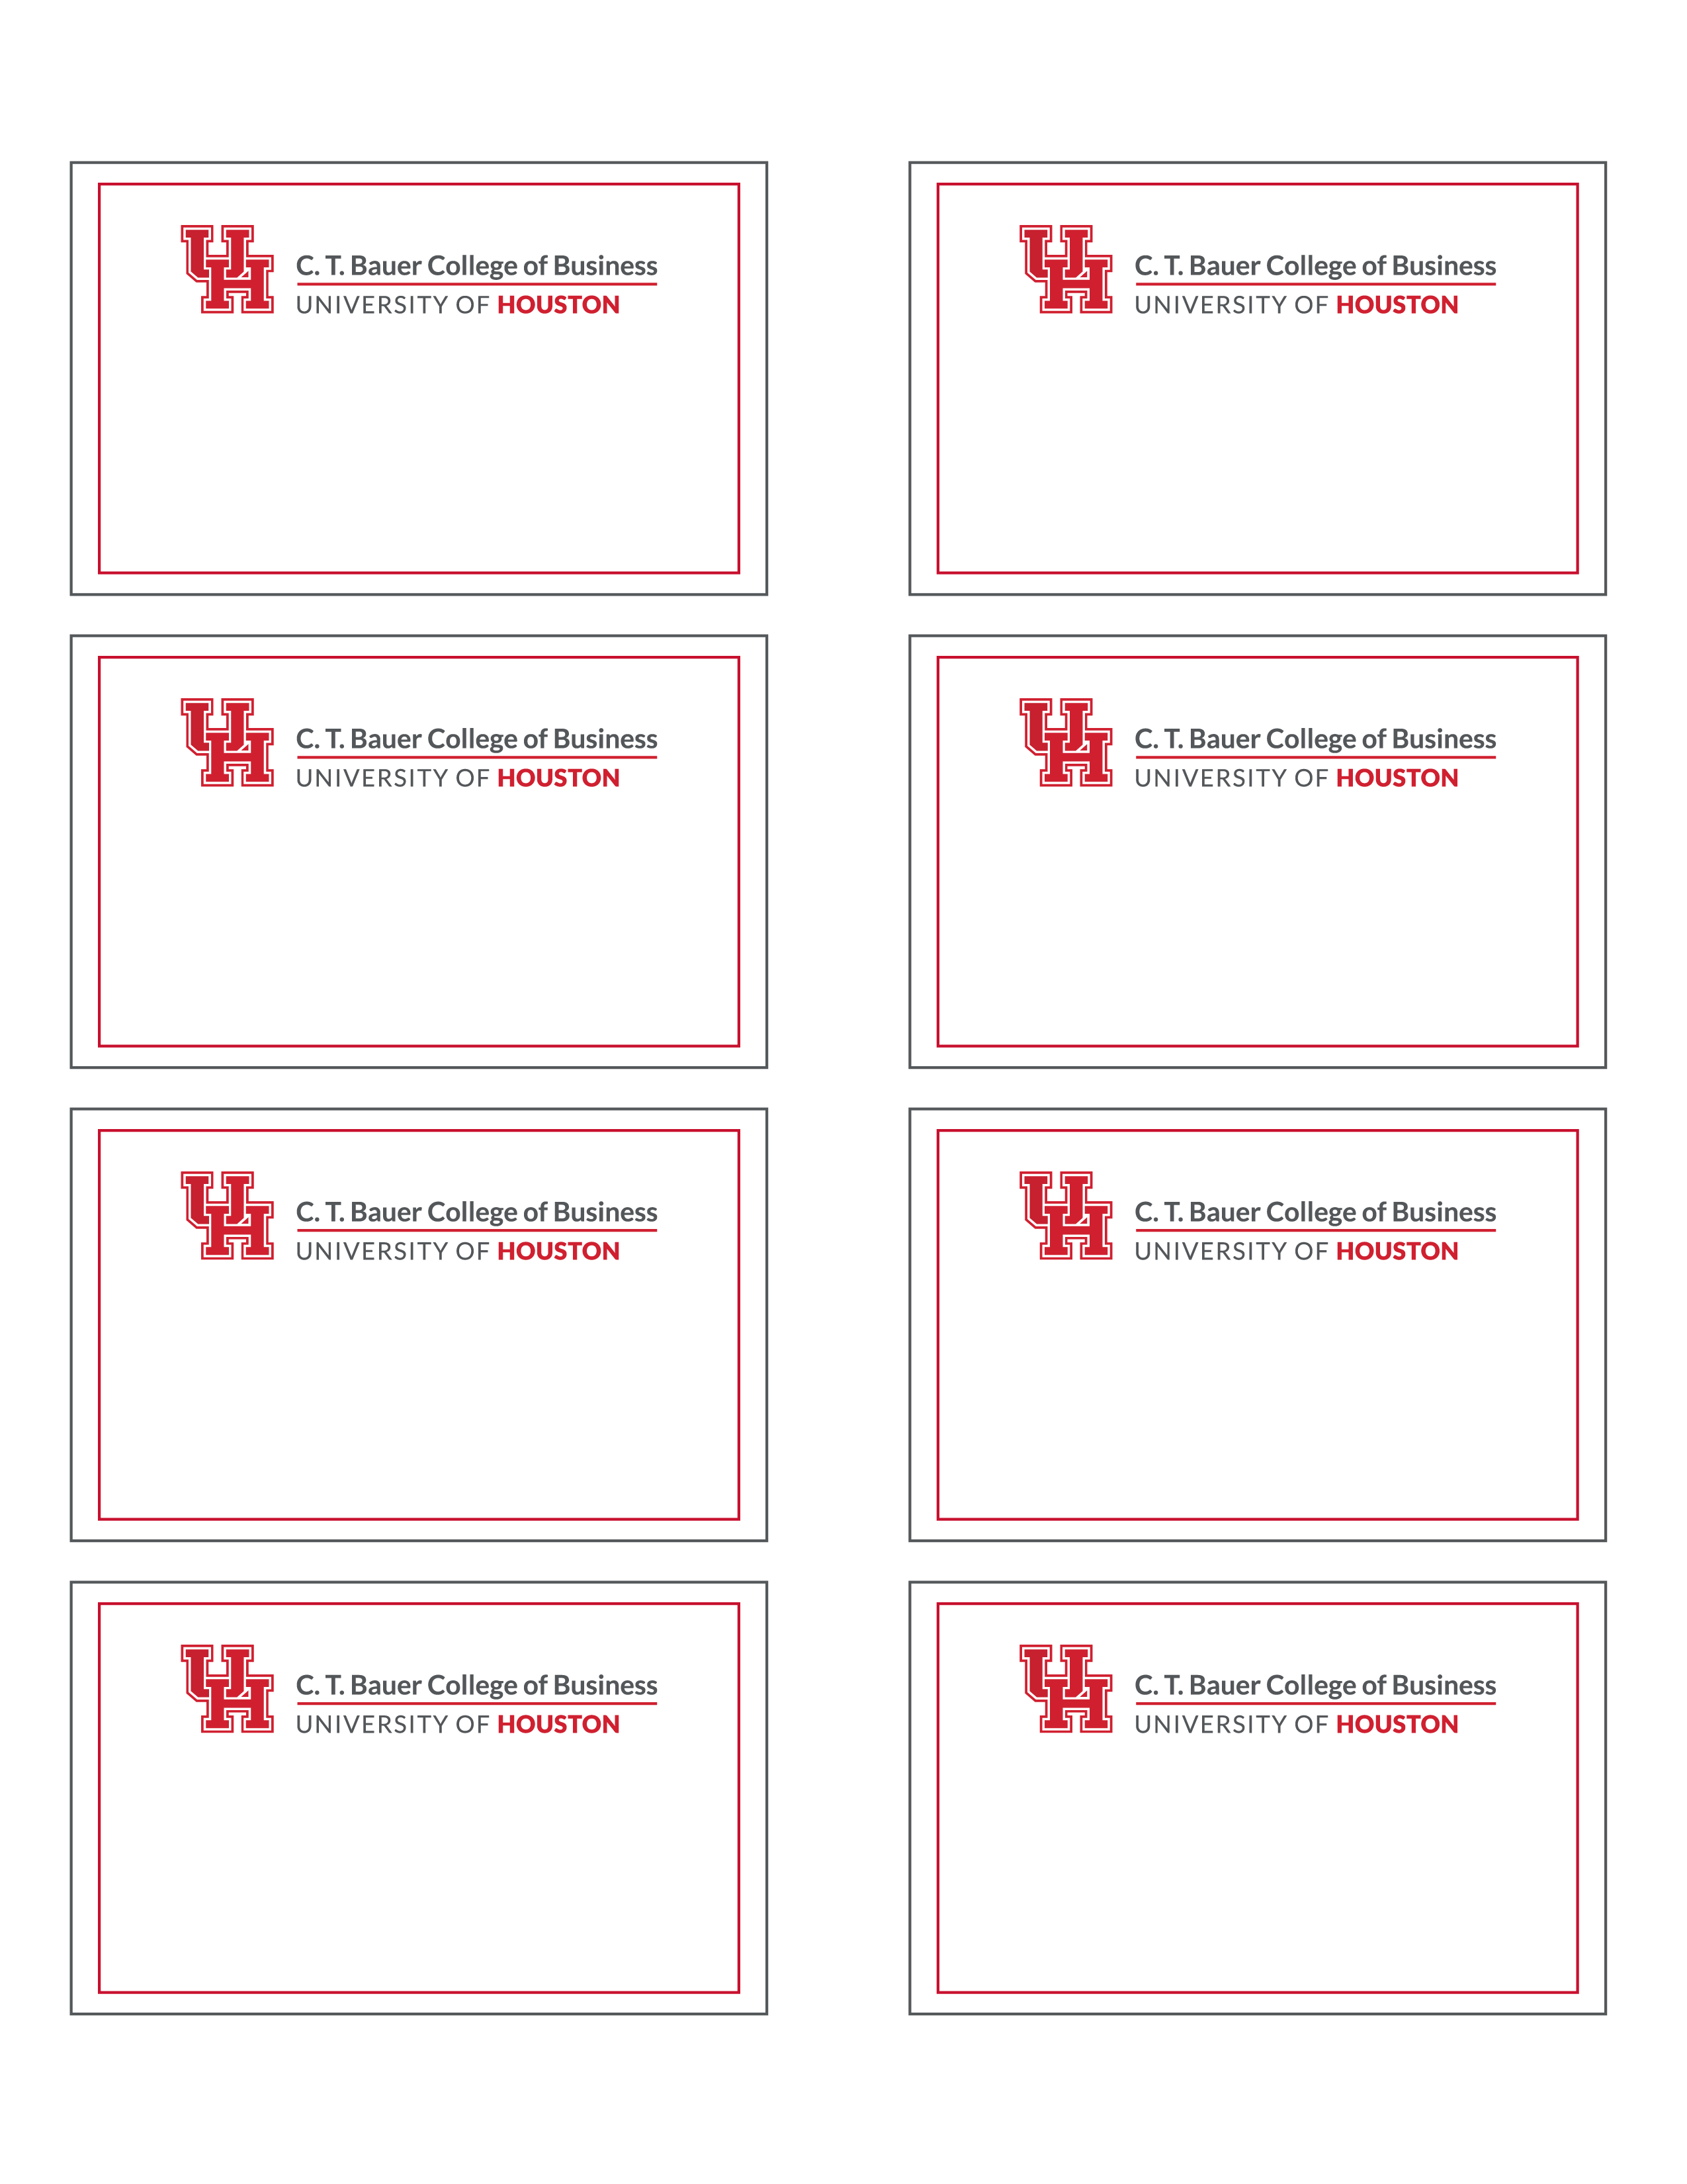

First

Last

First

Last

First

Last

First

Last

First

Last

First

Last

First

Last

First

Last