Fast Ion Battery (HBS Case 9-815-025)

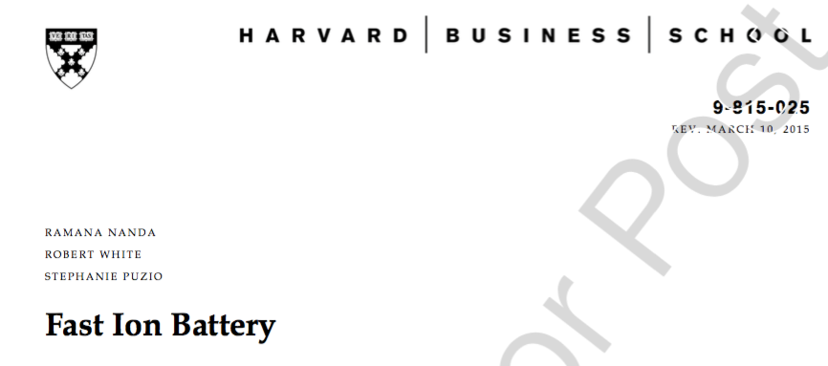

Assigned questions

- What are the costs/benefits from the point of view of Fast Ion Battery and the investors of introducing the abandonment option imbedded in bridge financing (Exhibit 4)? List arguments in favor and against extending the bridge round of funding.

- What are the contractual implications of non-participation in the bridge round (Exhibit 4)?

- Build the revised Cap Table (based on Exhibits 2 and 5) for Fast Ion by including the $5 million bridge round at $1.50/share. Assume that WSC and Franconia Ventures split the investments Bluelock would have made. Do this under two assumptions:

  - Bluelock does not participate and the “pay-to-play” clause is not implemented.

  - Bluelock does not participate and the “pay-to-play” clause is implemented?

- Do you think Bluelock should participate? How does you answer depend on whether the “pay-to-play” clause is implemented?

