Homework 2
Risk Aversion and Utility Functions: Calculus Exercise





Consumers face many types of hazards that could ruin their wealth: car wrecks, gambling losses, and hurricanes, to name three. Assuming that consumers evaluate the risks using their expected utility of wealth, we could describe their attitudes by a von Neumann-Morgenstern utility function of wealth, U(W), or an Arrow-Pratt risk aversion function, r(W). These two functions are related to each other:
r(W)= − U”(W)/U’(W) and $U(W)=a\int{e^{−\int{r(x)\text{dx}}}\text{dy}}+b$.
1. For the utility functions below, calculate the risk aversion functions. Are the utility functions concave and is the risk aversion positive? Do the level of risk aversion fall as wealth increases? Are the risk aversion functions convex or concave?
a. U(W)=aW-½bW², for a,b>0,
b. U(W)=aW^{b}, for a,b>0 and b<1,
c. U(W)=a+b·ln(W), for b>0.
2. Suppose that the risk aversion function was r(W)=μ+γW. What is the utility function?
[Hint 1: Use MathCad. Hint 2: Related to the cumulative normal distribution is a transcendental function called the “error function,” abbreviated erf(x), equals $\frac{2}{\sqrt{π}}\int{e^{−t^{2}}\text{dt}}$ and is available in MathCad and Excel. Its graph looks like the one below left (drawn using MathCad) and its derivative looks like the one below right (notice the bell shape).]
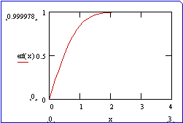
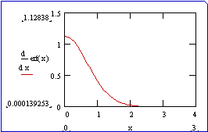

r(W)= − U”/U’ is related to the derivative of the natural log of U’, $U\text{\}\} over \{ size 10\{U'\}\} \} = \{ \{ size 10\{d\}\} over \{ size 10\{ ital }dW\text{\}\} \} }ln\text{ \backslash ( U' \backslash ( W \backslash ) \backslash ) }.\text{ \} \{}$ Thus, if we knew risk aversion, we could integrate both sides of the definition of r(W) to get $\text{ln}(U'(W))=−\int{r(x)\text{dx}+α}$, where α is an arbitrary constant of integration. This implies that $U'(W)=e^{−\int{r(x)\text{dx}+α}}={\text{ae}}^{−\int{r(x)\text{dx}}}$, where a≡e^{α} is an arbitrary positive number related to the constant of integration. Finally, integrating both sides of this gives the utility function $U(W)=a\int{e^{−\int{r(x)\text{dx}}}\text{dy}}+b$, where b is an arbitrary constant of integration. That is, we have recovered the von Neumann-Morgenstern utility function, unique up to scale and intercept, from knowledge only of the person’s Arrow-Pratt measure of risk aversion. In a sense, “utility” is “risk aversion” for individuals that evaluate uncertain prospects using expected utility.

