Poisson Regression
Pseudo-data on impulsive purchases from Lee and Kacen’s data looks like below where “g6_impbe” may be interpreted as the number of impulsive purchases made by each person, “imp_trai” is the person’s trait impulsiveness and “regic1i” =1 if the region is individualist and = 0 if collectivist. The Poisson process says that the probability of an impulse purchase is constant over time, but may differ between people. Hence, we are nesting a regression inside a Poisson model.

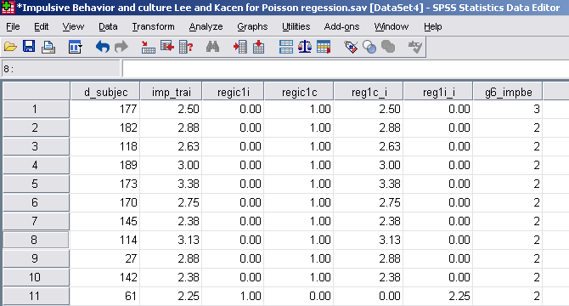

To do Poisson regression, click on Generalized Linear Model, and make a custom model with an identity link function. Note: had you used the Counts/Poisson loglinear or log link function, the link function would be logarithm so the mean response rate is exp(a+bX) rather than a+bX. This may be preferable because response rates should not be negative; but it makes the model more difficult to interpret. You could use the custom model with identity link.
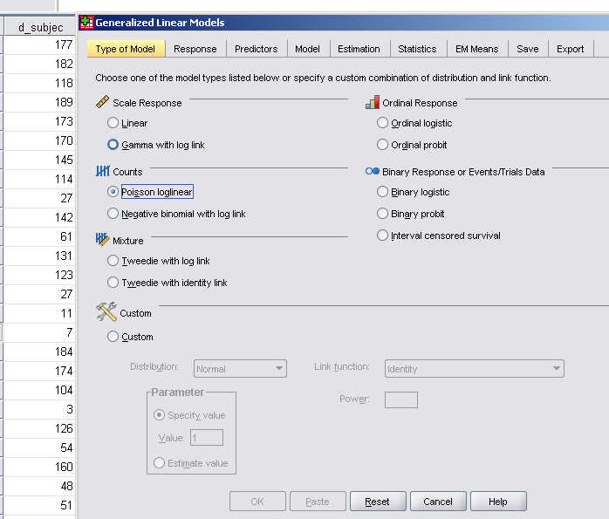
The response variable is g6_impbe, the number of impulse purchases.
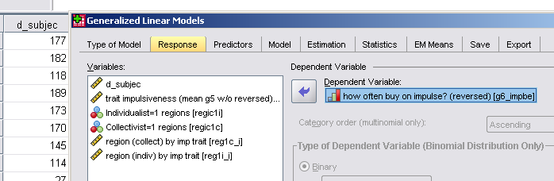
The predictors can either be dummy variables (Factors) or continuous (Covariates).
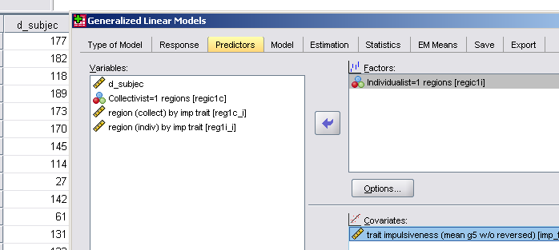
You have to build a model:
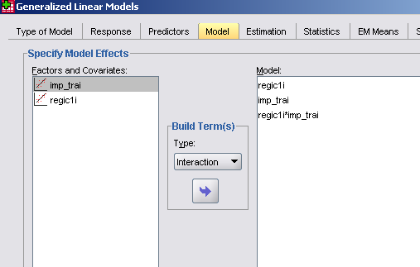
The output looks like
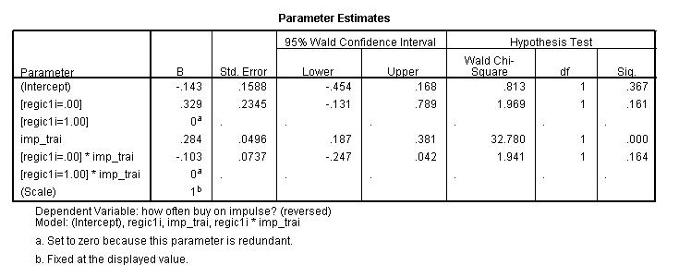
Notice that the program has chosen “individualistic”=1.00 as the baseline. Recall the model for impulse behavior is exp(Xβ) so the impact of switching from individualist to collectivist culture for a person with zero trait impulsivity is an increase in impulsive behavior by a factor exp(.329)=1.39 or about 39%. Similarly, an increase in trait impulsiveness by 1.0 for a person in an individualist culture increases impulsive behavior by exp(.284)=1.33 or 33%. Finally, the impact of trait impulsivity is lower for someone in a collectivist culture exp(2.84-.103)=1.20 or 20%.
Poisson Regression with Grouped Data

id | agegroup | smoker | pyears | deaths | age
1 | 1 | 2 | 18790 | 12 | 40
2 | 2 | 2 | 10673 | 12 | 50
3 | 3 | 2 | 5712 | 28 | 60
4 | 4 | 2 | 2585 | 28 | 70
5 | 5 | 2 | 1462 | 31 | 80
6 | 1 | 1 | 52407 | 32 | 40
7 | 2 | 1 | 43248 | 104 | 50
8 | 3 | 1 | 28612 | 206 | 60
9 | 4 | 1 | 12663 | 186 | 70
10 | 5 | 1 | 5317 | 102 | 80

'Coronary deaths from British male doctors. Doll & Hill(Nat Cancer Inst Monog 1996; 19:205-68)'. Smoker=1, Non-smoker=2

This is another way to do Poisson regression in SPSS. The number of deaths vary between each of ten groups. Each group had different populations, so we want to explain deaths per patient-years. We think that this death rate will vary by the age of the group and whether they smoke or not. The Poisson process says that the probability of a death is a constant over time, but may be higher for some groups than others. Hence we are nesting a regression inside a Poisson model. The link function is log, so the explanatory model is death rate=exp(Xβ). See below.

1. By default SPSS wants to count each row as “1” Death. You have to tell SPSS to count a row with more Deaths more heavily. To do this in SPSS, go to Data/Weight Cases and weight your cases by the Death variable. Note: SPSS will not like 0 counts, so recode variables so that 0 becomes 0.000000001.
2. Create an ID variable 1,2,3,…N for each row. That becomes your primary Factor in GENLOG. Given the weighting of point (1), each ID will define a cell in a Nx1 matrix and the entries in the cells will be the weighting variable, Death. ID does not become part of the “model,” however. It just defines the cells.
3. Put your categorical variables in the Factor box (along with ID). These might be Agegroup, Smoker, in your case. These must be part of the model.
4. Put the continuous variables into the Cell Covariate box. These might be Age etc. These must be part of the model.
5. Select the variables you want in your model by clicking Model/Custom. You can have interaction terms by selecting two variables on the left, and building an interaction term like Smoker*Agegroup.
6. The Cell structure box is for when you want to correct for number of things “at risk.” Suppose your weighting variable was count of Deaths for an age group and the Population of the age group varied from group to group. By putting Population in the Cell Structure box, SPSS would explain the count of Deaths/Population.
7. Click Options and ask for estimates, so that you can see the regression coefficients and their stats.

The interpretation of this is that the death rate is predicted by exp (Xβ). Hence if we switch to a one year older nonsmoker, the death rate go up by a factor exp(+0.1047×1)=1.11 or 11 percent. Note: death rates are very small since the constant is -12. Very young smokers have higher death rates than very young nonsmokers (higher by a factor of exp(+2.0308)=7.62), but as smokers age, the higher death rate for smokers moderates; every year the death rate factor drops from 7.62 at a rate of exp(-0.0249)=.975 or about 2.5% per year. This is because there is a systematic increase in other sources of death that are unrelated to smoking. At 81 years of age, the death rates of smokers and non smokers are equal (2.0308/0.0249=81).

