Ch 8 Homework Solutions: Quality Control

Problem 8-1

a. $C_{\text{pk}}=\text{min}\left\{\frac{\text{UTL}−\overline{X}}{3σ},\frac{\overline{X}−\text{LTL}}{3σ}\right\}=\text{min}\left\{\frac{1\text{.}\text{01}−1\text{.}\text{002}}{3(\text{.}\text{003})},\frac{1\text{.}\text{002}−\text{.}\text{99}}{3(\text{.}\text{003})}\right\}=\text{min}\left\{\text{.}\text{889},1\text{.}\text{333}\right\}$
= .889
b. The process is capable of producing the desired quality, but at present it is not capable
due to the process center. The process center should be adjusted.

Problem 8-2

a. Ten defectives were found in 10 samples of size 15.
$\overline{P}=\frac{\text{10}}{\text{10}(\text{15})}$= .067
$S_{p}=\sqrt{\frac{\overline{P}(1−\overline{P})}{n}}=\sqrt{\frac{\text{.}\text{067}(1−\text{.}\text{067})}{\text{15}}}$= .0645
UCL = $\overline{P}$ + 1.96$S_{p}$ = .067 + 1.96(.0645) = .194
UCL = $\overline{P}$ - 1.96$S_{p}$ = .067 - 1.96(.0645) = -.060 $→$ zero
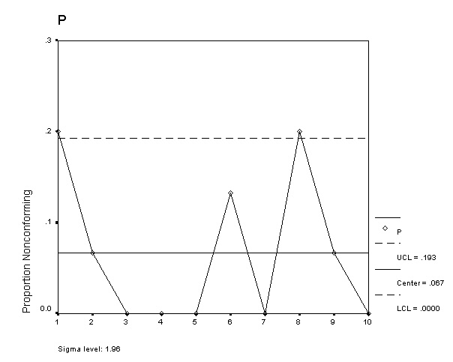

b. Stop the process and look for the special cause, it is out of statistical control.
Problem 8-3

Sample | 1 | 2 | 3 | 4 | mean | range
1 | 1010 | 991 | 985 | 986 | 993.00 | 25
2 | 995 | 996 | 1009 | 994 | 998.50 | 15
3 | 990 | 1003 | 1015 | 1008 | 1004.00 | 25
4 | 1015 | 1020 | 1009 | 998 | 1010.50 | 22
5 | 1013 | 1019 | 1005 | 993 | 1007.50 | 26
6 | 994 | 1001 | 994 | 1005 | 998.50 | 11
7 | 989 | 992 | 982 | 1020 | 995.75 | 38
8 | 1001 | 986 | 996 | 996 | 994.75 | 15
9 | 1006 | 989 | 1005 | 1007 | 1001.75 | 18
10 | 992 | 1007 | 1006 | 979 | 996.00 | 28
11 | 996 | 1006 | 997 | 989 | 997.00 | 17
12 | 1019 | 996 | 991 | 1010 | 1004.00 | 28
13 | 981 | 991 | 989 | 1003 | 991.00 | 22
14 | 999 | 993 | 988 | 984 | 991.00 | 15
15 | 1013 | 1002 | 1005 | 992 | 1003.00 | 21

$\overline{\overline{X}}=$ 999.1, $\overline{R}$= 21.733
Control limits for X-bar chart:
UCL, LCL = $\overline{\overline{X}}\underline{+}A_{2}\overline{R}$, = 999.1 + .73(21.733) = 1014.965, 983.235
Control limits for R chart:
UCL = $D_{4}\overline{R}$ = 2.28(21.7333) = 49.551
LCL = $D_{3}\overline{R}$ = 0(21.7333) = 0.00

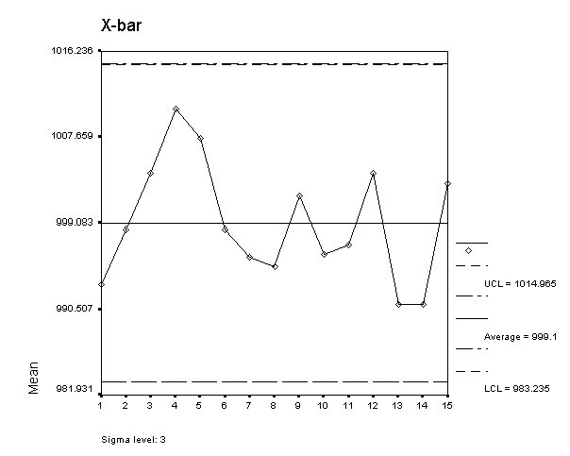

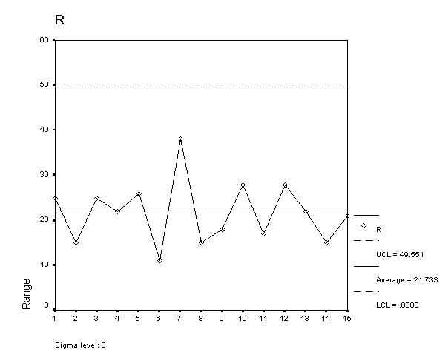
The process is in statistical control.

