Copyright by Keith Richards, 2007
ALL RIGHTS RESERVED
Relationship Effectiveness and Key Account Performance: Assessing Inter-Firm Fit between Buying and Selling Organizations

A Dissertation
Presented to
The faculty of the C.T. Bauer College of Business
University of Houston

In Partial Fulfillment
of the Requirements for the Degree
Doctor of Philosophy

by
Keith Richards
July 9, 2007
Relationship Effectiveness and Key Account Performance: Assessing Inter-Firm Fit between Buying and Selling Organizations

APPROVED:

_________________________________
Eli Jones
Professor of Marketing
Chairperson of Committee

_________________________________
Michael Ahearne
Associate Professor of Marketing

_________________________________
Steven P. Brown
Bauer Professor of Marketing

_________________________________
Wynne W. Chin
Professor of Decision and Information Systems

_________________________________
Arthur D. Warga
Dean, C. T. Bauer College of Business

For my family:

Jennie, this is for you.
I couldn’t have done it without your love, encouragement and support.
Thank you.

Andrew, Austin and Ansley know that I love you and believe in each of you.
If Dad can do this, you can do anything!

Relationship Effectiveness and Key Account Performance: Assessing Inter-Firm Fit between Buying and Selling Organizations
ABSTRACT

Key accounts represent one of a company’s most important opportunities for developing successful partnerships. To develop these key accounts companies employ dedicated managers and align resources with the needs of the customer. Based on qualitative interviews conducted during this study, managers indicate that they intuitively know that “fit” between the buying and selling company is of great importance. Managers suggest that assessed “fit” helps determine when to invest and when to withhold investments with key accounts. However, this degree of fit has largely been ignored in academic literature. This study examines these dimensions of fit between the buying and selling firms that lead to improved account performance. A theoretical framework is developed from previous work in relationship marketing, strategic alliances and personal selling to describe the key account managers’ evaluations of accounts across three inter-firm fit factors: strategic, operational and personal fit. By shifting the level of analyses from the organizational level to the account level, this study is operationalized at the level of managerial decision making. In addition to the qualitative data that were collected to shape the study, both survey data and company records were gathered from supporting organizations. An account-level structural model was estimated to determine the impact of inter-firm fit on a key account’s performance. Evidence was found to support the influence of strategic, operational and personal fit on relationship effectiveness. Further, two of these three types of fit moderate relationships between previously established antecedents of relationship effectiveness. Finally, support is found for the relationship between relationship effectiveness and account performance.
TABLE OF CONTENTS

ABSTRACT v
LIST OF TABLES viii
LIST OF FIGURES ix
INTRODUCTION 1
CONCEPTUAL BACKGROUND 3
Key Account Management Definitions 3
Key Account Management Literature Review 4
Inter-Firm Fit Qualitative Study 5
Three types of Inter-Firm Fit Defined 7
Key Mediating Variable: Relationship Effectiveness 8
HYPOTHESES DEVELOPMENT 11
Inter-Firm Fit to Relationship Effectiveness 11
Integrative Model: Established Antecedents to 15
Relationship Effectiveness
Interaction Effects 18
Relationship Effectiveness to Performance 22
METHODS 23
Sample 23
Scale Development 25
Scale Properties 27
Analytical Approach 32
RESULTS 34
Model Comparison 34
Hypotheses Testing 36
DISCUSSION 39
Contributions 44
Limitations and Future Research 46
APPENDICES 48
Appendix A: Analyses of Intent to Serve 48
TABLES 49
FIGURES 63
REFERENCES 75
LIST OF TABLES

TABLE 1: LITERATURE REVIEW 49
TABLE 2: MEAN COMPARISON OF GROUPS 54
TALBE 3: MEANS, STANDARD DEVIATIONS, AND 55
LOADINGS FROM CONFIRMATORY
FACTOR ANALYSIS IN PLS
TABLE 4: CONSTRUCT RELIABILITIES AND 59
INTERCORRELATIONS AMONG
REFLECTIVE CONSTRUCTS
TABLE 5: RESULTS FROM ESTIMATION OF 61
BASELINE MODEL
TABLE 6: RESULTS FROM ESTIMATION OF 62
HYPOTHESIZED MODEL

LIST OF FIGURES

FIGURE 1: BASELINE MODEL 63
FIGURE 2: HYPOTHESIZED MODEL 64
FIGURE 3: INTERACTION: STRATEGIC FIT X 65
INTRAPRENEURIAL ABILITY
FIGURE 4: INTERACTION: OPERATIONAL FIT X 66
ACTIVITY INTENSITY
FIGURE 5: INTERACTION: PERSONAL FIT X 67
COMMUNICATION QUALITY
FIGURE 6: INTERACTION: PERSONAL FIT X 68
ESPRIT DE CORPS
FIGURE 7: REDUNDANCY ANALYSIS: RELATIONSHIP 69
EFFECTIVENESS
FIGURE 8: REDUNDANCY ANALYSIS: ACTIVITY INTENSITY 70
FIGURE 9: REDUNDANCY ANALYSIS: ORGANIZATIONAL 71
SUPPORT
FIGURE 10: REDUNDANCY ANALYSIS: ACTIVITY 72
PROACTIVENESS
FIGURE 11: BASELINE MODEL: PLS RESULTS 73
FIGURE 12: HYPOTHESIZED MODEL: PLS RESULTS 74
Introduction

In recent years, marketing scholars and practitioners have embraced two important environmental shifts in marketing. First, the migration from short-term, transactional exchanges to long-term, relational exchanges has become standard practice for many marketing organizations (Webster 1992; Rackham and DeVincentis 1999). Second, marketers are increasingly moving away from the traditional assumption that consumer demand is homogeneous and are accepting the reality that customers are heterogeneous with respect to their needs and with respect to the value they provide to the selling firm (Hunt and Morgan 1995; Niraj, Gupta and Narasimhan 2001). The result of these two changes has been visible in several streams of marketing literature including relationship marketing (Dwyer, Schurr and Oh 1987; Parvatiyar and Sheth 2000), customer relationship management (Reinartz, Krafft, and Hoyer 2004), customer lifetime value (Blattberg and Deighton 1996; Rust, Lemon and Zeithaml 2004), customer orientation (Jaworski and Kohli 1993; Narver and Slater 1994) and key account (KA) management (Homburg, Workman and Jensen 2002; Workman, Homburg and Jensen 2003). In particular, KA management is at the intersection of these two shifts in the marketing landscape (Homburg, Workman and Jensen 2000) and KAs are critical to the lifeblood of selling companies. The goal of this study is to qualitatively and quantitatively explore important account-level issues in KA management through the investigation of the antecedents of relationship effectiveness. In addition to previously studied antecedents to the selling company’s relationship effectiveness, this study will add three types of inter-firm fit to the literature. Interactions between inter-firm fit and previously studied determinants will also be explored. More specifically this study will address the following two questions: How does inter-firm fit impact key account (KA) performance? How does inter-firm fit moderate antecedents in the current theoretical framework?
This study makes the following contributions. First, relationship effectiveness is established as the key mediating variable in key account studies and its first-order factors were expanded beyond trust and commitment. Second, three types of inter-firm fit (strategic, operational and personal) are introduced as important antecedents to relationship effectiveness. Third, two of the three types of inter-firm fit (operational and personal) are established as moderators with previously established antecedents to relationship effectiveness.
conceptual background

Key Account Management Definitions
For the purpose of this study, three terms related to KAs need to be defined: key account, key account management and key account manager. First, it is necessary to have a clear understanding of how to define KA. In this study, the term key account is defined as customers in a business-to-business market, identified by the selling company as the most important customers and serviced by the selling company with dedicated resources (Workman, Homburg and Jensen 2003). Second, Workman, Homburg and Jensen (2003, p. 7) defined key account management as “the performance of additional activities and / or designation of special personnel directed at an organization’s most important customers.” This definition implies two things: 1) KAs have been identified as requiring special treatment and 2) that the selling company has directed additional resources to these accounts. Finally, key account manager is defined as the individual designated by the selling firm to serve as an internal advocate for his or her KAs. This definition is consistent with the one offered by Sengupta, Krapfel and Pusateri (2000, p. 253): “A key account [manager] salesperson is responsible for maintaining and developing direct relationships with a few customer accounts that cut across product and geographical boundaries.” It is the primary responsibility of the KAM to assess the customer’s needs and to act as an advocate for his or her accounts within the selling organization.

Key Account Management Literature Review
As expected with any emerging stream of research, much of the KA literature has been theoretical rather than empirical (Weilbaker and Weeks 1997; Jones, et al. 2005). In addition, the empirical literature has focused on a narrow range of issues: appropriateness of KA programs (Sengupta, Krapfel and Pusateri 1997a, 1997b; Shapiro and Moriarty 1980, 1982, 1984a, and 1984b); KA managers and KA sales team effectiveness (Sengupta, Krapfel and Pusateri 2000; Schultz and Evans 2002; Arnett, Macy and Wilcox 2005); desirable characteristics of KAMs (Wotruba and Castleberry 1993) and KA organizational structures (Homburg, Workman and Jensen 2002; Workman, Homburg and Jensen 2003). Table 1 includes an overview of KA research organized by date. The genesis of this table is a similar compilation of references from the work of Homburg, Workman and Jensen (2002) and has been updated for use in this study. These earlier studies are grouped into three types: those in the personal selling literature (e.g., Sengupta, Krapfel and Pusateri 2000; Schultz and Evans 2002; Arnett, Macy and Wilcox 2005; and Wotruba and Castleberry 1993); those in the organization support literature (e.g., Homburg, Workman and Jensen 2002; Workman, Homburg and Jensen 2003); and those describing account characteristics that are sought when KAs are selected as partners (Colletti and Tubridy 1987; Napolitano 1997; Boles, Johnston and Gardner 1999; Wengler, Ehret and Saab 2006). To extend the current body of KA research, the goal of this study is to examine an integrative model of the antecedents of effective account relationships measured at the account level and to introduce levels of inter-firm fit – as perceived by the KAM – as important determinants of relationship effectiveness for KAs.

--------------------------------
Insert Table 1 about Here
--------------------------------

Inter-Firm Fit Qualitative Study
A qualitative study was conducted to investigate the three fit dimensions with KAMs and with the senior management of KA management organizations. The qualitative results and the preceding literature review were combined to create three constructs that capture the fit dimensions that KAMs evaluate most often. This qualitative study followed the methods used by Workman, Homburg and Gruner (1998) and Kohli and Jaworski (1990). In positivistic studies, field interviews typically serve as the first stage leading to a quantitative phase (e.g., Kohli and Jaworski 1990, followed by Jaworski and Kohli 1993). Similarly, these types of field studies may serve as a catalyst for the development or refinement of a positivistic model (e.g., Burgelman 1983; Miles and Snow, 1978; Robinson, Faris, and Wind 1967). Both of these research objectives are present in this study. Given the goal of identifying the main influences in KA management at the account level, field interviews were used that systematically explored these influences across different dimensions of KA relationship effectiveness. Previous studies have used similar qualitative studies to produce knowledge in cases where the subject area is vast and complicated (Bonoma 1985; Eisenhardt 1989; Zaltman, LeMasters, and Heffring 1982; Homburg, Workman and Jensen 2000). Homburg, Workman and Jensen (2000) verified the appropriateness of this qualitative methodology through a, “thorough review of qualitative work in the Journal of Marketing and the Journal of Marketing Research since 1984 (p. 462).” They determined that their approach came closest to those of Kohli and Jaworski (1990) and Workman, Homburg and Gruner (1998), in that they sought to develop a primary organizing theme and propositions. Similarly, the qualitative work here was developed to uncover an organizing theme concerning the attributes of a KA that KAMs use to evaluate their accounts. To this end, semi-structured, in-depth interviews were conducted with approximately 25 KAMs across 18 different organizations. The organizations represented were both located in the United States and in Europe and represent multiple industries: telecommunications, insurance, construction and engineering, management consulting, home appliances, personal care products, etc. These interviews lasted from 30 minutes to three hours and interviewer notes were taken in each interview. Findings from these interviews are used throughout this study in the development of constructs and hypotheses related to the theoretical model. In brief, results from the interviews suggested that KAMs are frequently involved in the assessment of their accounts. An analysis of comments on these types of assessments directed the research toward the notion of fit. KAMs were particularly concerned with fit between the buying and selling companies as it relates to the strategy, operations and personnel associated with a particular KA. Using the results of the qualitative research as a guide, existing literature was evaluated to identify a theoretical framework for these three types of inter-firm fit. Existing frameworks in the strategic alliance literature and personal selling literature are offered as theoretical support for the three types of inter-firm fit.

Three Types of Inter-Firm Fit Defined
The first two inter-firm fit dimensions were conceptualized based on work done in the strategic alliance literature. Sheth and Parvatiyar (1992) developed a typology to classify inter-firm alliances along two dimensions. In this categorization they proposed that alliances were a function of the parties to the alliance and to the function of the alliance. They defined parties to the alliance as being either competitors or non-competitors with KAs falling into the non-competitor classification, which is characterized as having higher degrees of trust than the competitor class. Further, they defined alliance purpose as being either strategic or operational. In their conceptualization of these alliance purposes, they dichotomized these two variables along a single continuum. However, they pointed out that this dichotomization is not necessary, and for many firms “the strategic and operations purposes of an alliance may overlap” (p. 76). It is expected that these two dimensions would overlap more often when non-competitive alliances are formed, such as those created when buyers and suppliers enter into KA partnerships. There are two aspects that make this alliance framework attractive for use in the KA context. First, KA partnerships are a form of inter-firm alliance (e.g., either strategic or operational, and non-competitive). Second, the motive for entering into a KA partnership is similar to that of an inter-firm alliance and spans the range from strategy to operations. These two alliance purposes – strategic fit and operational fit – are the first two inter-firm fit factors. Strategic fit is defined as the degree to which the buying and selling firms’ strategies are aligned. Operational fit is defined as the degree to which the service requirements of the KA are aligned with the capabilities of the selling company.
In addition to the alliance framework, which operates at the organizational level, KA management also has a close connection with personal selling (Weilbaker and Weeks 1997). Personal selling is based on person-to-person interactions and this type of relationship is important at the KA level. Wengler, Ehret and Saab (2006) indicate that KA management is one type of relationship marketing approach that is still closely linked to the classic sales task. This relationship between KA management and sales makes it particularly prone to the personal influences of the individuals responsible for managing and servicing these KAs. Personal fit is the degree to which the individuals in the buying and selling companies are similar to each other, the degree to which they get along well with each other. Based on findings in the qualitative interviews, individuals in both companies develop strong, lasting relationships during the time they work together. As an illustration of the importance of this personal match, one Vice President in a professional services firm interviewed for this study stated that they consider personal fit more important than account size. In their words, they would rather “pass” on a large account with poor personal fit, than risk destroying their company culture to gain the large account. The logic and hypotheses for strategic, operational and personal fit will be developed in the following sections.

Key Mediating Variable: Relationship Effectiveness
The following integrative account-level model is developed by combining work done by Workman, Homburg and Jensen (2003) with Sengupta, Krapfel and Pusateri (2000). This integrative model serves as a baseline model in the data analysis (see Figure 1). Relationship effectiveness – the mediating variable in the baseline model – was adapted from previous KA literature (Workman, Homburg and Jensen 2003; Narus and Anderson 1995). For this study, a new, second-order formative construct was developed to serve in the mediating role between the antecedents of relationship effectiveness and account-level performance. Relationship effectiveness is defined as the extent to which an organization achieves good relational outcomes for the KA of interest. Drawing on the commitment-trust theory of relationship marketing (Morgan and Hunt 1994) and previous KA research, trust, relationship commitment, cooperation, conflict resolution, and information sharing are posited as the formative elements of relationship effectiveness. Relationship effectiveness is a composite measure formed by each of these five sub-components.

--------------------------------
Insert Figure 1 about Here
--------------------------------

Trust is defined as a state that exists “when one party has confidence in an exchange partner’s reliability and integrity” (Morgan and Hunt 1994, p. 23). Relationship commitment is defined as “an exchange partner believing that an ongoing relationship with another is so important as to warrant maximum efforts at maintaining it” (Morgan and Hunt 1994, p. 23). Strong conceptual links exist between these definitions of trust and relationship commitment, and the types of desired intermediate outcomes that organizations are seeking with their KAs, such as the development of trust; increased information sharing; reduction of conflicts and increased relationship commitment (Workman, Homburg and Jensen 2003).
Information sharing is defined as the extent to which the buying and selling organizations communicate important information about the future that may be useful to the relationship (Cannon and Homburg 2001). Several authors have indicated that information sharing is critical to relationship development and effectiveness (Crosby, Evans and Cowles 1990; Lages, Lages and Lages 2005). Cooperation refers to situations wherein both parties work together to achieve mutual goals (Anderson and Narus 1990). Anderson and Narus (1990, p. 45) add that, “joint efforts will lead to outcomes that exceed what the firm would achieve if it acted solely in its own best interests.” Conflict resolution is defined as the “extent to which…disagreements are replaced by agreements and consensus,” (Chin and Goles 2005; Robey et al. 1989, p. 1174). Conflicts are a normal part of any relationship and how they are resolved have a large impact on the health of a relationship (Chin and Goles 2005). Combining information sharing, cooperation, and conflict resolution with trust and relationship commitment provides a more comprehensive mediating variable that captures the complex nature of KA relationships. Next, hypotheses will be developed for the integrative, baseline model and the full model including the introduction of fit and interactions between fit and the established antecedents of relationship effectiveness.

Hypotheses development

Inter-Firm Fit to Relationship Effectiveness
Levels of inter-firm fit – as perceived by the KAM – are hypothesized to be important determinants of effectiveness in managing KAs (see Figure 2). The three types of inter-firm fit (strategic, operational, and personal) are based on the KAM’s understanding of the important attributes or characteristics that each KA has, and on how those characteristics match the supplier’s ability to service the account. The first two inter-firm fit dimensions were conceptualized based on work done in the strategic alliance literature. In particular, Sheth and Parvatiyar’s (1992) alliance framework specifies two alliance purposes based on strategy and operations that are the first two inter-firm fit factors.

--------------------------------
Insert Figure 2 about Here
--------------------------------

Strategic fit is defined as the degree to which the buying and selling firms’ strategies are aligned. Sheth and Parvatiyar (1992) provide four strategic motives that drive firms into alliances: growth opportunities, strategic intent, protection against external threats, and diversification. Each of these motives exists in the KA context as was confirmed in the qualitative interviews. As previously discussed, account volume or growth, is a central goal of KA strategies. In addition, strategic intent may be sought for other types of supplier firm strategies where partnering is a natural means to the strategic end (e.g., seeking to open new markets). Protection against external threats may be likened to protecting market share or share of wallet in a KA setting. Finally, diversification is reflected in a supplier firm’s desire to lower risk by maintaining several KAs and not relying too heavily on any one account.
Strategic fit is particularly important at the KA level where relationships often involve senior-level management and the cocreation of products and services. Based on qualitative interviews, KAMs believe that the greater the fit between their company’s strategy and the buyer’s strategy, the higher the likelihood of establishing an effective relationship. In addition, KAMs believe that when their company’s strategy is closely aligned with the buying company’s strategy, synergies may be created between other marketing and distribution efforts that are designed to serve the total company. For example, in qualitative interviews, one executive in a service company noted that his organization had built a technological platform to provide service to its smallest accounts. The firm’s strategy with this technology was designed to improve the cost structure of servicing its small accounts. However, he was quick to point out that even their largest accounts were benefiting from the technology, particularly when the larger accounts had multiple locations with small numbers of employees in each location. These types of synergistic investments in technology, advertising and logistics are more likely to occur when the strategies of the two exchange partners are more closely aligned. This leads to a positive relationship between strategic fit and relationship effectiveness. Therefore:
H_{1a}: As the KAM’s perceptions of strategic fit between the selling company and the KA increase, relationship effectiveness will increase.

Beyond strategic fit, KAMs are also concerned with operational fit. Operational fit is defined as the degree to which the service requirements of the KA are aligned with the capabilities of the selling company. Again, Sheth and Parvatiyar (1992) offer four motives for entering into an alliance, this time, based on operations: resource efficiency, increasing asset utilization, enhancing core competence, and closing the performance gap. In the KA context, resource efficiency is equated to entering into a KA relationship to centralize operations and address the complexity of an account’s service requirements. A national director of a large industrial service company indicated that several accounts were considered KAs due to the complexity of handling their service requirements. In order for her company to serve these accounts effectively, they needed central coordination that was not available in the field sales organization.
In addition to addressing issues of resource efficiency, KAMs also work to increase asset utilization. This effort may take the form of seeking incremental volume from an account that provides only enough gross margin to cover the variable costs of the service. This action is particularly relevant when KAMs realize that the added volume will enable the selling organization to keep its plants running efficiently and to retain skilled employees. Enhancing core competencies is another operational motive for entering into a KA relationship for some KAMs. For example, a KAM may enter into an account relationship and either take over some of the buyer’s function or outsource some functions to the buyer. This cooperative sharing of responsibilities is typically based on the understanding that core competencies will be enhanced by focusing only on important functions and outsourcing others. Finally, KAMs may enter into a KA relationship in order to close a performance gap. This type of performance seeking happens when an arrangement is made for the buyer to provide distribution of the products based on their strong distribution system.
In addition to the motivators found in the current strategic alliances literature, operational fit is also sought by finding partners who can benefit from the automated ordering, delivery, and payment processes in which the supplier has already invested. When operational fit is high, goods and services are efficiently exchanged for payments, and both the buyers and sellers stand to benefit from the improved relationship. Therefore:
H_{1b}: As the KAM’s perceptions of operational fit between the selling company and the KA increase, relationship effectiveness will increase.

Aside from the alliance framework, which operates at the organizational level, KA management is closely linked to personal selling (Weilbaker and Weeks 1997; Wengler, Ehret and Saab 2006). This relationship between KA management and sales makes it particularly prone to the personal influences of the individuals responsible for managing and servicing these KAs. Personal fit is the degree to which the individuals in the buying and selling companies are similar to each other and have strong personal relationships. Individual-level relationships established between the KAM and members of the buying center are an example of the types of relationships that are developed when personal fit is high. The nature of these relationships is based on these individuals sharing similar values. These relationships result in positive emotional ties (Price and Arnould 1999) and a greater likelihood of the customer continuing to do business with the firm (Seabright, Levinthal, and Fichman 1992). Therefore:
H_{1c}: As the KAM’s perceptions of personal fit between the selling company and the KA increase, relationship effectiveness will increase.

Integrative Baseline Model: Established Antecedents to Relationship Effectiveness
Previous KA research has identified six antecedents to relationship effectiveness. Hypotheses for these six antecedents (intrapreneurial ability, communication quality, activity intensity, activity proactiveness, esprit de corps, and organizational support) remain consistent with previous studies. First, work done on KA salesperson effectiveness by Sengupta, Krapfel and Pusateri (2000) found that a KAM’s ability to work entrepreneurially is mediated by trust and is ultimately a determinant of effectiveness. Intrapreneurial ability is defined as, “entrepreneurship inside the corporation” (Sengupta, Krapfel and Pusateri 2000, p. 254). Wotruba and Castleberry (1993) suggested that KAMs have to be innovative and able to locate resources within the seller’s firm to assist customers. KAMs take risks and may go against conventional wisdom to serve their KAs (Kuratko, Montagno and Hornsby 1990). This risk-taking behavior was evident in my qualitative study as well. Several KAMs indicated that they needed to “take some chances” to serve their accounts well. Based on these earlier results, a KAM’s intrapreneurial ability is expected to be positively related to relationship effectiveness. Therefore:
H_{2a}: As the KAM’s intrapreneurial ability increases, relationship effectiveness will increase.

Second, the lifeblood of a good relationship is communication, and the exchange of information between trading partners is critical to the success of that relationship. Communication quality is the degree to which the appropriate content of the communication is received and understood by the other party in the relationship. This definition is based on work by Sengupta, Krapfel and Pusateri (2000), Schultz and Evans (2002), and Johlke and Duhan (2001). Following the previous research in this area, as communication quality increases, it is expected that relationship effectiveness will increase. Therefore:
H_{2b}: As communication quality increases between the buying and selling companies, relationship effectiveness will increase.

Third, consistent with Workman, Homburg and Jensen’s (2003) earlier work, activity intensity is hypothesized to be an antecedent of relationship effectiveness. Activity intensity is defined as the extent to which activities are performed for the focal KA as compared to other KAs within the same company. Account-level activities are associated with improved collaboration with respect to the “4Ps,” (product, price, place and promotion), and improved communication and information sharing (Mohr and Nevin 1990). Higher levels of activity intensity at the account level bring the following benefits to a KA: they signal supplier commitment and trust; reduce cost structure for customer; improve competitive position, help KAs compete via improved logistical arrangements; and improve communication which leads to improved responsiveness (Workman, Homburg and Jensen’s 2003). Therefore, as activity intensity increases, relationship effectiveness will also increase.
H_{2c}: As activity intensity increases, relationship effectiveness will increase.

Fourth, in addition to the intensity of account-level activities, activity proactiveness is a determinant of KA relationship effectiveness. Activity proactiveness is defined as “the extent to which the supplier initiates activities” (Workman, Homburg and Jensen 2003, p. 9). The same activities from the activity intensity scale will be used to assess proactiveness in this formative scale. Support for this hypothesis mirrors the support given by Workman, Homburg and Jensen (2003). Proactiveness is beneficial because it allows the supplier to create first-mover advantage by being the first supplier to establish a long-term relationship with the buyer. This may lock out competitive suppliers and preclude still others from entering into similar agreements (Kerin, Varadarajan, and Peterson 1992; Lieberman, and Montgomery 1988). Therefore, it is expected that the more proactive a supplier firm is in its dealings with a KA, the more effective it will be in developing a strong relationship.
H_{2d}: As activity proactiveness increases, relationship effectiveness will increase.

Fifth, supplier organizations expect individuals within their company to form strong personal relationships with other individuals in the buying organization (Day 2000; Menon, Jaworski and Kohli 1997). Esprit de corps is defined as, “the extent to which people feel obligated to common goals and to each other” (Workman, Homburg and Jensen 2003, p. 10). Menon, Jaworski and Kohli (1997, p. 188) argued that, “greater esprit de corps allows for early and quick exchange of customer and market information.” Day (2000, p. 24) suggested that, “a relationship orientation must pervade the mindset, values and norms of the organization.” A strong desire to work together to serve KAs can create a company culture that is an intangible asset – one that can be employed to create comparative advantage for the supplier company (Barney 1986). This evidence points to an understanding that better relational outcomes result from individuals inside the supplier firm working together to serve the KAs. Therefore:
H_{2e}: As esprit de corps increases, relationship effectiveness will increase.

Sixth, in addition to the intangible team resources provided by esprit de corps, there are tangible assets that must be employed to serve KAs. Previous literature looked at two particularly relevant sources of these resources, the marketing and sales functions within the supplier company. Workman, Homburg and Jensen’s (2003, p. 10) definition of access to marketing and sales resources is “the extent to which KAMs can obtain needed contributions to KA management from marketing and sales groups.” To make this definition fit with the hypothesized model, it will be broadened and recast as follows. Organizational Support is defined as the extent to which a KAM can obtain needed resources from his or her organization to support the focal account. Moon and Armstrong (1994) indicate that each team selling effort requires a coordinator who is able to identify and obtain the resources needed to support the customer. Therefore, the better able a KAM is in obtaining resources for the focal account from the supplier organization, the greater the relationship effectiveness.
H_{2f}: As organizational support increases, relationship effectiveness will increase.

Interaction Effects
One of the important contributions of this research is the addition of inter-firm fit factors to the model explaining relationship effectiveness. To further understand the impact of fit on relationship effectiveness, interactions are also hypothesized between inter-firm fit and previously established antecedents. Throughout the qualitative interviews, executives indicated that certain accounts seem to respond better to the selling company’s attempts to establish deeper relationships. One account executive described a “multiplier effect” that he believed good fit had on his business relationships. Specified below are four such multiplier effects, wherein inter-firm fit interacts with known antecedents to impact relationship effectiveness. First, consider the combined impact of strategic fit and intrapreneurial ability. Based on the qualitative interviews with KAMs and their leadership teams, the intersection of strategic fit and intrapreneurial ability has a greater impact on relationship effectiveness when both strategic fit and intrapreneurial ability are high (see Figure 3). When strategic fit is high and a KAM shows strong intrapreneurial ability it will be easier for the KAM to work internally to coordinate resources and support for an account. Therefore,
H_{3a}: When the KAM perceives high levels of strategic fit, the KAM’s intrapreneurial ability will have a more positive impact on relationship effectiveness than when strategic fit is low.

--------------------------------
Insert Figure 3 about Here
--------------------------------

The second interaction is between operational fit and activity intensity. When operational fit is high, activities directed toward the focal account are expected to be more effective in establishing good relationships (see Figure 4). These activities are closely aligned with the buying and selling companies’ operations (e.g., product adaptation, training, logistics, joint advertising and promotion, etc.). The higher the operational fit, the better the match between the types of account-level activities offered by the selling company and those required by the buying company. This fulfillment of the buyer’s needs will result in stronger relationships between the buying and selling companies than would result if operational fit were low. Therefore,
H_{3b}: When the KAM perceives high levels of operational fit, activity intensity will have a more positive impact on relationship effectiveness than when operational fit is low.

--------------------------------
Insert Figure 4 about Here
--------------------------------

The third and fourth hypothesized interactions involve personal fit (see Figures 5 and 6). These two interactions are based on the understanding that KA management remains a personal event and inherent in these business-to-business relationships are people on both sides that have to work together (Boles, Johnston and Gardner 1999). Working together requires the ability to communicate and a desire to work together. These critical elements of an effective relationship are captured in two different antecedents: communication quality and esprit de corps. The expected effects of different levels of personal fit on the relationships between these two variables and relationship effectiveness are as follows. When personal fit is perceived at high levels by the KAM, the relationship between communication quality and relationship effectiveness is greatly enhanced as compared to when low levels of personal fit are perceived. Similarly, when personal fit is perceived at high levels by the KAM, the relationship between esprit de corps and relationship effectiveness is also greatly enhanced. When both personal fit and esprit de corps are high, it is expected that relationship effectiveness will be greatly enhanced. However, with respect to esprit de corps, the interaction is more pronounced. When perceived personal fit between the buying and selling organization is low, it is expected that strong esprit de corps will weaken relationship effectiveness. This crossover interaction is hypothesized based on the realization that, when the personal relationships between the buyer and KAM are weak, it will be difficult for the KAM to serve the KA. In addition, when the buyer-seller relationship is weak, strong esprit de corps will hinder the selling company from developing a relationship with the buying company. The selling team’s strong internal relationships will deter relationship building with an account where poor personal fit exists. This results from an in-group / out-group bias that develops when a close-knit group experiences an outsider that does not match the group (Stürmer, Snyder and Omoto 2005). The result of this strong in-group relationship will make it difficult for an out-group member to gain access. Therefore:
H_{3c}: When personal fit is high, communication quality will have a more positive impact on relationship effectiveness than when personal fit is low.

H_{3d}: When personal fit is high, esprit de corps will have a more positive impact on relationship effectiveness. When personal fit is low, esprit de corps will have a negative effect on relationship effectiveness.

--------------------------------
Insert Figure 5 about Here
--------------------------------
--------------------------------
Insert Figure 6 about Here
--------------------------------

Relationship Effectiveness to Performance
KA performance (e.g., sales as a percent to plan, contribution margin) is dependent on the quality of the relationship between the selling and buying companies (Workman, Homburg and Jensen 2003). From the selling firm’s point of view, a successful relationship will lead to improved performance. Based on the qualitative interviews conducted for this study, two financial measures were frequently cited as important for the success of the partnership. These two measures are actual sales compared to planned sales and growth in contribution margin. A combination of these two measures and a subjective measure of overall firm performance developed by Jaworski and Kohli (1993) and modified by Olson, Slater and Hult (2005) will be used to determine the financial success of the KA. KA performance is defined as the extent to which the focal KA is performing as expected in the context of the selling firm’s objectives. In addition to subjective performance data, objective, account-level performance data will be analyzed in the structural model and are expected to correlate highly with the subjective data. Therefore:
H₄: As relationship effectiveness increases, KA performance will increase.
METHODS

Sample
A sample of KAMs from three multi-national organizations was gathered to test the hypotheses. These corporations provided access to their global, national and strategic account managers in the US, Asia, Europe and Latin America. Survey responses from KAMs were combined with objective performance data from the participating organizations to create a multi-source dataset.
The three participating companies represent three different industries: construction services, solid waste removal and recycling, and global logistics. These companies sell a variety of products and services and each seeks to develop strong relationships with key customers. To achieve these strong relationships they operate across multiple countries, with both service and sales operations across the globe.
Due to the global nature of the sample, surveys were deployed electronically via the Internet. In each company a sponsoring executive indicated support for the project via e-mail to his or her team. Subsequently, a link was sent to each respondent requesting participation in the survey. Follow up e-mails were sent from both the sponsoring executive and the researcher over an 8-week time period. Eighty nine subjects were sent surveys and 76 responses were received for an 85% response rate. Once the responses were evaluated for completeness there were 63 useable responses for a useable 71% response rate. Each respondent was asked to provide information on two KAs. These accounts were chosen randomly. Respondents were asked to identify an account based on the name of the account being close to a letter in the alphabet. Once the account was identified, a set of questions was presented about that account. Then the respondents were given a different letter and asked to identify a second account. All of the questions in the survey were repeated for each account.
Since the level of analysis is at the account level, these 63 subjects were able to serve as the key informant for 117 unique accounts. It is important to note that the chosen method of analyses, Partial Least Squares (PLS), does not require independence of cases (Chin 1998). Ultimately, the samples from each of the three companies were compared to ensure that the samples could be combined for the analyses. Because the sample size from each company was small, formal tests of group invariance could not be performed so the means of key variables were compared to ensure that the subjects could be pooled and used as one large sample. Table 2 indicates that the means of several key variables are similar and a visual analysis indicates that these subjects can be pooled into a single sample.

--------------------------------
Insert Table 2 about Here
--------------------------------

Scale Development
To obtain the measures used in this study a combination of established scales were used along with the development of new scales. Items for the scales listed used in this study are available in Table 3. These scales were developed/adapted to fit the context of KA management and account-level analyses. The central variable in the model is relationship effectiveness. This measure is a higher-order construct consisting of five first-order factors: trust, relationship commitment, information sharing, conflict resolution, and cooperation. It was adapted from Workman, Homburg and Jensen (2003); Cannon and Homburg (1991) and Anderson and Narus (1990). Each of the five first-order factors is measured and combined to form the higher-order construct. Trust, (α = .95), relationship commitment (α = .89), and cooperation were adapted from Morgan and Hunt (1994). To aid in the adaptation Goles and Chin’s (2005) items were also evaluated. Information sharing was adapted from Sengupta, Krapfel and Pusateri (2000, α = .82) and Schultz and Evans (2002, α = .75). Conflict resolution was adapted from Chin and Goles (2005) and Morgan and Hunt (1994). All of these previously published scales were adapted to fit the current context in a KA study.

--------------------------------
Insert Table 3 about Here
--------------------------------

Activity intensity was adapted from Workman, Homburg and Jensen (2003, α = .71). This scale was altered to accommodate an account-level model. Similarly, activity proactiveness was also adapted from Workman, Homburg and Jensen (2003). This scale was modeled formatively and therefore no previous measures of internal consistency were reported. Esprit de corps was adapted from Workman, Homburg and Jensen (2003, α = .90). This scale was modified to accommodate the account level analysis rather than an organizational level of analysis. Intrapreneurial ability was adapted from Sengupta, Krapfel and Pusateri (2000, α = .69) and originally based on a measure from Kuratko, Montagno and Hornsby (1990). Communication quality was adapted from Johlke and Duhan (2001, α = .83), Frone and Major (1988), Sengupta, Krapfel and Pusateri (2000, α = .82), and Mohr, Fisher, and Nevin (1996). The ultimate dependent variable is KA performance. KA performance is adapted from Olson, Slater and Hult (2005, α = .88) and Jaworski and Kohli (1993). The three inter-firm fit variables, strategic fit, operational fit, personal fit, were developed following Churchill (1979). Interviews from the qualitative study assisted in the development and refinement of items for these constructs and pre-testing with KAMs and academic experts further refined the list of variables.
In addition to relationship effectiveness, three other constructs are modeled formatively in this study. Despite some methodological challenges associated with formative constructs, Diamantopoulos and Winklhofer (2001) and MacKenzie, Podsakoff and Jarvis (2005) suggest that formative indicators remain theoretically useful for the measurement of constructs that bring together several disparate elements in their definition. The formative indicators in this study were developed via the methods recommended by Diamantopoulos and Winklhofer (2001). Organizational support, activity intensity, activity proactiveness and relationship effectiveness are all modeled formatively in this study. Workman, Homburg and Jensen (2003) modeled activity intensity reflectively, but it appears that it should be modeled formatively based on the guidelines in MacKenzie, Podsakoff and Jarvis (2005). Therefore a new set of reflective items for activity intensity that was tested along with the original set of items from Workman, Homburg and Jensen (2003). A redundancy analysis was conducted to demonstrate the scale properties of each formative construct.

Scale Properties
To evaluate the reflective scales, an exploratory factor analysis was conducted using SPSS (version 13) for all reflective constructs in the model. Scales were analyzed using principal components analysis and Varimax rotation. After removing two items with unusually high cross-loadings each construct’s loadings were acceptable (none below .68). Following this exploratory factor analysis, Cronbach’s alphas were calculated for each scale (see Table 4).

--------------------------------
Insert Table 4 about Here
--------------------------------

A confirmatory factor analysis was performed using PLS (Version 3). Based on the loadings and cross-loadings each scale demonstrated good properties as no item’s cross-loadings were higher than its loadings on the intended construct (row analysis). Further, all construct’s had the intended items load higher than the remaining constructs (column analysis) (Chin 1989; Brown and Chin 2004). The intercorrelations among the latent constructs appear in Table 4 along with measures of construct reliability. First, Cronbach’s alpha, a measure of internal consistency, is provided for each scale and no scale has an alpha below .80, including the new scales. This meets Nunnally’s (1978) preferred standard of scores above .80. Second, Werts, Linn and Jöreskog’s (1974), composite reliability, a measure of the proportion of the shared variance to error variance in the constructs, is provided. No scale’s composite reliability is below .88, which passes the “reasonably high” standard set by Bagozzi (1980). Third, Fornell and Larcker’s (1981) average variance extracted, which is a measure of the average variance extracted from the items by each construct, are all above .50. These analyses help demonstrate the convergent validity of each construct. Discriminant validity is demonstrated by the correlations among the constructs being significantly less than one, and the square of the intercorrelations being less than the average variance extracted by the construct (see Table 4).
To examine the validity of each formative scale, a reflective scale was developed and used to compare the formative construct with its reflective counterpart (Chin 1989). When the correlation between the formative and reflective operationalization of the same construct is high and the paths between items and constructs are high, it indicates that the formative scale is capturing the full array of contributing factors in the measurement of the latent construct. Relationship effectiveness was modeled as a first-order reflective, second-order formative construct. Because PLS estimates the latent values of each construct in the model, we are able to create latent variable scores for each first order factor (trust, relationship commitment, cooperation, conflict resolution and information sharing). Once these latent scores are saved, a formative second-order construct labeled, relationship effectiveness, is modeled using the latent variable scores for each first-order variable.
The formative measures were correlated (r = .708) with the reflective measure of relationship effectiveness and R² for the reflective variable is .50 (see Figure 7 for a description of the two block model). Scale properties for the reflective measure are reported in Tables 3 and 4. The properties for the reflective scale are good with loadings .90 and higher for its two items suggesting convergent validity of the reflective measure. This redundancy analysis indicates that trust (B = .369, p < .05) and relationship commitment (B = .204, p < .10) both contribute to relationship effectiveness as expected from Morgan and Hunt (1994), but that cooperation (B = .596, p < .01) was the most important contributor to relationship effectiveness in this two block model. The result of this analysis suggests that an adequate set of formative measures is used for the second-order formative measure of relationship effectiveness, providing a valid representation of its intended construct. This redundancy analysis provides initial evidence that Morgan and Hunt’s (1994) theory can be expanded to include additional factors to relationship effectiveness in relation to KAs.

--------------------------------
Insert Figure 7 about Here
--------------------------------

Activity intensity (Figure 8) and organizational support (Figure 9) were also examined via a two block redundancy analysis and found to have an adequate set of formative measures. Both constructs were correlated with relationship effectiveness at satisfactory levels (r_{AI} = .655 and r_{OS} = .602). In addition, the reflective measures of both reflective constructs demonstrated good scale properties with item loadings higher than .95 and an R²_{AI} = .43 and R²_{OS} = .36. Tables 3 and 4 provide additional information on this redundancy analysis. These two formative scales demonstrate validity in capturing their intended constructs.

--------------------------------
Insert Figure 8 about Here
--------------------------------
--------------------------------
Insert Figure 9 about Here
--------------------------------

Finally, a redundancy analysis was conducted for the formative and reflective measures of activity proactiveness (Figure 10). The reflective measures showed good properties (see Tables 3 and 4 for scale properties) with loadings above .92. However, the correlation between the formative and reflective set of measures was only .395 and the R² = .16. Despite the fact that the organizational support scale was adapted from a previously published scale (Workman, Homburg and Jensen 2003), it fails to demonstrate validity in this redundancy analysis. As previously mentioned, Workman, Homburg and Jensen (2003) modeled the published scale reflectively, but it did not appear to have the properties of a reflective scale so for this study, their initial scale was expanded and a new reflective scale was developed. From this analysis it appears that the reflective scale is adequate, but the formative scale is not adequate and additional work is required in future research to fully develop a formative list of items that captures activity intensity in the KA context.

--------------------------------
Insert Figure 10 about Here
--------------------------------

Organizational support, activity intensity, and activity proactiveness will all be modeled using this redundancy approach in the baseline and full models. PLS allows the reflective indicator to serve as a direct antecedent to relationship effectiveness while its formative counterpart serves as an antecedent to the reflective measure. This technique takes advantage of the good scale properties for each of the reflective measures and provides insights into which items in the formative measures contribute to the explanation of construct in the context of the model (see Figures 11 and 12).

--------------------------------
Insert Figure 11 about Here
--------------------------------
--------------------------------
Insert Figure 12 about Here
--------------------------------

Analytical Approach
The hypothesized model was estimated using a partial least squares (PLS) approach. PLS is an alternative to covariance based structural equation modeling. Similar to other SEM techniques, PLS accounts for the effects of measurement error and the predictor and dependent variables are considered latent. Multiple, observed indicators are used to estimate these latent variables. There are several reasons for choosing PLS to analyze this particular model including the complexity of the model, sample size, dependence among the sample cases, and its ability to easily model formative and reflective indicators. The large number of latent variables in the model makes covariance-based SEM difficult to use, particularly when new theoretical relationships are being explored. Using covariance-based SEM is best done with less complex models and established theoretical frameworks. Given our desire to predict relationship effectiveness and performance in a KA context, PLS is a better choice for analyzing the model (Chin 1998). Second, given the difficulty in collecting data on KAs, a large sample size of more than 500 accounts is not available for the analysis of such a complex model. PLS is able to estimate this model on a much smaller sample size because its sample size requirements are typically smaller (Chin 1998; Rangarajan, Jones and Chin 2004)). Third, the structure of the data in this analysis is such that each independent case is not independent from the other cases. This dependence violates the independence assumption required for covariance-based SEM (Chin 1998). Fourth, “PLS factors are determinant and unique case values for the latent variables are estimated” (Chin 1998) allowing PLS to model formative and reflective indicators. Covariance-based SEM packages are able to model reflective indicators, but it is more difficult to estimate models with formative indicators. For all of these reasons, PLSGraph (Version 3) was chosen for the analysis. Bootstrapping with 500 resamples was chosen to provide t-statistics for the analysis of each hypothesized path.

RESULTS

To begin the analysis, previously established results were replicated in the KA area to ensure that the data and analysis techniques are appropriate to test additions to the theory. The baseline model contains a subset of the hypothesized model excluding only the three fit variables and the four interactions involving fit. To analyze the baseline model, the mediating variable was modeled in a two-step process. Latent variable scores were estimated for each of the five first-order factors (trust, relationship commitment, conflict resolution, cooperation and information sharing). Once these latent variable scores were captured they were used as surrogates for the first-order latent variables in forming the second-order construct relationship effectiveness. This technique allows each first order factor to be modeled reflectively and the second order factor to be modeled formatively in PLS. As previously noted, relationship effectiveness was operationalized with both formative and reflective measures. These two sets of measures were compared to each other to ensure validity of the formative construct.
Finally, three covariates were used in examining these models. Channel power (B = .329, p < .01) was used as a control variable on activity proactiveness to account for differences in channel power among the trading partners. Relationship length between the buying and selling firm and KAM’s tenure with the focal account were modeled in one formative construct (B = .141, p < .05) and used as covariates on performance. These covariates were included in all additional analyses unless otherwise noted.

Model Comparison
The baseline model is a combination of two previous streams of research and includes relationship effectiveness as the mediating variable with an R² of .595 and account performance as the ultimate dependent variable with an R² of .118 (see Table 5 for details on the baseline model). In addition, each path (communication quality, intrapreneurial ability, esprit de corps, organizational support, activity intensity and activity proactiveness) in the model was significant at the p = .05 level or greater except for activity intensity which was significant at the p = .10 level. These results indicate that the data and analysis techniques are appropriate for testing an extension of the previously established model.

--------------------------------
Insert Table 5 about Here
--------------------------------

To determine the value of adding fit to the existing literature, a model comparison is conducted to compare the baseline model (without fit) to the full model (with the three fit variables). To determine the improvement in R² of relationship effectiveness due to the addition of the three fit variables, Formula 1 is used to compute an F statistic:

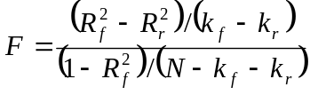 (1)

Notation in the proceeding formula is as follows: subscript f indicates full model with all of the fit variables included, subscript r indicates restricted model or baseline model without the fit variables included, k is the number of parameters in a model, and N is the sample size. The R² of relationship effectiveness in the full model is .663 and k_{f} = 3 because three additional predictors were used in the full model. Using the formula above, the test statistic is 6.28 and the critical value is F_{(.05, kf – kr, N-kf-kr)} or F_{(.05, 3, 92)} = 2.70. Given that the test statistic is larger than the critical value, we conclude that adding the three fit variables makes a statistically significant improvement in our ability to predict relationship effectiveness. Similarly, when the four interaction terms involving fit are added to the model the test statistic is F_{(4, 92)} = 3.55 and the critical value is F_{(.05, 4, 92)} = 2.47. Therefore, adding the interaction terms to the model with the three direct effects of fit appears statistically significant as well. Next we examine each hypothesis individually.

Hypotheses Testing
Table 6 includes a summary of results from hypotheses testing. Each hypothesis is provided in the table with the betas and corresponding levels of significance. Hypothesis 1_{(a, b, c)} pertains to the three fit variables’ (strategic, operational and personal) relationship with relationship effectiveness. Each was hypothesized to have a positive linear relationship with relationship effectiveness. The results indicate that strategic fit (H_{1a}, B = .145, p < .05) and personal fit (H_{1c}, B = .277, p < .05) are both significantly related to relationship effectiveness in the hypothesized direction. Operational fit (H_{1c}, B = .148, p < .10) is marginally significant in the hypothesized direction. Thus H_{1a} and H_{1c} are both supported and H_{1b} is marginally supported. Additional discussion of the results will be presented in the discussion section below.

--------------------------------
Insert Table 6 about Here
--------------------------------

Hypotheses 2_{(a, b, c, d, e, f)} suggests that previously tested antecedents of relationship effectiveness in KAs were all linearly and positively related to relationship effectiveness. Communication quality (H_{2b}, B = .342, p < .01) was positively related to relationship effectiveness in the full model. Activity proactiveness (H_{2d}, B = .176, p < .10) and esprit de corps (H_{2e}, B = .146, p < .10) were both marginally significant and positively related to relationship effectiveness in the full model. In contrast, intrapreneurial ability (H_{2a}, B = .007, NS), activity intensity (H_{2c}, B = .020, NS), and organizational support (H_{2f}, B = .082, NS) were not significantly related to relationship effectiveness in the full model. Thus H_{2b} was fully supported; H_{2d} and H_{2e} were marginally supported; and H_{2a}, H_{2c} and H_{2f} were not supported in the full model.
There were four interaction terms hypothesized involving various forms of fit as moderators to previously established antecedents to relationship effectiveness. As hypothesized, operational fit was found to positively moderate the relationship between activity intensity and relationship effectiveness (H_{3b}, B = .204, p < .01). Personal fit moderates the relationship between both communication quality (H_{3c}, B = .203, p < .10) and esprit de corps (H_{3d}, B = -.185, p < .10) and relationship effectiveness. However, these hypotheses (H_{3c} and H_{3d}) only received marginal support at the p = .10 level. Finally, strategic fit did not moderate the relationship between intrapreneurial ability (H_{3a}, B = .068, NS) and relationship effectiveness. So support was found for H_{3b} and marginal support was found for H_{3c} and H_{3d}, but no support was found for H_{3a}.
The final hypothesis indicates that relationship effectiveness has a positive linear relationship with account performance. Results indicate that relationship effectiveness is indeed a direct antecedent to performance at the KA level (H₄, B = .288, p < .01). Relationship effectiveness explains approximately 12% of the variance in performance once relationship length and account tenure have been controlled for as previously noted. Therefore, H₄ was supported.
DISCUSSION

This study introduces inter-firm fit into the KA research stream and provides initial evidence that fit is an important antecedent to developing effective KA relationships. After first replicating the existing relationships in two streams of KA research via the integrative baseline model, this study goes beyond the existing literature to introduce inter-firm fit as both antecedent and moderator to relationship effectiveness. Adding inter-fit into the baseline model, significantly improved the explanation of variance in relationship effectiveness. In addition to their direct effects on relationship effectiveness, strategic, operation and personal fit also moderate relationships between previously analyzed antecedents of relationship effectiveness. Each hypothesis will be discussed below.
As hypothesized, the introduction of all three types of inter-firm fit was found to improve the prediction of levels of relationship effectiveness. Specifically, strategic fit is associated with higher levels of relationship effectiveness. This supports the argument that when strategies are aligned between the buying and selling firms more effective relationships can be built and maintained. These higher levels of relationship effectiveness have been argued to result from synergies that exist between the two companies (Sheth and Parvatiyar 1992) when strategic fit is high. Operational fit also has a direct positive relationship with relationship effectiveness, but its statistical support was marginal. This may indicate a focus on the strategic elements of these important accounts to the selling company. Given the correct direction and marginal support for operational effectiveness, it is clear that managers should not ignore operational fit, but their focus should remain on other types of fit (e.g., strategic and personal).
Finally, personal fit has a direct positive impact on relationship effectiveness. This important finding suggests that despite the large size and financial importance of these large KA relationships, personal fit between the account manager and his or her counterpart at the buying company remains a critical determinant to developing effective relationships. The reliance on this personal relationship has been noted in previous studies. This evidence clarifies earlier findings by suggesting that not only the loss of the account manager (e.g., Bendapudi and Leone 2002), but a poor fit between the account manager and his or her counter part is costly to the selling company.
In summary of the direct effects of inter-firm fit, we find that the presence of higher levels of strategic and personal fit, indicate that sellers should be able to build higher levels of trust, relationship commitment, cooperation, conflict resolution, and information sharing with the buyers. Further, while operational fit cannot be ignored, it is of secondary importance to developing effective relationships.
In addition to their direct effects on relationship effectiveness, inter-firm fit variables moderate existing antecedent relationships. Previous KA studies demonstrated that intrapreneurial ability, communication quality, activity intensity, and esprit de corps all are important positive antecedents to developing effective KA relationships between buying and selling companies. Results from the analysis of the baseline model in this study, also indicate that these relationships were found in the data. However, when fit variables were added to the model, two of these direct effects were no longer statistically significant (activity intensity and intrapreneurial ability). In addition, to changes in the significance of these direct relationships, there are three interactions that demonstrate boundaries on these relationships. First, operational fit moderates the relationship between activity intensity and relationship effectiveness. At the mean level of operational fit, the activity intensity → relationship effectiveness path coefficient is B = .020. Using a technique from Brown and Chin (2004), I determine that when operational fit is high, it has a positive enhancing effect on the relationship between activity intensity and relationship effectiveness (B = .224 when operational fit is one standard deviation above the mean). However, when operational fit is low (e.g., one standard deviation below the mean) the relationship between activity intensity and relationship effectiveness is negative (B = -.184). These two diverging slopes indicate that the relationship between activity intensity and relationship effectiveness is more complex than previous studies suggest (Workman, Homburg and Jensen 2003). In this study, I hypothesized that this interaction would have no effect at low levels of operational fit and a positive enhancement at high levels of operational fit. While the results confirmed that high levels of operational fit steepened the slope between activity intensity and relationship effectiveness, it is surprising to note that low levels of operational fit actually create a negative relationship between activity intensity and relationship effectiveness. This stands to reason that higher levels of operational fit would provide a foundation for greater results from investments in activities such as enhancements to distribution, logistics, joint advertising, product adaptation, etc., but it is surprising to note that low levels of operational fit actually reverses the positive direct relationship and creates a negative slope. The implications of this finding should encourage managers to take advantage of high operational fit by increasing investments in activities to serve their KAs with higher levels of operational fit. Alternatively, in conditions of poor operational fit it would be better to minimize investments in the same activities because the yield in terms of improved relationships will be negative. This finding supports the “theories in use” that the qualitative study uncovered. Many account managers indicated that similar investments of activities in their accounts often yielded vastly different responses from different accounts. This variation in response to similar activities may have resulted from varying levels of operational fit.
Second, personal fit moderates two different relationships between communication quality and relationship effectiveness and between esprit de corps and relationship effectiveness. From a managerial point of view it is logical to expect that stronger personal fit or similarity between two parties would enhance those parties ability to communicate. At one standard deviation above the mean level of personal fit, the slope between communication quality and relationship effectiveness increases from B = .203 (mean level) to B = .545. Additionally at one standard deviation below the mean, the slope between communication quality and relationship effectiveness is reduced to B = .139. This relationship is not surprising, but its presence in the data indicates that these data provide valid evidence of the relationships in the model. The implication here is that communication quality has a positive impact on relationship effectiveness under all conditions, but its effect is particularly large when people in the buying and selling company get along well with each other.
In contrast, the results from the interaction between personal fit and esprit de corps produces a more surprising result. These data indicate that higher levels of personal fit between the buying and selling company actually reduces the effects of esprit de corps on relationship effectiveness (B = -.039 at one standard deviation above the mean of personal fit). This negative slope is close to zero and indicates that higher levels of personal fit do not enhance the positive impact of esprit de corps on relationship effectiveness as expected. However, low levels of personal fit are shown to increase the effectiveness of esprit de corps on relationship effectiveness (B = .331 at one standard deviation below the mean of personal fit). This result suggests that when personal fit is high, higher levels of esprit de corps may result in slightly lower levels of relationship effectiveness. This result is surprising and runs contrary to the hypothesized relationship. The managerial implications of this result suggest that managers should work hard to build esprit de corps inside his or her company when the selling organization does not get along well with the buying company and not to focus on esprit de corps when personal fit is high. Perhaps the post hoc logic behind this relationship is based on the old adage “misery loves company”. If it is tough to get along with the buying organization (low personal fit), then team work inside the selling company will make it easier to build a good relationship. Certainly more studies should examine this surprising result.
Finally, strategic fit does not moderate the relationship between intrapreneurial ability and relationship effectiveness. We did not find evidence of a moderated relationship between intrapreneurial ability and relationship effectiveness under varying levels of strategic fit. This result and the loss of statistical significance between intrapreneurial ability and relationship effectiveness may indicate that the KAM’s intrapreneurial ability is not as strong a predictor of relationship effectiveness as previously thought.

Contributions
This study makes several contributions to the academic literature and to managers responsible for KA management and relationship marketing. First, this research extends and deepens our understanding of relationship marketing frameworks in the context of a company’s largest accounts. Relationship marketing literature has a long history of moving forward the goals of organizations to partner for mutual benefit. This study provides further evidence of the importance of relationships between buying and selling companies. Second, we find evidence that all three types of inter-firm fit are important as antecedents to relationship effectiveness. Evidence suggests that when a KAM’s perceptions of strategic, operational and personal fit increase, relationship effectiveness also increases. These direct effects when added to the baseline KA model explain significantly greater amount of variance in relationship effectiveness. Third, this study continues the search for conditions under which different account management approaches improve relationship effectiveness and account performance. Three such boundary conditions were evidenced in this study. These “multiplier effects” were noted in the qualitative interviews and provide evidence that managers will benefit from evidence confirming their “theories in use.” Both operational fit and personal fit positively moderated activity intensity and communication quality respectively. One exception to this overall positive effect of fit as a moderator is the interaction found between personal fit and KA management team esprit de corps. When personal fit is low, high levels of esprit de corps reduce relationship effectiveness; however, when personal fit is high then higher levels of esprit de corps will greatly enhance relationship effectiveness. This creates the crossover interaction that bears further study. Fourth, the body of knowledge related to the management of a company’s best accounts will improve as common terms are used for KAs, KA management and KAMs. Finally, a new second-order construct, relationship effectiveness, was developed to improve academicians’ ability to measure the relational aspects of KA management. By using the qualitative interviews as a guide, Morgan and Hunt’s (1994) commitment trust theory was enhanced to better serve the needs of measuring relationship effectiveness for KAs.
Account managers and KA organizations benefit in the following ways from this research. First, this study introduces three types of inter-firm fit as antecedents to relationship effectiveness. Understanding the impact of these important antecedents improves a KAM’s ability to identify and support KAs with the greatest potential for success. The critical role these KAMs play in managing their accounts provides them an intimate understanding of the accounts. Their perceptions of fit between the buying and selling company have a significant impact on the relationship effectiveness (trust, cooperation, information sharing, etc.) between the two companies. Second, managers now have empirical support for their “theories in use” related to the multiplier effects of fit on their investments in each KA. Account managers must make tradeoffs with respect to the investment of their time and resources. This research speaks directly to the antecedents of effective relationships and helps KAMs better understand the moderation effects that impact their causal inferences. This should help in making investments in accounts and in determining the success of these investments on relationship effectiveness and account performance. Third, the expansion of the number of first order factors in the mediating variable from commitment trust theory enhances manager’s abilities to monitor future performance. These intermediate marketing outcomes (e.g., trust, information sharing, cooperation, conflict resolution, and relationship commitment) serve as an early warning system to prevent losses and enhance financial gains. Evidence in this study indicates that when these relationship components begin to decline, for example a weakening of relationship commitment, then account performance will also decline. Account managers can use this information to better prepare for changes in account relationships and prevent future performance dips.

Limitations and Future Research
The following limitations represent opportunities for future research on this topic. Based on the cross-sectional design of the study, it should be noted that theoretical arguments were made to support the causal direction of the effects of variables in this model, but no statistical evidence of causality was observed in this study. Despite this limitation in the study design, we have been able to determine a statistical relationship exists between these antecedents, relationship effectiveness and performance. Further, we provided strong theoretical evidence from relationship marketing to support the direction of these effects. Longitudinal studies or experiments in future studies would provide evidence to support claims of causality.
This study uses a second-order variable to operationalize relationship effectiveness. The nature of this operationalization aggregates the effects of each antecedent across all five first-order factors. In future research it would be beneficial to investigate each antecedent’s effects on each individual first order factor. For example, it may be that higher perceived levels of operational fit may lead to higher levels of cooperation (where coordination of efforts is easier), but not higher levels of trust. These individual effects across the five first-order factors should reveal further insights into how specific elements of relationship effectiveness are built.
To reduce the potential effects of common method bias, additional informants from each of the accounts would be beneficial. While the KAM is the logical choice for a single informant study on KAs, data may also be collected from customer service, individuals within the selling company and buyer’s representatives within the buying company. These additional sources of data will enrich the data and provide further evidence of these findings in KA relationships.
Based on the results of the interaction between personal fit and esprit de corps, further research should be conducted to duplicate the result and to explore causes of this surprising finding. Additional studies should examine the relationship between team work inside the company and relationship building with customers outside of the company.
In addition to the additional research mentioned along with the limitations the following opportunities also exist. First, this type of study would benefit from additional informants. These may be additional informants within the selling company (e.g., customer service or field sales) or informants from the customer organization. Customer data would provide additional sources of data to evaluate the customer’s perceptions of relationship effectiveness.
APPENDIX A: ANALYSIS OF INTENT TO SERVE

In addition to the model hypothesized in the dissertation, I analyzed the data to determine if strategic fit also influences the KAM’s intentions to serve the KA in the future. I measured intent to serve with a four item scale (α = .94, AVE = .851, composite reliability = .958) and included the construct in the structural model. There are two hypotheses associated with intent to serve. First, it is expected that strategic fit has a direct positive effect on intent to serve. This stands to reason that when the KAM perceives a high level of strategic fit, then he or she will increase their intentions to serve the KA. Second, intent to serve is expected to have a direct positive relationship with performance. When the KAM’s intentions to serve an account increase then account performance should also increase. In analyzing the full hypothesized model with these relationships included, we learn that strategic fit is indeed antecedent to intent to serve (B = .340, p < .01), but intent to serve only has a marginally significant relationship with performance (B = .155, p < .10). This result is surprising in as much as intentions to perform should be an antecedent to performance, but it should be noted that these intentions to serve may only have a relationship with performance in the next period and not in the current period. Since I only have cross-sectional data we will not be able to test this with the current data. Given the results I have, I can concluded that when KAM’s perceive higher levels of strategic fit between the buying and selling companies, then the KAM’s intentions to serve the account increases. Although not hypothesized, both operational fit and personal fit did not have a significant relationship as antecedent to intent to serve.
Table 1

LITERATURE REVIEW

Authors | Year | Empirical Basis | Main Focus/ Key Statements
Pegram | 1972 | 250 interviews with executives in manufacturing and service companies | - Describes alternatives for assigning KA management responsibility on a part-time or a full-time basis
Stevenson | 1981 | 34 executives in 33 manufacturing companies | - Explores selling firm’s financial and relational benefits from national account management
Platzer | 1984 | 130 interviews with national account executives | - Describes activities for KAs  - Describes types of national account units  - Describes success factors of national account programs
Shapiro and Moriarty | 1984a | 100+ interviews in 19 manufacturing and service companies | - Describes alternatives for integrating a KA management program into the structural organization  - Discusses issues pertaining to the internal structure of KA management units
Shapiro and Moriarty | 1984b | 100+ interviews in 19 manufacturing and service companies | - Describes customer need for activities in such areas as pricing, products, service, and information  - Describes roles of various functional groups in the performance of activities for KAs
Colletti and Tubridy | 1987 | 105 National Account Management Association (NAMA) members | - Explores reporting level, time utilization, compensation and required skills of account managers
Wotruba and Castleberry | 1993 | 107 NAMA members | - Explores staffing procedures for KA management positions  - Performance of KAMs is affected by length of tenure, age of program, and time devoted to KAs
Pardo, Salle, and Spencer | 1995 | 10 interviews within one telecom company | - Case study of one KA program over 20 years
Boles, Barksdale, and Johnson | 1996 | 73 national account decision makers from NAMA list | - Identifies salesperson activities, skills, and attitudes that are appreciated by KA decision makers
Yip and Madsen | 1996 | Case studies of IBM, AT&T, and Hewlett-Packard | - Develops framework for global account management  - Describes internal cooperation for KAs in global management
Lambe and Spekman | 1997 | 118 managers, mostly US-based | - Explores differences between national account relationships and other types of strategic alliances
McDonald, Millman, and Rogers | 1997 | Interviews with 11 KA manager/purchasing manager dyads | - Describes development of KA relationships from pre-KA management, transactional phase to collaborative relationship that goes along with increasing complexity of involvement
Napolitano | 1997 | NAMA study among Fortune-1000 companies, no sample size provided | - The number of national account managers has tripled between 1992 and 1998  - 53% of selling companies report poor effectiveness of partnering with customers
Pardo | 1997 | 20 interviews with KA of electricity and telephone companies | - Suggests three ways that KAs perceive KA management; disenchantment, interest, enthusiasm  - Moderators of KA management program perception by customers are: perceived product importance and centralization of purchase decisions
Sharma | 1997 | 109 interviews with buyers of telephone equipment | - Customers’ preference for KA management programs depends on level of buyers involved in purchasing, functions involved in purchasing, and time taken for purchasing
Weeks and Stevens | 1997 | 133 NAMA members | - KAMs are dissatisfied with sales training programs  - Descriptive research on experience and skills of KAMs
Weilbaker and Weeks | 1997 | Theoretical | - Explores early KA management research  - Provides a “life-cycle” view of KA management development in academic literature
Sengupta, Krapfel, and Pusateri | 1997a | 176 NAMA members in manufacturing and service companies | - Descriptive statistics on growth of KA management approaches and KAM workload  - Identifies customer-based compensation as a success factor of KA management
Sengupta, Krapfel, and Pusateri | 1997b | 176 NAMA members in manufacturing and service companies | - Switching costs in KA relationships
Dishman and Nitse | 1998 | 27 interviews with NAMA members whose KA program is older than five years | - Discusses implementation options of national account management: cooperation with existing sales force, company executives, or a separate sales force  - Describes on number and size of customers in KAM program
Homburg, Workman, and Jensen | 2000 | Theoretical | - Examines overall changes in marketing organizations  - KA management will become more important  - Increased use of teams  - Increased selling complexity with multiple products and services
Montgomery and Yip | 2000 | 191 managers in 185 manufacturing and service companies | - Use of global account management structures will increase  - Use of global account management structures is driven by customer demand  - Customer demands encompass coordination of resources, uniform terms of trade, and consistency in service quality and performance
Sengupta, Krapfel, and Pusateri | 2000 | 176 SAMA members in manufacturing and service companies | - Investigates individual-level abilities of KAMs that lead to KAM effectiveness  - Mediation between abilities and perceived KAM effectiveness include communication quality and trust
Homburg, Workman, and Jensen | 2002 | 264 German and 121 US companies, both large and small firms | - Identifies seven KA management approaches  - Investigates organizational support of KAs (activity support, top-management involvement, use of teams, and access to resources, etc.  - Examines effectiveness of each type of KA approach
Schultz and Evans | 2002 | 121 KAMs in a Fortune 500 consumer package goods company | - Investigates communication quality as an antecedent to KA trust, solution development and performance  - KA communication was measured in terms of informality, bi-directionality, frequency, and strategic content
Workman, Homburg, and Jensen | 2003 | 264 German and 121 US companies, both large and small firms | - Explored organizational factors leading to effective KA management organizations  - Examined activities, actors, resources and formalization and determined that activities and resources were most impactful on effectiveness  - Effective KA management leads to superior financial performance
Jones, Dixon, Chonko, and Cannon | 2005 | Theoretical | - Use of teams in KA management is growing  - Examine five types of team relationships both within selling firm and with buying firm
Wengler, Ehret, and Saab | 2006 | 91 single informants from different German companies | - Describes current state of KA management practice in Europe  - Investigates factors related to the decision to implement KA management  - Explores implementation process of KA management  - Uncovers “hidden KAs” in firms with no formal KA programs
Ryals | 2006 | Qualitative interviews with 10 companies | - Investigate best practices on how companies manage pricing, costs to serve and customer risk in KA context
Gosselin and Bauwen | 2006 | Theoretical | - Evaluates relationship marketing theory and strategic marketing theory as a means to determine a value network for KAs
Hutt and Walker | 2006 | Theoretical | - Examines the social networks of KAMs and its relationship to their success
Toulan, Birkinshaw and Arnold | 2007 | 106 global accounts from 16 companies | - Examined fit between KAM approach and vendor needs
Pardo, Hennenberg, Mouzas and Naudë | 2006 | Theoretical | - Explores the meaning of value in KA context  - Provides insights into building value in KA organizations
Guenzi, Pardo and Georges | 2007 | 130 European account managers | - Relational selling strategies were found to be antecedent to customer-oriented selling, adaptive selling, and team selling in KA context  - No evidence of taking a relational selling strategy leading to organizational citizenship behaviors
Ivens and Pardo | 2007 | 91 key account relationships and 206 ordinary supplier–buyer dyads | - Investigates differences in satisfaction, trust, and commitment between regular accounts and KAs  - Finds that KAs have same levels of trust and no greater commitment levels as regular accounts
Note: Table adapted from Homburg, Workman and Jensen (2002).
Table 2

MEAN COMPARISON OF GROUPS

Key Variables for Group Comparison | Company A  Means | Company B  Means | Company C  Means
Number of accounts in data set from each company | 16 | 67 | 34
Length of time required to complete survey (seconds) | 2451 | 2790 | 2413
Number of years account manager has served focal account | 1.9 | 3.1 | 3.0
Age of account manager (years) | 46 | 40 | 47
Number of accounts each account manager serves | 3.9 | 2.9 | 2.6
Gender of account managers (% male) | 60% | 70% | 100%
Manager’s total sales experience (years) | 25 | 19 | 24
Priority assigned to account (7 = highest priority) | 4.53 | 5.27 | 4.53
Future intention to serve account (7 = highest intention) | 5.92 | 5.92 | 5.75
Note: Groups in table are based on company affiliation of each subject.
Table 3

Means, Standard Deviations, and Loadings from Confirmatory factor analysis in pls

 | Mean | Std.  Dev. | CFA Loadings
Strategic Fit
The focal key account:
Fits with my company’s strategic goals | 5.33 | 1.22 | .774
Has similar strategic objectives to my company | 4.83 | 1.27 | .908
Looks at business opportunities with the same strategic perspective as my company | 4.66 | 1.41 | .854
Operational Fit
On an operational level, the focal account:
Fits very poorly / well with my company | 5.54 | 1.23 | .872
Is very dissimilar / similar to my company | 5.03 | 1.43 | .911
Is poorly / well matched with my company | 5.30 | 1.45 | .923

Personal Fit
On an inter-personal level, the employees of the focal account and my company’s employees:
Are a very poor / good fit for each other | 5.51 | 1.35 | .907
Are very dissimilar / similar to each other | 4.99 | 1.44 | .947
Are poorly / well matched with each other | 5.22 | 1.51 | .934
Intrapreneurial Ability
To what extent do you agree with the following statements:
Overall, people think I act like an entrepreneur in my dealings with this account | 4.88 | 1.24 | .903
People recognize that I take calculated risks and try new approaches in serving this account | 4.97 | 1.24 | .937
Communication Quality
To what extent do you agree with the following statements:
Overall, the communication quality between me and the focal account is good | 5.78 | 0.81 | .923
I have generated excellent communication between the focal account and my company | 5.74 | 1.01 | .933
Communication between me and the focal account is of the highest quality | 5.40 | 1.11 | .894

 | Mean | Std.  Dev. | CFA Loadings
Activity Intensity
To what extent do you agree with the following statements:
We work very intensely to modify our offerings to meet the focal account’s needs | 4.68 | 1.43 | .969
Our company works hard to make changes to the products and services offered to the focal account | 4.40 | 1.44 | .968
Account-level Activity Intensity (Formative)ª
Please indicate the level to which your company engages in the following activities for the focal account:
Product-related activities (e.g., product adaptation, new product development, technology exchange) | 4.03 | 1.44
Service-related activities (e.g., training, advice, troubleshooting, guarantees) | 4.39 | 1.41
Price-related activities (e.g., special pricing terms, corporate-wide price terms, offering of financing solutions, revelation of own cost structure) | 4.53 | 1.28
Distribution and logistics activities (e.g., logistics and production processes, quality programs, placement of own employees in account’s facilities, taking over business processes from customer) | 4.32 | 1.46
Activity Proactiveness
To what extent do you agree with the following statements:
Our company is proactive in making changes to our products and services to meet the needs of the focal account | 4.22 | 1.43 | .926
We anticipate changes to our products, prices, services, promotions, etc. that will benefit the focal account | 4.24 | 1.41 | .925
We act first and initiate product and service related activities to better serve the focal account | 4.21 | 1.33 | .925
Activity Proactiveness (Formative)
Please indicate which company most often initiates the following activities (customer or your company):
Product-related activities (e.g., product adaptation, new product development, technology exchange) | 3.72 | 1.80
Service-related activities (e.g., training, advice, troubleshooting, guarantees) | 3.83 | 1.56
Price-related activities (e.g., special pricing terms, corporate-wide price terms, offering of financing solutions, revelation of own cost structure) | 3.64 | 1.69
Distribution and logistics activities (e.g., logistics and production processes, quality programs, placement of own employees in account’s facilities, taking over business processes from customer) | 3.29 | 1.72

 | Mean | Std.  Dev. | CFA Loadings
Esprit de Corps
People in my company that are involved in the management of the focal key account:
Feel a part of the team | 5.19 | 1.20 | .893
Feel like they are part of a big family | 4.77 | 1.21 | .920
Feel a team spirit that pervades all ranks involved | 4.60 | 1.26 | .884
Organizational Support
To what extent do you agree with the following statements:
In my company, I have access to the resources needed to serve this account well | 4.88 | 1.33 | .955
I am able to obtain the resources I need to serve this account well | 4.77 | 1.34 | .976
In general, the resources I need to serve this account well are available to me | 4.76 | 1.34 | .967
Organizational Support (Formative)
When necessary, how easy is it for you to obtain needed support from the following groups for the focal account:
Field Sales | 4.31 | 2.08
Customer Service | 4.97 | 1.49
Marketing | 3.42 | 1.84
Finance | 3.96 | 1.58
Senior Management | 5.03 | 1.34
Key Account Performance
The focal account:
Greatly under-performed / over-performed expectations last year | 4.55 | 1.67 | .940
Performed well below / above its performance targets | 4.57 | 1.62 | .973
Strongly under-performed / over-performed its goal | 4.45 | 1.61 | .973
Channel Power
The focal account:
Can greatly influence my company’s activities | 4.40 | 1.43 | .916
Has a major say in how my company serves them | 4.67 | 1.39 | .882
Can force my company to comply with its desires | 4.28 | 1.42 | .911
Intent to Serve
With respect to the future of the focal account, my company plans to…
Do more to build a relationship with this account next year | 5.92 | 0.98 | .907
Focus more effort on this account next year | 5.83 | 1.07 | .945
Strengthen the relationship with this account next year | 5.95 | 0.95 | .927
Do more next year to serve this account | 5.77 | 1.10 | .907

 | Mean | Std.  Dev. | CFA Loadings
Relationship Effectiveness – Overall
Overall my company’s relationship with the focal account is very…
Strong / Weak | 5.32 | 1.20 | .943
Good / Bad | 5.45 | 1.17 | .890
Relationship Effectiveness
To what extent do you agree with the following statements: In our relationship we…
Trust
Can both be counted on to do what is right | 5.44 | 1.01 | .960
Build trust between the two companies | 5.44 | 1.04 | .962
Can both be trusted to behave fairly | 5.38 | 1.11 | .960
Conflict Resolution
Successfully resolve disagreements | 5.49 | 0.94 | .958
Resolve conflicts effectively | 5.43 | 1.00 | .963
Can successfully reach an agreement following a conflict | 5.48 | 1.02 | .962
Information Sharing
Both share information | 5.35 | 1.02 | .910
Exchange important information | 5.45 | 1.08 | .930
Effectively communicate important information between the two companies | 5.34 | 0.97 | .846
Relationship Commitment
Are highly committed to the relationship | 5.90 | 0.79 | .926
Are committed to a long-term relationship | 5.97 | 0.80 | .913
Work to maintain a strong long-term relationship | 5.93 | 0.80 | .902
Cooperation
Are both easy to work with | 5.09 | 1.25 | .904
Work together to achieve joint goals | 5.36 | 0.98 | .929
Cooperate well with each other | 5.49 | 0.99 | .913
ª Loadings were not estimated for formative indicators in the confirmatory factor analysis.

Table 4

Construct Reliabilities and Intercorrelations AMONg Reflective constructs

 | α | CR | AVE | 1 | 2 | 3 | 4 | 5 | 6 | 7 | 8 | 9
1. Personal Fit | .93 | .95 | .86 | 1.00
2. Strategic Fit | .80 | .88 | .72 | .22 | 1.00
3. Operational Fit | .87 | .93 | .81 | .57 | .28 | 1.00
4. Performance | .96 | .97 | .93 | .42 | .32 | .37 | 1.00
5. Intent to Serve | .94 | .96 | .85 | .18 | .34 | .13 | .21 | 1.00
6. Relationship Effectiveness^{b} | .80 | .91 | .84 | .44 | .33 | .21 | .29 | .13 | 1.00
7. Trust | .96 | .97 | .92 | .40 | .32 | .14 | .15 | .02 | .61 | 1.00
8. Conflict Resolution | .96 | .97 | .92 | .28 | .32 | .12 | .27 | .13 | .50 | .68 | 1.00
9. Relationship Commitment | .90 | .94 | .83 | .37 | .38 | .22 | .27 | .45 | .51 | .48 | .42 | 1.00
10. Information Sharing | .88 | .92 | .80 | .33 | .41 | .21 | .17 | .27 | .46 | .49 | .43 | .43
11. Cooperation | .89 | .94 | .84 | .41 | .45 | .17 | .26 | .27 | .68 | .73 | .68 | .60
12. Overall Fit | .86 | .90 | .70 | .26 | .61 | .26 | .29 | .19 | .30 | .38 | .36 | .37
13. Intrapreneurial Ability | .82 | .92 | .85 | .27 | .37 | .07 | .27 | .22 | .37 | .40 | .47 | .34
14. Communication Quality | .89 | .94 | .84 | .32 | .27 | .33 | .06 | .12 | .57 | .57 | .51 | .52
15. Activity Intensity^{b} | .93 | .97 | .94 | -.03 | .20 | -.04 | .20 | .13 | .24 | .27 | .25 | .42
16. Activity Proactiveness^{b} | .92 | .95 | .86 | .10 | .31 | .08 | .15 | .19 | .33 | .40 | .35 | .52
17. Organizational Support^{b} | .96 | .98 | .93 | .13 | .26 | .14 | .30 | .11 | .32 | .26 | .27 | .38
18. Esprit de Corps | .89 | .93 | .81 | .27 | .19 | .14 | .25 | .07 | .55 | .43 | .44 | .52
19. Account Priority | .91 | .96 | .91 | .15 | .36 | .18 | .33 | .34 | .13 | .00 | .02 | .26
20. Channel Power | .89 | .93 | .82 | .14 | .29 | .10 | .12 | .30 | .10 | .07 | .20 | .32
ª α = Cronbach’s index of internal consistency reliability, CR = Werts, Linn and Jöreskog’s (1974) composite reliability index (ρ),
and AVE = Fornell and Larcker’s (1981) index of the average variance extracted.
^{b} These variables also have formative counterparts, but the reflective versions are reported here.
Table 4 (Continued)

Construct Reliabilities and Intercorrelations AMONg Reflective constructs

 | α | CR | AVE | 10 | 11 | 12 | 13 | 14 | 15 | 16 | 17 | 18 | 19 | 20
1. Personal Fit | .93 | .95 | .86
2. Strategic Fit | .80 | .88 | .72
3. Operational Fit | .87 | .93 | .81
4. Performance | .96 | .97 | .93
5. Intent to Serve | .94 | .96 | .85
6. Relationship Effectiveness^{b} | .80 | .91 | .84
7. Trust | .96 | .97 | .92
8. Conflict Resolution | .96 | .97 | .92
9. Relationship Commitment | .90 | .94 | .83
10. Information Sharing | .88 | .92 | .80 | 1.00
11. Cooperation | .89 | .94 | .84 | .70 | 1.00
12. Overall Fit | .86 | .90 | .70 | .32 | .39 | 1.00
13. Intrapreneurial Ability | .82 | .92 | .85 | .30 | .48 | .35 | 1.00
14. Communication Quality | .89 | .94 | .84 | .48 | .53 | .31 | .41 | 1.00
15. Activity Intensity^{b} | .93 | .97 | .94 | .15 | .30 | .21 | .31 | .34 | 1.00
16. Activity Proactiveness^{b} | .92 | .95 | .86 | .31 | .41 | .31 | .35 | .40 | .75 | 1.00
17. Organizational Support^{b} | .96 | .98 | .93 | .06 | .32 | .30 | .23 | .15 | .43 | .37 | 1.00
18. Esprit de Corps | .89 | .93 | .81 | .17 | .46 | .32 | .36 | .47 | .47 | .46 | .43 | 1.00
19. Account Priority | .91 | .96 | .91 | .11 | .08 | .29 | .26 | .18 | .26 | .24 | .10 | .17 | 1.00
20. Channel Power | .89 | .93 | .82 | .23 | .27 | .18 | .32 | .23 | .37 | .39 | .23 | .19 | .37 | 1.00
ª α = Cronbach’s index of internal consistency reliability, CR = Werts, Linn and Jöreskog’s (1974) composite reliability index (ρ),
and AVE = Fornell and Larcker’s (1981) index of the average variance extracted.
^{b} These variables also have formative counterparts, but the reflective versions are reported here.

Table 5

RESULTS FROM ESTIMATION OF BASELINE MODEL

 | Expected  Direction | Hypothesized Model  Parameter Estimates
Relationships |  | Beta | t-value
Intrapreneurial Ability → Relationship Effectiveness | + | .180 | 1.75**
Communication Quality → Relationship Effectiveness | + | .376 | 3.05***
Activity Intensity → Relationship Effectiveness | + | .159 | 1.33*
Activity Proactiveness → Relationship Effectiveness | + | .281 | 2.38***
Esprit de Corps → Relationship Effectiveness | + | .206 | 2.38***
Organizational Support → Relationship Effectiveness | + | .171 | 1.99**
Relationship Effectiveness → Performance | + | .291 | 3.08***
Notes: (1) Critical Values for t test: 1.282 or greater is sig. at .10 (*); 1.645 or greater is sig. at .05 (**); 2.362 or
greater is sig. at .01 (***).
(2) Significance determined via bootstrapping with 500 samples.
(3) R² for relationship effectiveness = .595, R² for performance = .118.
Table 6

RESULTS FROM Estimation of Hypothesized Model

 | Expected  Direction | Hypothesized Model  Parameter Estimates
Relationships |  | Beta | t-value
H_{1a}: Strategic Fit → Relationship Effectiveness | + | .145 | 1.94**
H_{1b}: Operational Fit → Relationship Effectiveness | + | .148 | 1.43*
H_{1c}: Personal Fit → Relationship Effectiveness | + | .277 | 2.28**
H_{2a}: Intrapreneurial Ability → Relationship Effectiveness | + | .007 | .08
H_{2b}: Communication Quality → Relationship Effectiveness | + | .342 | 3.65***
H_{2c}: Activity Intensity → Relationship Effectiveness | + | .020 | .17
H_{2d}: Activity Proactiveness → Relationship Effectiveness | + | .176 | 1.29*
H_{2e}: Esprit de Corps → Relationship Effectiveness | + | .146 | 1.64*
H_{2f}: Organizational Support → Relationship Effectiveness | + | .082 | .94
H_{3a}: Strategic Fit X Intrapreneurial Ability → Relationship Effectiveness | + | .068 | .38
H_{3b}: Operational Fit X Activity Intensity → Relationship Effectiveness | + | .204 | 1.79**
H_{3c}: Personal Fit X Communication Quality → Relationship Effectiveness | + | .203 | 1.45*
H_{3d}: Personal Fit X Esprit de Corps → Relationship Effectiveness | - | -.185 | 1.32*
H₄: Relationship Effectiveness → Performance | + | .288 | 2.76***
Notes: (1) Critical Values for t test: 1.282 or greater is sig. at .10 (*); 1.645 or greater is sig. at .05 (**); 2.362 or
greater is sig. at .01 (***).
(2) Significance determined via bootstrapping with 500 samples.
(3) R² for relationship effectiveness = .708, R² for performance = .115.
Figure 1

BASELINE MODEL

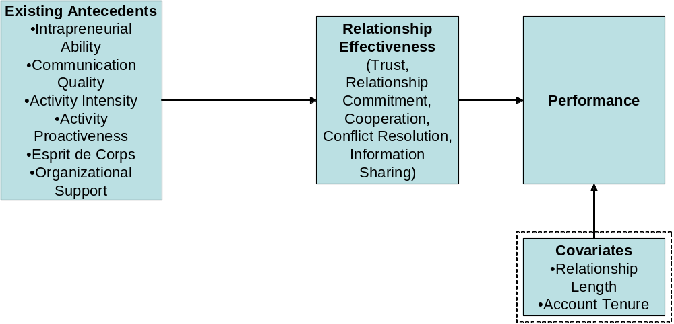
Figure 2

HYPOTHESIZED MODEL

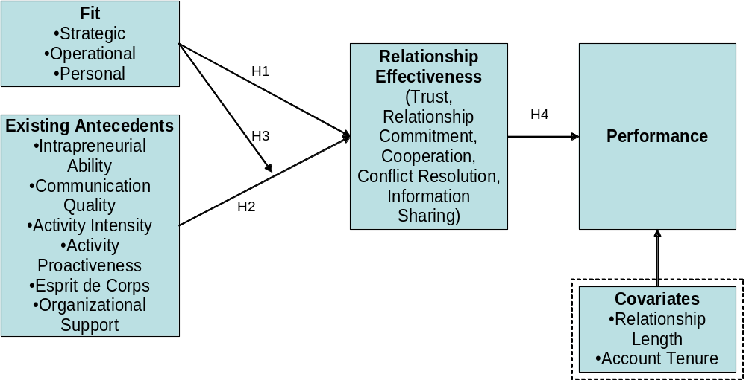
Figure 3

INTERACTION: STRATEGIC FIT X INTRAPRENEURIAL ABILITY

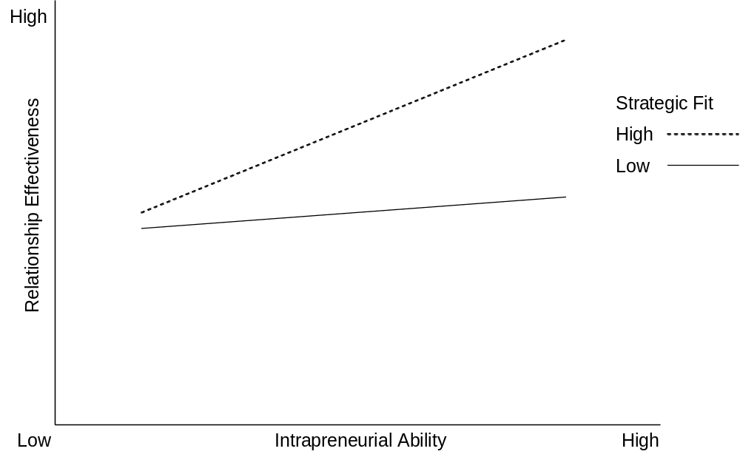
Figure 4

INTERACTION: OPERATIONAL FIT X ACTIVITY INTENSITY

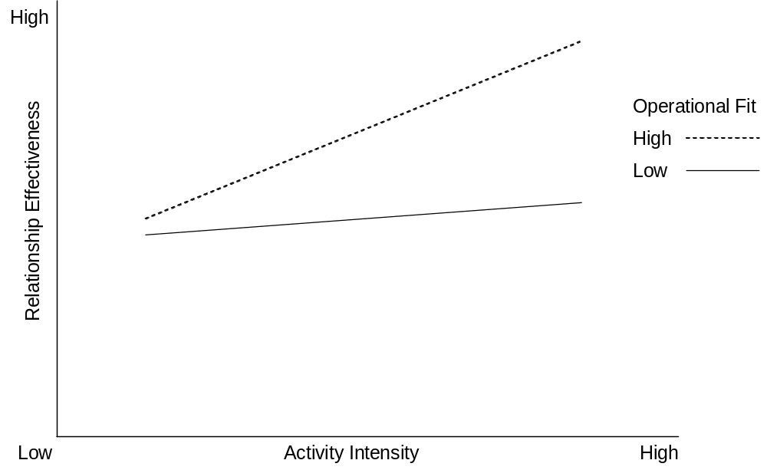
Figure 5

INTERACTION: PERSONAL FIT X COMMUNICATION QUALITY

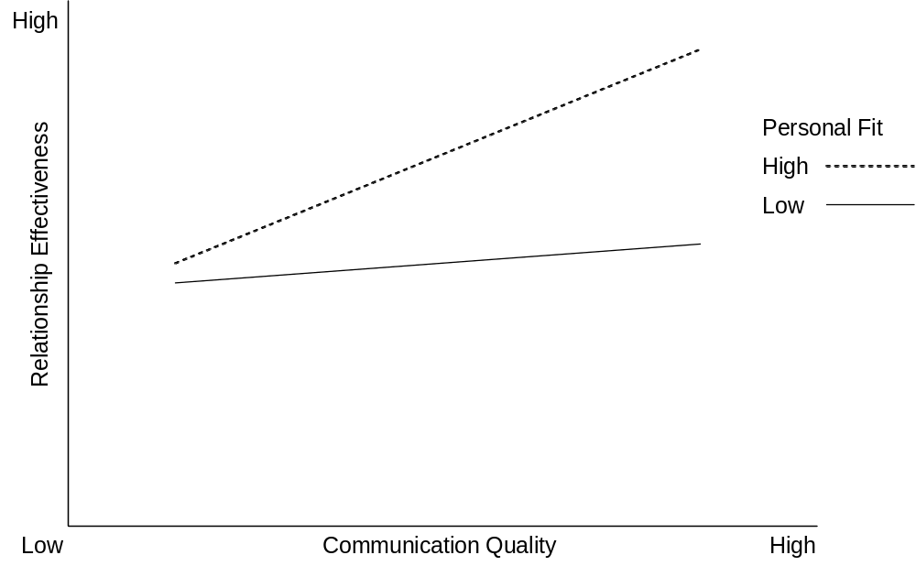
Figure 6

INTERACTION: PERSONAL FIT X ESPRIT DE CORPS

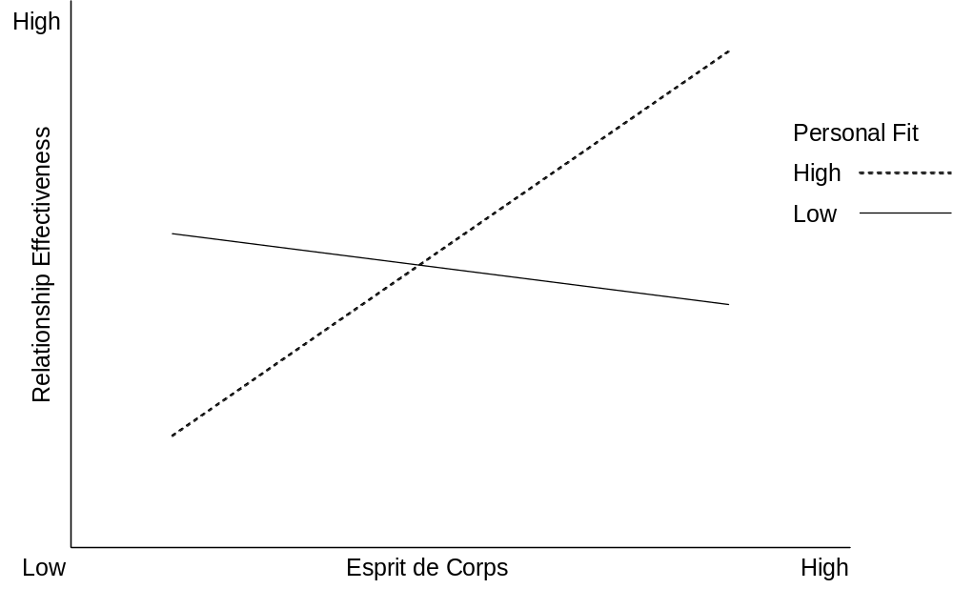
Figure 7

REDUNDANCY ANALYSIS: RELATIONSHIP EFFECTIVENESS

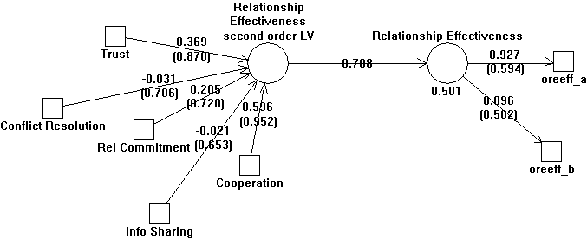
Figure 8

REDUNDANCY ANALYSIS: ACTIVITY INTENSITY

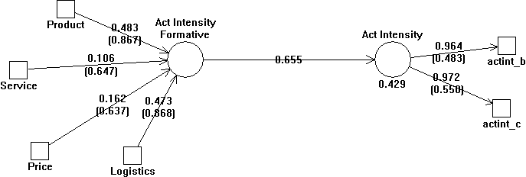
Figure 9

REDUNDANCY ANALYSIS: ORGANIZATIONAL SUPPORT

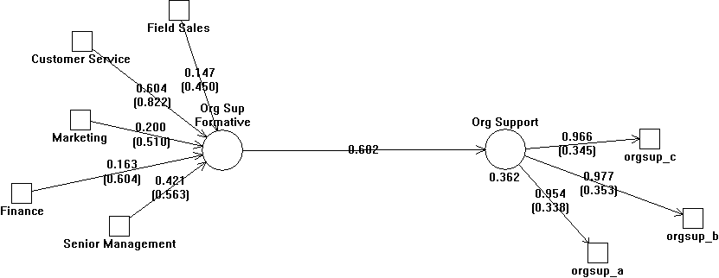
Figure 10

REDUNDANCY ANALYSIS: ACTIVITY PROACTIVENESS

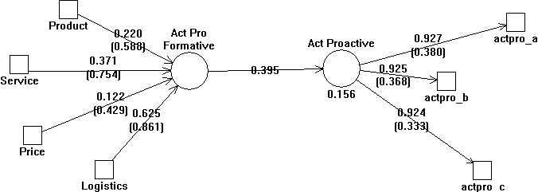

Figure 11

BASELINE MODEL: PLS RESULTS

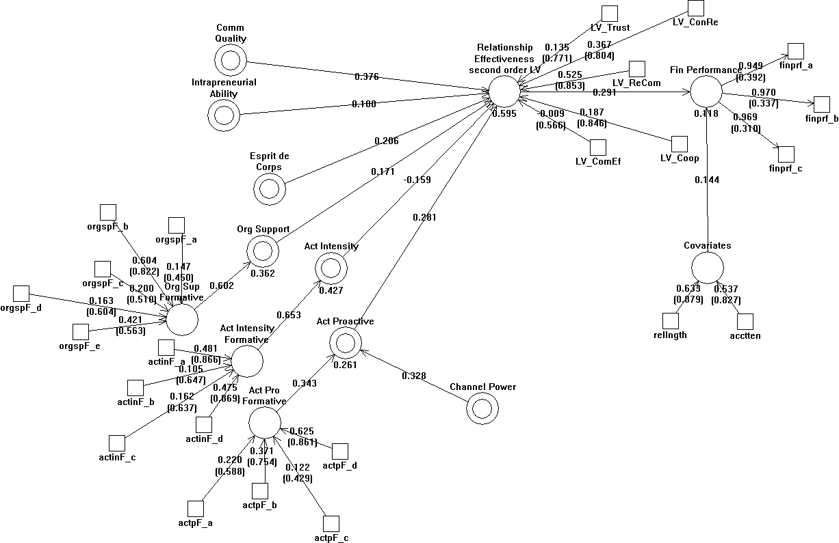
Note: All relationships are positive in the results. The negative signs are an artifact of PLS output, but do not accurately indicate directionality.

Figure 12

HYPOTHESIZED MODEL – PLS RESULTS

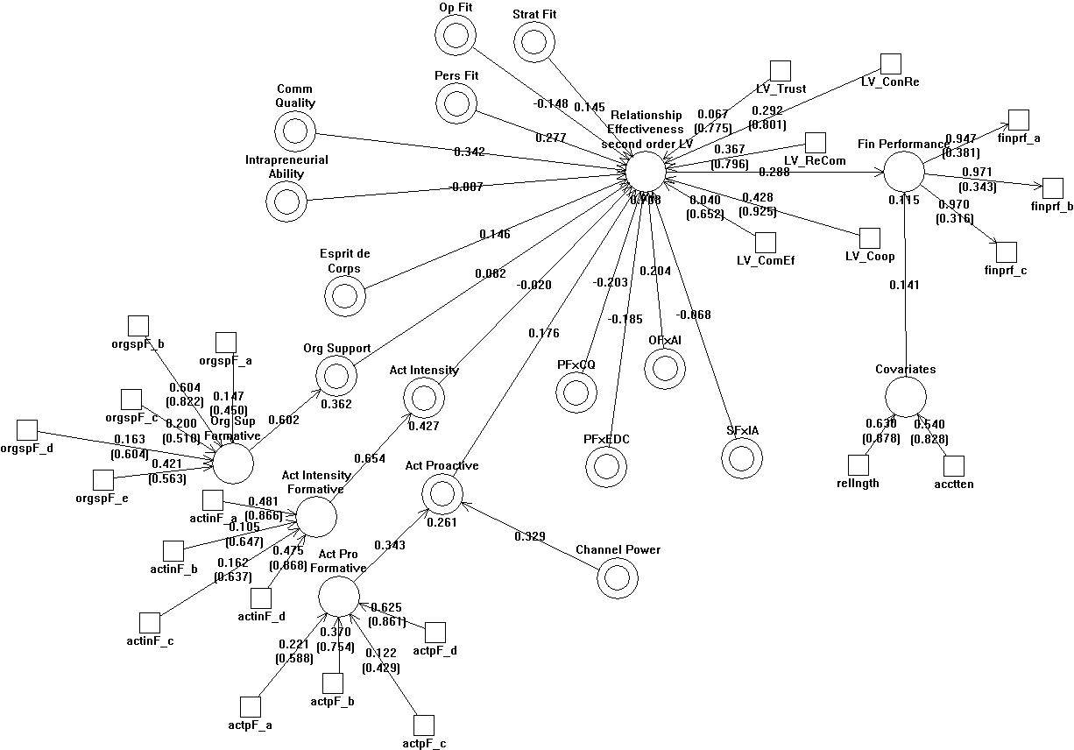
Note: All relationships are positive in the results except for PFxEDC to Relationship Effectiveness. The other negative signs are an artifact of PLS output, but do not accurately indicate directionality.
References

Achrol, Ravi S. (1991), “Evolution of the Marketing Organization: New Forms for Turbulent Environments,” Journal of Marketing, 55 (October) 77-93.
Anderson, James C., Håkan Håkansson, and Jan Johanson (1994), “Dyadic Business RelationshipsWithin a Business Network Context,” Journal of Marketing, 58 (October) 1-15.
__________ and James Narus (1990), “A Model of Distributor Firm and Manufacturer Firm Working Partnerships,” Journal of Marketing, 54 (January), 42-58.
Arnett, Dennis B., Barry A. Macy and James B. Wilcox (2005), “The Role of Core Selling Teams in Supplier-Buyer Relationships,” Journal of Personal Selling & Sales Management, 25 (1), 27-42.
Bagozzi, Richard (1980), Causal Model in Marketing. New York: Wiley.
__________ and Youjae Yi (1988), “On the Evaluation of Structural Equation Models,” Journal of the Academy of Marketing Science, 16 (Spring), 74-94.
Barney, Jay B. (1986), “Organizational Culture: Can It Be a Source of Sustained Competitive Advantage?” Academy of Management Review, 11 (3) 656-665.
Barrett, John (1986), “Why Major Account Sales Works,” Industrial Marketing Management, 15 (1), 63-73.
Baumgartner, Hans and Christian Homburg (1996), “Applications of Structural Equation Modeling in Marketing and Consumer Research: A Review,” International Journal of Research in Marketing, 13 (2), 139-161.
Beatty, Sharon E., Morris Mayer, James E. Coleman, Kristy Ellis Reynolds, and Jungki Lee (1996), "Customer-Sales Associate Retail Relationships," Journal of Retailing, 72 (3), 223-47.
Bendapudi, Neeli and Robert P. Leone (2002), “Managing Business-to-Business Customer Relationships Following Key Contact Employee Turnover in a Vendor Firm,” Journal of Marketing, 66 (2), 83-101.
Bentler, Peter M. (1990), “Comparative Fit Indexes in Structural Models.” Psychological Bulletin, 107, 238-246.
__________ (1992), “On the Fit of Models to Covariances and Methodology to the Bulletin,” Psychological Bulletin, 112, 400-404.
Berger, Paul D. and Nada I. Nasr (1998), “Customer Lifetime Value: Marketing Models and Applications,” Journal of Interactive Marketing, 12 (Winter), 17-30.
Blattberg, Robert, Gary Getz, and Jacquelyn S. Thomas (2001), Customer Equity: Building and Managing Relationships as Valuable Assets. Boston: Harvard Business School Press.
__________ and John Deighton (1996), “Manage Marketing by the Customer Equity Test,” Harvard Business Review, July-August, 126-144.
Boles, James S., Wesley Johnston, and Alston Gardner (1999), “The Selection and Organization of National Accounts: A North-American Perspective,” Journal of Business & Industrial Marketing, 14 (4), 264-75.
__________, Hiram C. Barksdale, Jr., and Julie T. Johnson (1996), “What National Account Decision Makers Would Tell Salespeople about Building Relationships,” Journal of Business & Industrial Marketing, 11 (2), 6-19.
Bollen, Kenneth A. (1989), Structural Equations with Latent Variables. New York: John Wiley.
Bolton, Ruth, Katherine Lemon, and Peter C. Verhoef (2004), “The Theoretical Underpinnings of Customer Asset Management: A Framework and Propositions for Future Research,” Journal of the Academy of Marketing Science, 32 (3), 271-292.
Bonoma, Thomas V. (1985), “Case Research in Marketing: Opportunities, Problems and a Process,” Journal of Marketing Research, 22 (2), 199-208.
Brown, Steven P. and Wynne W. Chin (2004), “Satisfying and Retaining Customers through Independent Service Representatives,” Decision Sciences, 35 (3), 527-550.
Browne, M. W. and R. Cudeck (1993), “Alternative Ways of Assessing Model Fit,” In Testing Structural Equation Models. Eds. K. A. Bollen and J. S. Long, Newbury Park, CA: Sage.
Burgelman, Robert A. (1983), “A Process model of Internal Corporate Venturing in the Diversified Major Firm,” Administrative Science Quarterly, 28 (June), 223-244.
Byrne, Barbara M. (2001), Structural Equation Modeling with AMOS: Basic Concepts, Applications, and Programming. Mahwah, NJ: Lawrence Earlbaum Associates, Publishers.
Cannon, Joseph P. and Christian Homburg (1998), “Buyer-Supplier Relationships and Customer Firm Costs,” ISBM Report, 13-1998, Penn State University, University Park, PA.
__________ and __________ (2001), “Buyer-Supplier Relationships and Customer Firm Costs,” Journal of Marketing, 65 (January), 29-43.
Chin, Wynne W. (1998). Modern Methods for Business Research, Ed. George A. Marcoulides, The Partial Least Squares Approach to Structural Equation Modeling, Mahwah, New Jersey: Lawrence Earlbaum Associates, 295-336.
Churchill, Gilbert A., Jr. (1979), “A Paradigm for Developing Better Measures of Marketing Constructs,” Journal of Marketing Research, 16 (February), 64-73.
Cohen, J. (1992). Statistical Power Analysis for the Behavioural Sciences, 2nd Ed. Hillsdale, NJ: Erlbaum.
Colletti, Jerome A. and Gary S. Tubridy (1987), "Effective Major Account Sales Management," Journal of Personal Selling & Sales Management, 7 (August), 1-10.
Crosby, Lawrence A., Kenneth R. Evans, and Deborah Cowles (1990), “Relationship Quality in Services Selling: An Interpersonal Influence Perspective,” Journal of Marketing, 54 (July), 68-81.
Day, George (2000), “Managing Market Relationships,” Journal of the Academy of Marketing Science, 28 (Winter) 24-30.
Demsetz, Harold (1992), The Emerging Theory of the Firm. Uppsala, Sweden: Acta Universitatas Uppsaliensis.
Diamantopoulos, Adamantios and Heidi M. Winklhofer (2001), “Index Construction with Formative Indicators: An Alternative to Scale Development,” Journal of Marketing Research, 38 (2), 269-27.
Doney, Patricia M. and Joseph P. Cannon (1997), “An Examination of the Nature of Trust in Buyer-Seller Relationships,” Journal of Marketing, 61 (April) 35-51.
Dwyer, R. Robert, Paul H. Schurr, and Sejo Oh (1987), “Developing Buyer-Seller Relations,” Journal of Marketing, 51 (April), 11-28.
Eisenhardt, Kathleen (1989), “Building Theories from Case Study Research,” Academy of Management Review, 14 (4), 532-550.
Fornell, Cleas and David F. Larcker (1981), “Evaluating Structural Equation Models with Unobservable Variables and Measurement Error,” Journal of Marketing Research, 28 (1), 39-50.
Frazier, Gary, Robert E. Spekman, and Charles R. O’Neal (1988), “Just in Time Exchange Relationships in Industrial Markets,” Journal of Marketing, 52 (October) 52-67.
Frone, Michael R. and Brenda Major (1988), “Communication Quality and Job Satisfaction among Managerial Nurses,” Group and Organizational Studies, 13 (September), 332-347.
Gardner, Alston, Stephen J Bistritz, and Jay E. Klopmaker (1998), “Selling to Senior Executives: Part 2,” Marketing Management, 7 (Fall) 18-27.
Germain, Richard, Cornelia Dröge, and Patricia J. Daugherty (1994), “The Effect of Just-in-Time Selling on Organizational Structure: An Empirical Investigation,” Journal of Marketing Research, 31 (November) 471-483.
Goles, Tim and Wynne W. Chin (2005), “Information Systems Outsourcing Relationship Factors: Detailed Conceptualization and Initial Evidence,” The DATA BASE for Advances in Information Systems, 36 (4), 46-67.
Gossellin, Derrick Philippe and Guy André Bauwen (2006), “Strategic Account Management: Customer Value Creation through Customer Alignment,” Journal of Business and Industrial Marketing, 21 (6), 678-689.
Guenzi, Paolo, Catherine Pardo and Georges Laurent (2006), “Relational Selling Strategy and Key Account Manager’s Relational Behaviors: An Exploratory Study,” Industrial Marketing Management, 36 (1), 121-133.
Gundlach, Gregory and Ernest R. Cadotte (1994), “Exchange Interdependence and Interfim Interaction: Research in a Simulated Channel Setting,” Journal of Marketing Research, 31 (November) 516-532.
Homburg, Christian, John P. Workman Jr., and Ove Jensen (2000), “Fundamental Changes in Marketing Organization: The Movement Toward a Customer-Focused Organizational Structure,” Journal of the Academy of Marketing Science, 28 (4), 459-478.
__________, __________, and __________ (2002), “A Configurational Perspective on Key Account Management,” Journal of Marketing, 66 (April), 38-60.
Hu, L.-T. and P. M. Bentler (1999), “Cutoff Criteria for Fit Indexes in Covariance Structure Analysis: Conventional Criteria Versus New Alternatives,” Structural Equation Modeling: A Multidisciplinary Journal, 6, 1-5.
Hunt, Shelby D. and Robert M. Morgan (1995), “The Comparative Advantage Theory of Competition,” Journal of Marketing, 59 (April), 1-15.
Hutt, Michael D. and Beth A. Walker (2006), “A Network Perspective of Account Manager Performance,” Journal of Business and Industrial Marketing, 21 (7), 466-473.
Ivens, Björn Sven and Catherine Pardo (2007), “Are Key Account Relationships Different? Empirical Results on Supplier Strategies and Customer Reactions,” Industrial Marketing Management, 36 (4), 470-482.
Jackson, Jr., Donald, W., Scott M. Widmeir, Ralph Giacobbe, and Janet E. Keith (1999), “Examining the Use of Team Selling by Manufacturers’ Representatives,” Industrial Marketing Management, 28 (2), 155-164.
Jaworski, Bernard J. and Ajay K. Kohli (1993), “Market Orientation: Antecedents and Consequences,” Journal of Marketing, 57 (July) 53-70.
Johlke, Mark C. and Dale F. Duhan (2001), “Testing Competing Models of Sales Force Communication,” Journal of Personal Selling & Sales Management, 21 (4), p. 265-277.
Jones, Eli, Andrea L. Dixon, Lawrence B. Chonko and Joseph P. Cannon (2005), “Key Accounts and Team Selling,” Journal of Personal Selling & Sales Management, 25 (2), 181-198.
Kalwani, Manohar U. and Narakesari Narayandas (1995), “Long-Term Manufacturer-Supplier Relationships: Do They Pay Off for Supplier Firms?” Journal of Marketing, 59 (January) 1-16.
Kerin, Roger A., P. Rajan Varadarajan, and Robert A. Peterson (1992), “First-Mover Advantage: A Synthesis, Conceptual Framework, and Research Propositions,” Journal of Marketing, 56 (October) 33-52.
Kohli, Ajay K. and Bernard J. Jaworski (1990), “Market Orientation: The Construct, Research Propositions, and Managerial Implications,” Journal of Marketing, 54 (April) 1-18.
Kraemer, H.C. and Theimann, S. (1987), How many subjects? Statistical Power Analysis in Research. Newbury Park, CA: Sage.
Kuratko, Donald F., Ray V. Montagno and Jeffrey S. Hornsby (1990), “Developing an Intrapreneurial Assessment Instrument for an Effective Corporate Entrepreneurial Environment,” Strategic Management Journal, 11 (Summer), 49-58.
Lages, Carmen, Cristina Raquel Lages and Louis Filipe Lages (2005), “The RELQUAL Scale: A Measure of Relationship Quality in Export Market Ventures,” Journal of Business Research, 58, 1040-1048.
Lambe, Jay C. and Robert E. Spekman (1997), “National Account Management: Large-Account Selling or Buyer-Supplier Alliance?” Journal of Personal Selling & Sales Management, 17 (4), 61-74.
Lieberman, Marvin B. and David B. Montgomery (1988), “First-Mover Advantages,” Strategic Management Journal, 9 (Summer) 41-58.
MacKenzie, Scott B., Phillip M. Podsakoff and Cheryl Burke Jarvis (2005), “The Problem of Measurement Model Misspecification in Behavioral and Organizational Research and Some Recommended Solutions,” Journal of Applied Psychology, 90 (4), 710-730.
McDonald, Malcolm, Tony Millman, and Beth Rogers (1997) “Key Account Management: Theory, Practice, and Challenges,” Journal of Marketing Management, 13, 737-757.
McKinney, George and Marie McKinney (1989), “Forget the Corporate Umbrella – Entrepreneurs Shine in the Rain,” Sloan Management Review, 30 (4), 77-82.
Menon, Ajay, Bernard J. Jaworski, and Ajay Kohli (1997) “Product Quality: Impact of Interdepartmental Interactions,” Journal of the Academy of Marketing Science, 25 (Summer) 187-200.
Miles, Raymond E. and Charles E. Snow (1978), Organizational Strategy, Structure and Process. New York: McGraw-Hill.
Mohr, Jakki J. and John R. Nevin (1990), “Communication Strategies in Marketing Channels: A Theoretical Perspective,” Journal of Marketing, 54 (October) 36-51.
__________, Robert J. Fisher, and John R. Nevin (1996), “Collaborative Communication in Interfirm Relationships: Moderating Effects of Integration and Control,” Journal of Marketing, 60 (July) 103-115.
Moon, Mark A. and Gary M. Armstrong (1994), “Selling Teams: A Conceptual Framework and Research Agenda,” Journal of Personal Selling & Sales Management, 14 (Winter) 17-30.
Moorman, Christine, Gerald Zaltman and Rohit Deshpandé (1992), “Relationships between Providers and Users of Market Research: The Dynamics of Trust within and Between Organizations,” Journal of Marketing Research, 29 (3), 314-328.
__________, Rohit Deshpandé, and Gerald Zaltman (1993), “Factors Affecting Trust in Market Research Relationships,” Journal of Marketing Research, 57 (January) 81-101.
Morgan, Robert M. and Shelby D. Hunt (1994), “The Commitment-Trust Theory of Relationship Marketing,” Journal of Marketing, 58 (July) 20-38.
Morgan, Neil A., Anna Kaleka and Constantine S. Katsikeas (2004), “Antecedents of Export Venture Performance: A Theoretical Model and Empirical Assessment,” Journal of Marketing, 68 (1), 90-108.
Napolitano, Lisa (1997), “Customer-Supplier Partnering: A Strategy Whose Time Has Come,” Journal of Personal Selling & Sales Management, 17 (4), 1-8.
Narus, James A. and James C. Anderson (1995), “Using Teams to Manage Collaborative Relationships in Business Markets,” Journal of Business to Business Marketing, 2 (3) 17-46.
Narver, John C. and Stanley F. Slater (1990), “The Effect of a Market Orientation on Business Profitability,” Journal of Marketing, 54 (October) 20-35.
Niraj, Rakesh, Mahendra Gupta and Chakravarthi Narasimhan (2001), “Customer Profitability in a Supply Chain,” Journal of Marketing, 65 (July), 1-65.
Nunnally, Jum C. (1967), Psychometric Theory. New York: McGraw-Hill.
__________ (1978), Psychometric Theory. (2nd Ed.). New York: McGraw-Hill.
__________ and Ira H. Bernstein (1994), Psychometric Theory (3rd Ed.). New York: McGraw-Hill.
Olson, Eric M., Stanley F. Slater and G. Thomas M. Hult (2005), “The Performance Implications of Fit Among Business Strategy, Marketing Organization Structure, and Strategic Behavior,” Journal of Marketing, 69 (July), 49-65.
Pardo, Catherine, Stephan C. Henneberg, Stefanos Mouzas, and Peter Naudë (2006), “Unpicking the Meaning of Value in Key Account Management,” European Journal of Marketing, 40 (11/12), 1360-1374.
Parvatiyar, Atul, and Jagdish N. Sheth (2000), “The Domain and Conceptual Foundations of Relationship Marketing,” In J. N. Sheth and A. Parvatiyar (Eds.) Handbook of Relationship Marketing, (p. 3-38), Thousand Oaks, CA: Sage Publications.
__________ and Jagdish N. Sheth (2001), “Customer Relationship Management: Emerging Practice, Process, and Discipline,” Journal of Economic and Social Research, 3 (2), 1-34.
Pegram, Roger M. (1972), “Selling and Servicing the National Account,” Report No. 557, The Conference Board, New York.
Price, Linda L. and Eric J. Arnould (1999), “Commercial Friendships: Service Provider-Client Relationships in Context,” Journal of Marketing, 63 (4), 38-56.
Rangarajan, Deva, Eli Jones and Wynne Chin (2004), “Impact of Sales Force Automation on Technology-related Stress, Effort, and Technology Usage Among Salespeople,” Industrial Marketing Management, 34, 345-354.
Rackham, Neil and John DeVincentis (1999), Rethinking the Sales Force: Redefining Selling to Create and Capture Customer Value, New York: McGraw Hill.
Reinartz, Werner J. and Manfred Krafft, and Wayne D. Hoyer (2004), “The Customer Relationship Management Process: Its Measurement and Impact on Performance,” Journal of Marketing Research, 68 (August), 293-305.
__________ and V. Kumar (2000), “On the Profitability of Long Lifetime Customers: An Empirical Investigation and Implications for Marketing,” Journal of Marketing, 64 (October), 17-35.
__________ and __________ (2003), “The Impact of Customer Characteristics on Profitable Lifetime Duration,” Journal of Marketing, 67 (1), 77-99.
Robey, D., D. Farrow, and C. Franz (1989), “Group Process and Conflict System Development,” Management Science, 35(10), 1172 – 1191.
Robinson, Patrick J., Charles W. Faris and Yoram Wind (1967), Industrial Buying and Creative Marketing. Boston: Allyn & Bacon.
Rust, Roland T., Katherine N. Lemon, and Valarie A Zeithaml (2004), “Return on Marketing: Using Customer Equity to Focus Marketing Strategy,” Journal of Marketing, 68 (January), 109-127.
Ryals, Lynette (2007), “Profitable Relationships with Key Customers: How Suppliers Manage Pricing and Customer Risk,” Journal of Strategic Marketing, 24 (2-3), 101-113.
Sales Educators (2006), Strategic Sales Leadership: BREAKthrough Thinking for BREAKthrough Results. Mason, OH; Thomson.
Schultz, Roberta J. and Kenneth Evans (2002), “Strategic Collaborative Communication by Key Account Representatives,” Journal of Personal Selling & Sales Management, 22 (1), 23-31.
Seabright, Levinthal and Fichman (1992), “Role of Individual Attachments in the Disillusion of Interorganizational Relationships,” Academy of Management Journal, 35 (1), 122-160.
Sengupta, Sanjit, Robert E. Krapfel, and Michael A. Pusateri (2000), “An Empirical Investigation of Key Account Salesperson Effectiveness,” Journal of Personal Selling & Sales Management, 20 (Fall), 253-261.
__________, __________, and __________ (1997a), “The Strategic Sales Force,” Marketing Management, 6 (Summer), 29-34.
__________, __________, and __________ (1997b), “Switching Costs in Key Account Relationships,” Journal of Personal Selling & Sales Management, 17 (4), 9-l6.
Shapiro, Benson P. and Rowland T Moriarty (1980), “National Account Management,” Marketing Science Institute Working Paper No. 80-104. Cambridge, MA: Marketing Science Institute.
__________ and __________ (1982), “National Account Management: Emerging Insights.” Marketing Science Institute Working Paper No. 82-100. Cambridge, MA: Marketing Science Institute.
__________ and __________ (1984a), “Organizing the National Account Force,” Marketing Science Institute Working Paper No. 84-101. Cambridge, MA: Marketing Science Institute.
__________ and __________ (1984b), “Support Systems for National Account Management Programs,” Marketing Science Institute Working Paper No. 84-102. Cambridge, MA: Marketing Science Institute.
Sheth, Jagdish N. and Parvatiyar (1992), “Towards a Theory of Business Alliance Formation,” Scandinavian International Business Review, 1 (3), 71-87.
Smith, J. Brock (1997), “Selling Alliances: Issues and Insights,” Industrial Marketing Management, 26 (March), 149-161.
__________ and Donald Barclay (1999), “Selling Partner Relationships: The Role of Interdependence and Relative Influence,” Journal of Personal Selling & Sales Management, 19 (Fall), 21-40.
Stevenson, Thomas H. and Albert L. Page (1979), “The Adoption of National Account Marketing by Industrial Firms,” Industrial Marketing and Management, 8 (January), 94-100.
__________ (1980), “Classifying a Customer as a National Account,” Industrial Marketing Management, 9 (April), 133-36.
Stürmer, Stefan, Mark Snyder and Allen M. Omoto (2005), “Prosocial Emotions and Helping: The Moderating Role of Group Membership, Journal of Personality and Social Psychology, 88 (3), 532-546.
Toulan, Omar, Julian Birkinshaw and David Arnold (2007), “The Role of Interorganizational Fit in Global Account Management,” International Studies of Management and Organization, 36 (4), 61-81.
Webster, Frederick E., Jr. (1992), “The Changing Role of Marketing in the Corporation,” Journal of Marketing, 56 (October), 1-17.
Weilbaker, Dan C. and William A. Weeks (1997) “The Evolution of National Account Management: A Literature Perspective,” Journal of Personal Selling & Sales Management, 17 (Fall), 49-59.
Wengler, Stefan, Michael Ehret and Samy Saab (2006), “Implementation of Key Account Management: Who, Why, and How? An Exploratory Study on the Current Implementation of Key Account Management Programs,” Industrial Marketing Management, 35, 103-112.
Werts, C. E., R. L. Linn, and K. G. Jöreskog’s (1974), “Intraclass Reliability Estimates: Testing Structural Assumptions,” Educational and Psychological Measurement, 34, 25-33.
Winer, Russell S. (2001), “A Framework for Customer Relationship Management,” California Management Review, 43 (4), 89-105.
Workman, John P., Jr., Christian Homburg, and Kjell Gruner (1998), “Marketing Organization: An Integrative Framework of Dimensions and Determinants,” Journal of Marketing, 62 (July), 21-41.
__________, __________, and Ove Jensen (2003), “Intraorganizational Determinants of Key Account Management Effectiveness,” Journal of the Academy of Marketing Science, 31 (1), 3-21.
Wotruba, Thomas R. and Stephen B. Castleberry (1993), “Job Analysis and Hiring Practices for National Account Marketing Positions,” Journal of Personal Selling & Sales Management, 13 (3), 49-65.
Wuyts, Stefan and Inge Geyskens (2005), “The Formation of Buyer-Seller Relationships: Detailed Contract Drafting and Close Partner Selection,” Journal of Marketing, 69 (4), 103-117.
Zaltman, Gerald, Karen LeMasters and Michael Heffring (1982), Theory Construction in Marketing: Some Thoughts on Thinking, New York: John Wiley.

