Protocol for Leave Times

- Obtain pre-approved Leave Request Form, signed by supervisor.
- Before leaving, change voicemail message to indicate
  - Dates you’ll be on leave
  - Instructions on whether or not to leave a voice message
  - Instructions on who to contact instead for important issues
  - Possibly your email address if you prefer messages left that way
- If you prefer not to set up voicemail instructions, forward your phone to another line for someone else to answer
  - Pick up the receiver
  - Dial # 9 (pound, nine) and the five digit extension of the phone you want to forward your calls to.
  - When you return, pushing # # 9 will unforward the phone.
- Before leaving, set up an automated “out of office” email response
OPTION ONE
  - Go to the following link: http://mail.uh.edu/
  - Enter your username and password. (Password is your DOB in the following format: mmddyyyy If you receive a bad username/password – please contact 3-4871 so RICS may verify and if needed be, reset.)
  - Once you are logged on, click on “Options” located on the left side of page. 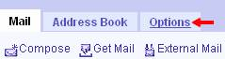 .
  - Click on “Vacation Message”: 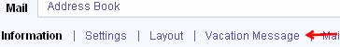
  - The following window will appear – as shown below:
  - Make sure to check “Enable Vacation Message for the time period:”
  - Select the correct start and end notice dates.
  - Enter your Subject: and Message:.
  - Enter “0” (zero) for the “Number of days between replies to send the vacation message.:“
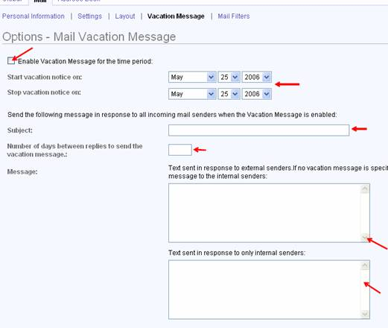

  - Once you are finished click on: .
  - This should work around 3-4 minutes, if not immediately.
  - You may now log off of mail.uh.edu 
OPTION TWO
  - THIS MUST BE DONE THROUGH YOUR EXHANGE WEB BASED OUTLOOK: Go to the following link: https://bauer-msx.bauer.uh.edu/exchange/
  - Enter your RICSNT username (make sure to include the domain): ricsnt\username
  - Enter your RICSNT password
  - Click on the “go to options” icon as shown below:
      - 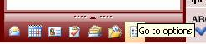
  - Got to options icon will take you to your Out of Office Assistant (as shown below)
      - 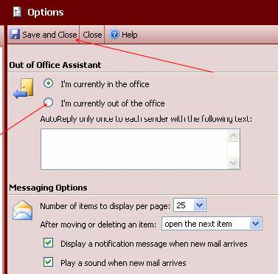
  - Click on the radial button to enable “I’m currently out of the office” and enter your auto reply message in the white text box.
  - Once done make sure to click on the Save and Close Button located at the top of the window.

** These procedures should also be followed any time you are out of your office for a lengthy meeting or training.

