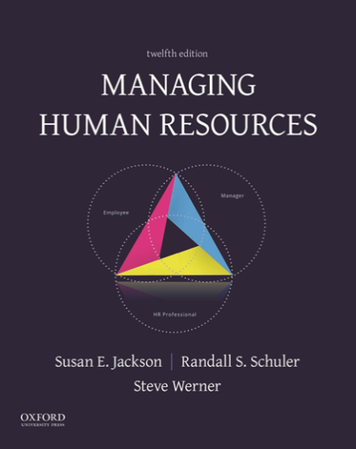
pp. 728 / Publishing: 11/20/2017
Prices starting at: $94.95*

(*See Pricing and Alternative Formats section below for further details.)

A well-respected, thematically-focused text that explains how successful companies manage human resources in order to compete efficiently.

Managing Human Resources, 12th Edition
Susan E. Jackson, Rutgers University
Randall S. Schuler, Rutgers University
Steve Werner, University of Houston

Clear and well-integrated, Managing Human Resources uses the authors' well-established Integrative Framework for Managing Human Resources to describe specific human resource (HR) activities including recruitment, training, performance management, and compensation. An important learning objective for students using Managing Human Resources is to develop an understanding of how the many specific HR activities can work together as a system that improves organizational effectiveness. This edition is a significantly revised and improved version of a title previously published by Cengage Learning.

New To This Edition

Distinctive Features
- Three New Chapters: Chapter 2, "Formulating and Implementing Human Resource Management Strategies," Chapter 5, "Managing Talent through Workforce Planning, Recruitment, and Retention," and Chapter 14, "Managing Globalization"
- Five Important Themes: Each chapter includes feature boxes highlighting five current themes in managing human resources: new technologies; metrics and analytics; ethics and corporate social responsibility; diversity and inclusion; and teams
- The HR Triad: Within each chapter, the HR Triad feature details the roles and responsibilities of line managers, HR professionals, and other employees, emphasizing the importance of collaboration for effectively managing an organization's human resources
- End-Of-Chapter Cases: Short cases provide students with an opportunity to apply what they have learned to analyze HR management challenges and suggest improvements
- Projects to Extend Learning: Students are encouraged to actively engage with chapter content through intensive case studies, internet research, and experiential activities
- Certification Preparation: The text's comprehensive coverage can be used to help students prepare for the exams required for PHR/SPHR certification and SHRM-CP/SHRM-SCP certification

Ancillaries
- Companion Website: www.oup.com/us/jackson -Available 11/20/2017
- Ancillary Resource Center (ARC): at https://arc2.oup-arc.com/contains additional teaching tools, including:
  - Instructor’s Manual
  - Computerized Test Bank
  - Power Point Slides
Table of Contents
- Managing Human Resources
- Formulating and Implementing Human Resource Management Strategies
- Ensuring Fair Treatment and Legal Compliance
- Using Job Analysis and Competency Modeling
- Managing Talent Through Workforce Planning, Recruitment, and Retention
- Selecting Employees to Fit the Job and Organization
- Training and Developing a Competitive Workforce
- Conducting Performance Management
- Developing an Approach to Total Compensation
- Using Performance-Based Pay to Achieve Strategic Objectives
- Providing Benefits
- Promoting and Improving Safety, Health, and Well-Being
- Understanding Unionization and Collective Bargaining
- Managing Human Resources Globally

Pricing and Alternate Formats

e-book | Looseleaf | Bound
$94.95  ISBN 9780190857578,  via Redshelf, Vitalsource | $142.99  ISBN 9780190857615 | $189.95  ISBN 9780190857561

Packages
Package our Business texts with any Oxford book for a 20% savings off the total package price! Visit www.oup.com/us/he for Oxford’s full catalog.

Compare
We invite you to compare the price* and quality of our book to other books published for your course:

Author | Title | Publisher | Publish date | Page Count | Price
Jackson/Schuler/Werner | Managing Human Resources | Oxford University Press | November 2017 | 656 | $189.95
Mathis/Jackson | Human Resource Management, 15e | Cengage | January 2016 | 705 | $279.95
Mello | Strategic Human Resource Management, 4e | Cengage | January 2014 | 696 | $279.95
Gomez-Mejia | Managing Human Resources, 8e | Pearson | January 2015 | 624 | $255.00
*List (suggested retail) prices as advertised on publishers' websites as of May 2017. Prices quoted are for comparable formats. Other formats may be available. Prices subject to change

