NT Server and SQL Server Accounts

There are two steps in the process for a student to have access to the NT Server and SQL Server 6.5 database. Each student needs to have a Windows NT account and a SQL Server 6.5 database created.

1). Create NT 4.0 user accounts

The first part of the task is to establish the Windows NT accounts. While this may seem like a daunting task, it is actually quite simple if done via a batch file. The following example contains a snippet of code from the batch file used to create the user accounts and add the users to a group. This example shows the lines that created the first three users and added them to a group which was created called “SQLUser”.

The batch file was created in VB. The loop size can be adjusted to create as many accounts as needed. (This one creates 99 accounts).

set HOMEBASE=\\disc-nt\e-drive\students

mkdir %HOMEBASE%\gl001
net user gl001 11111 /add /passwordchg:no/passwordreq:yes/homedir:%HOMEBASE%\gl001
net group "SQLUser" gl001 /add
cacls %HOMEBASE%\gl001 /E /G gl001:F

mkdir %HOMEBASE%\gl002
net user gl002 22222 /add /passwordchg:no /passwordreq:yes /homedir:%HOMEBASE%\gl002
net group "SQLUser" gl002 /add
cacls %HOMEBASE%\gl002 /E /G gl002:F

mkdir %HOMEBASE%\gl003
net user gl003 33333 /add /passwordchg:no /passwordreq:yes /homedir:%HOMEBASE%\gl003
net group "SQLUser" gl003 /add
cacls %HOMEBASE%\gl003 /E /G gl003:F

Once this is done you are halfway there. The difficult and important part is making sure that the batch file is set up correctly.

2). Create database in SQL Server Enterprise Manager

a). By navigating through the Start menu, select the SQL Server Enterprise Manager. See figure 2.1 for pictorial representation.

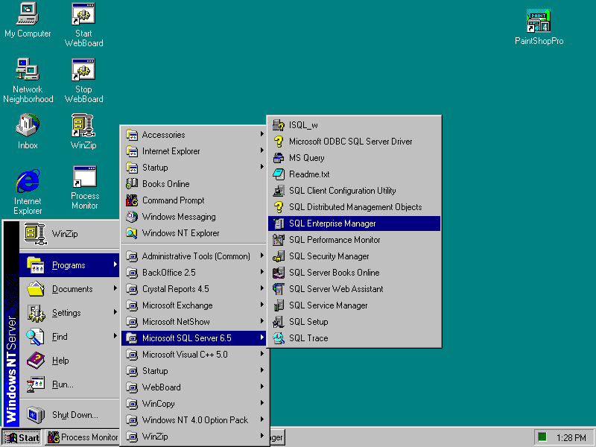
Figure 2.1

b). Go to the menu bar, look under the Manage menu, and click Database. This will allow you to manage the databases. See Figure 2.2 pictorial representation.

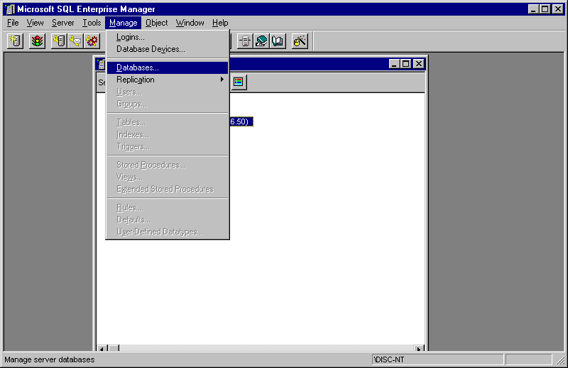
Figure 2.2

c). Next, click New Database. This will add a new database. See figure 2.3 for pictorial representation.

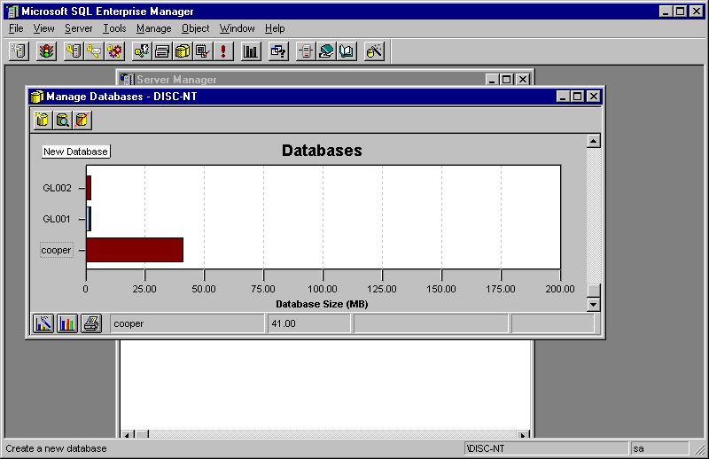
Figure 2.3
d). Enter database information for the database you are creating.

1. Enter the database name for the database that you are creating. In our example, we used 'gl199' to better illustrate the process.
2. Enter Data Device = Students
3. Leave Log Device = (none)
4. Enter Size(MB) = 2 ** It is important that students only have 2 MB's of Space.
5. Click Create Now
6. Close Dialog Box

See figure 2.4 for pictorial representation.
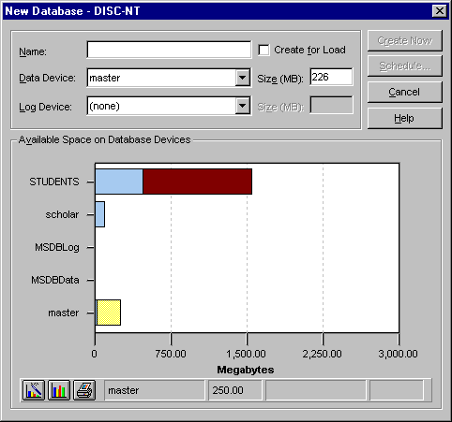
Figure 2.4

After this step is complete, you need to set up the Login Name for the Database.

3). Set up Login Name in SQL Enterprise Manager.

a). Select Manage Logins. See figure 2.5 for pictorial representation.

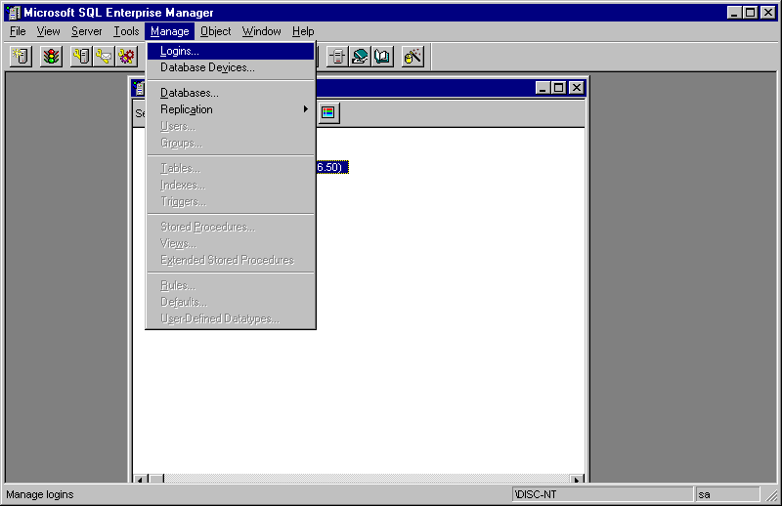
Figure 2.5

b). Enter Login Name. In this case, we use the same name that we named our database.
c). Enter Password (follows the naming convention for passwords).
d). Default language stays the same at <Default>.

See figure 2.6 on the next page for a pictorial representation.
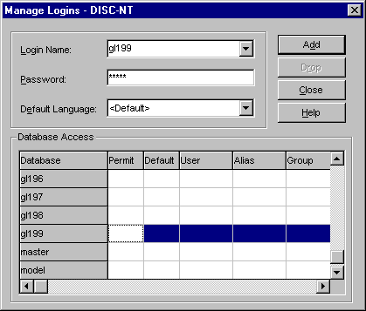

e). Make sure the database that you are interested in adding is highlighted as in the picture.
f). Click 'Add' to add the information you just entered.
g). Close Dialog Box (which is actually the Manage Logins Box).

4). Manage Users in SQL Enterprise Manager

a). Make sure that the database that you are just created is highlighted.

Under Manage on the menu bar select Users. This will allow you to manage the users for the database that you just created.

See figure 2.7 on the next page for a pictorial representation
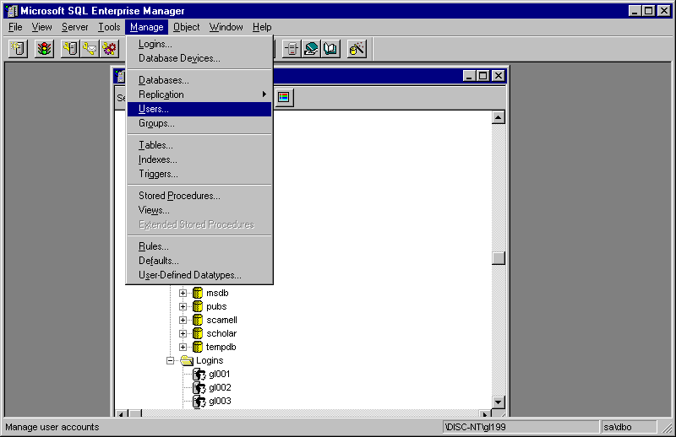
Figure 2.7

b). Enter the User Name (which in our example is the same as Login Name)
c). Enter Login Name (same as before)
d). Leave the group as Public.
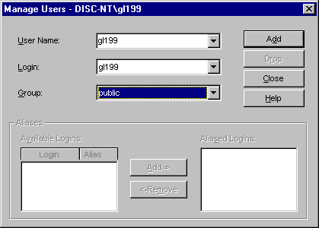
e). Select Add then Close..

5). Edit the Database Permissions

a). Make sure the Database is highlighted, then right mouse click.
b). Select Edit

See figure 2.8 for pictorial representation.
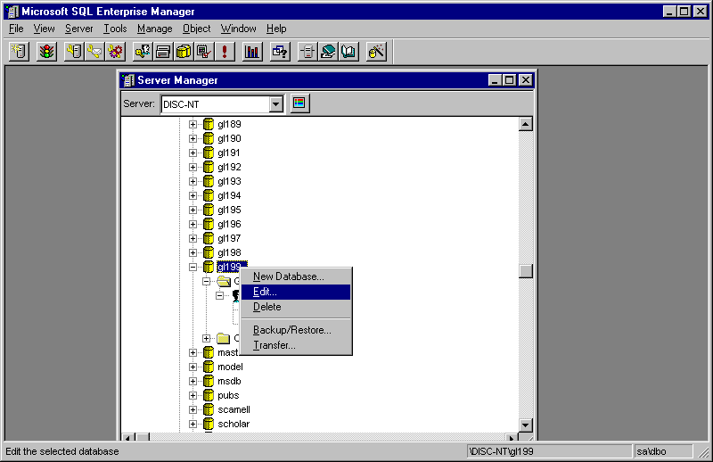
Figure 2.8

c). Click Permissions
d). Select the Create Table for the user.
e). Select the Create View for the User
f). Select O.K.
***Make sure the you can see the user name of the user you want to give permissions to.***

See Figure 2.9 on the next page for a pictorial representation.
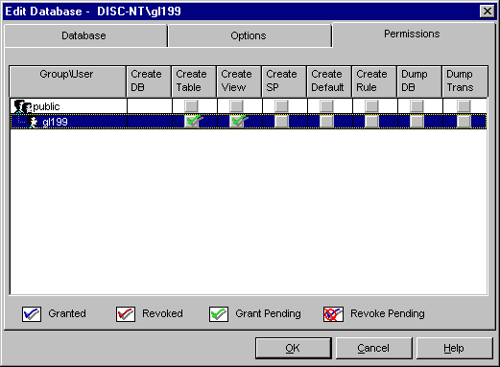
Figure 2.9

6). Create ODBC Driver connection to the SQL Server 6.5 database

The Next Step in the Procedure is to add the SQL Server 6.6 ODBC device driver so that the students accounts can communicate with the SQL Server database.

a). Under the Start Menu, click Control Panel
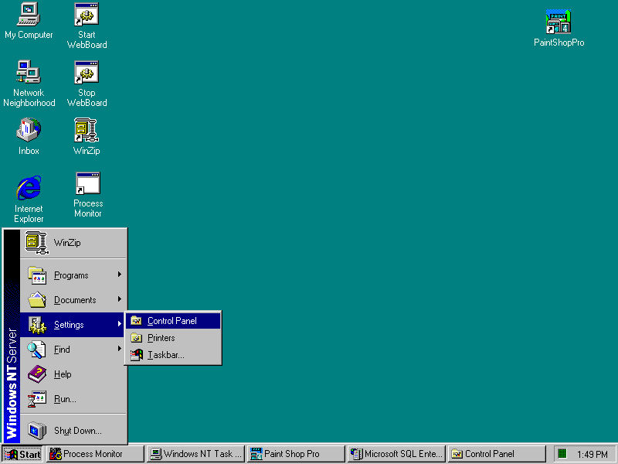

b). Click ODBC
c). Make sure the System DSN tab is selected, then click Add.

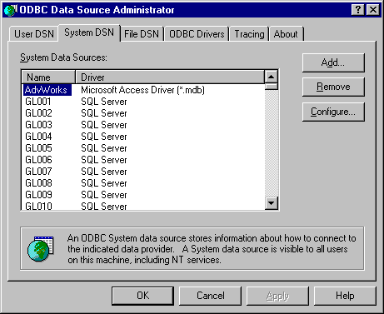
Figure 2.10

d). Select SQL Server
e). Click Finish and this will bring you to a Wizard.

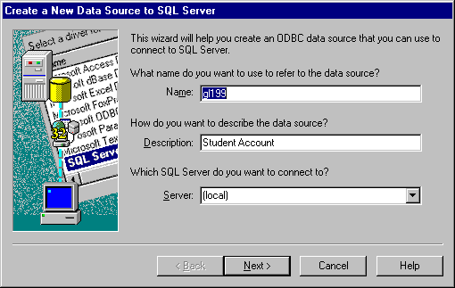
Figure 2.12

f). Enter Database Name (the same as in the previous examples).
g). Enter the Description as Student Account
h). Leave the Server as (local)
i). Click Next

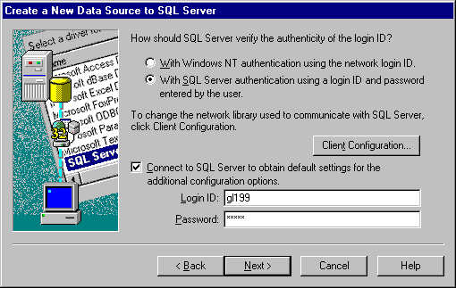
Figure 2.13

The following should appear on the screen.

j). Click the RadioBox that says 'With SQL Server authentication using Login ID and Password entered by the user'.
k). Make sure the checkbox for 'Connect to SQL server to obtain default settings for the additional configuration options ' is checked
l). Enter Login ID: (Same as in previous examples).
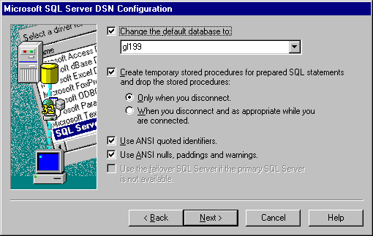
m). Enter Password: (same as when you typed in the password for the database permissions).

n). Click Next. The following should appear.
o). Make sure the 'Change the Default database to:' checkbox is checked, and select the database name from the pull-down menu. Make sure that you choose the database name and not the Master.
p). Don't Change anything else.
q). Click Next for the remaining Dialog Boxes that appear.
This is the end of the Procedure to add someone to a database.

