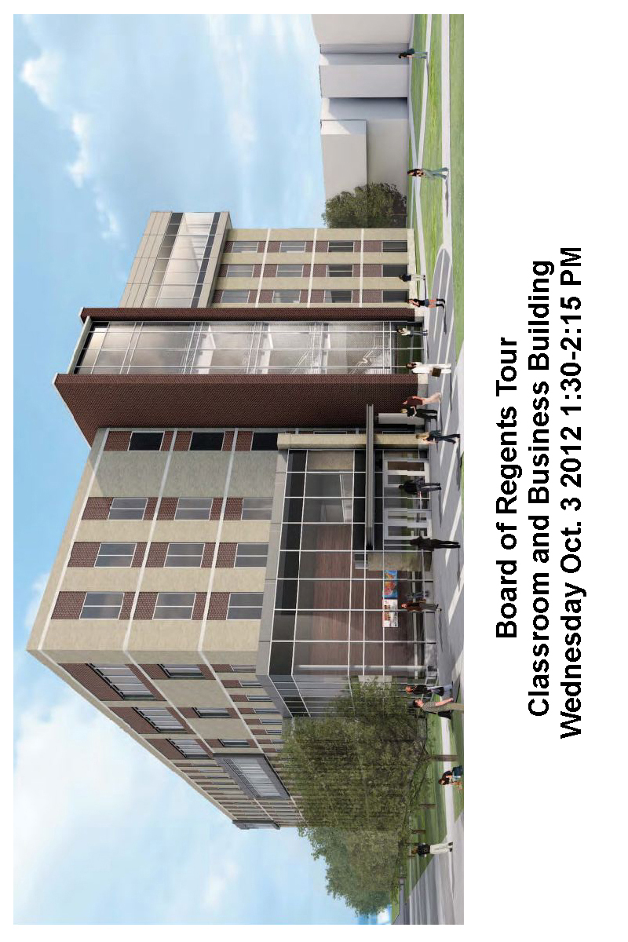

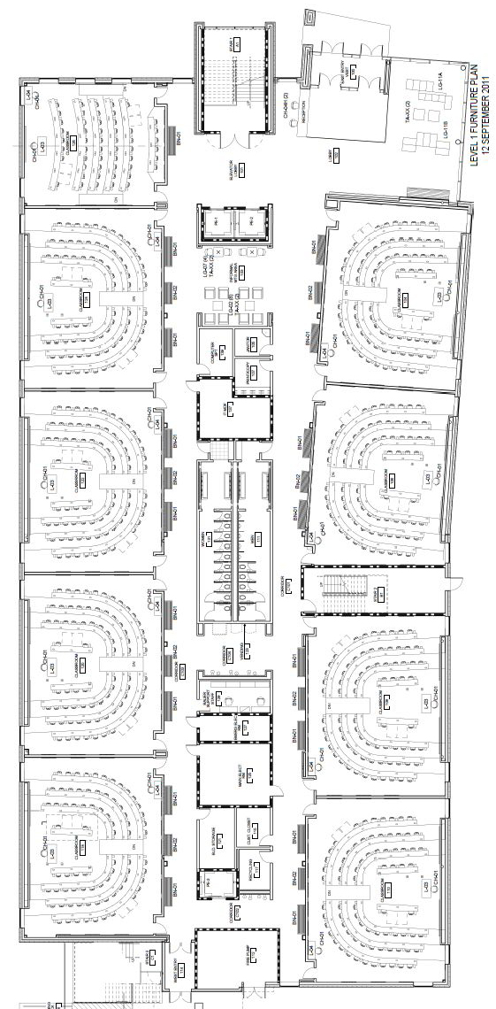

First Floor

Eight 80 Seat General Purpose Classrooms

One 52 Person Computer Lab

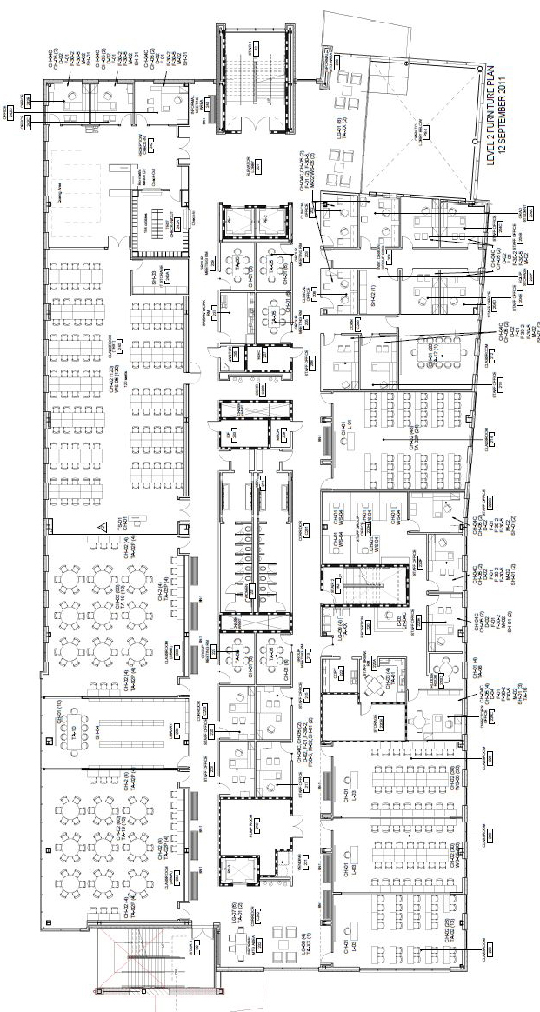

Second Floor

Testing Center

Writing Center

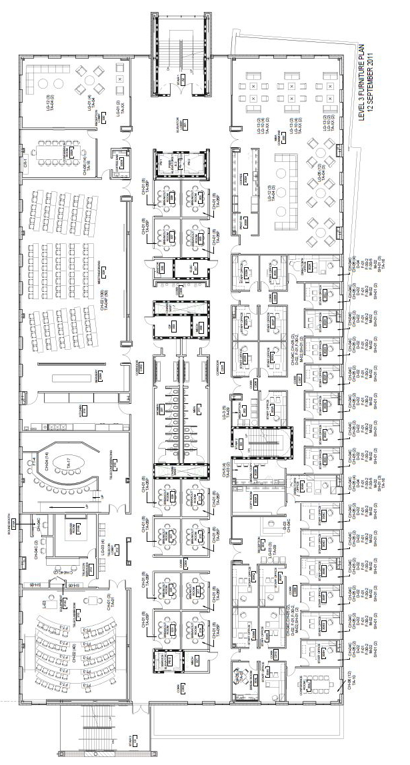

Third Floor (Bauer College)

Teleconferencing Center (Videoconferencing) Global Energy Management Institute

Events/Dining (for 100) with Servery Real Estate

Professional Programs in Accounting (PPA) MBA Lounge

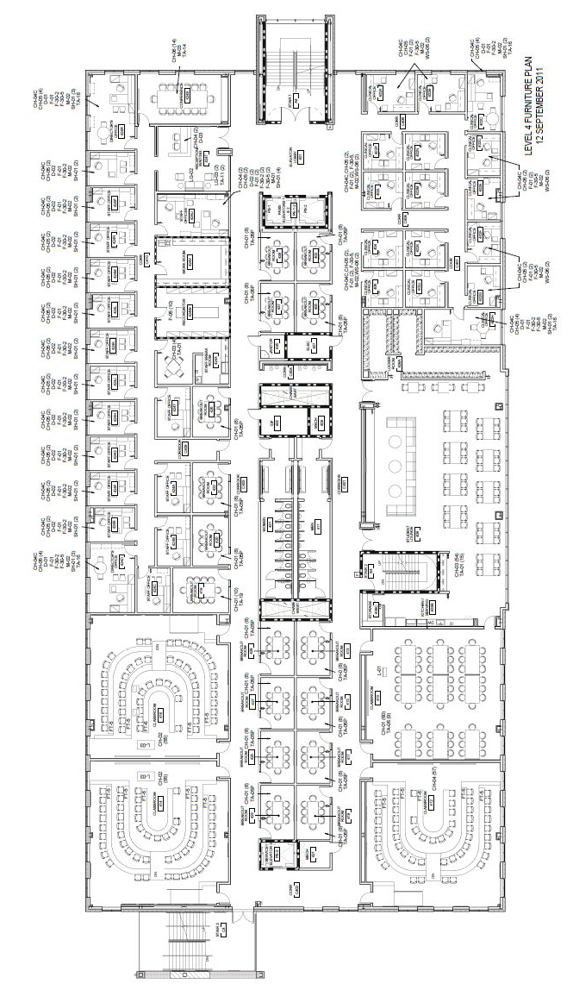

Fourth Floor (Bauer College)

Executive MBA Administration/Advising Suite

Four 60 seats Classrooms

Executive MBA Dining/Lounge

Clinical Faculty Offices

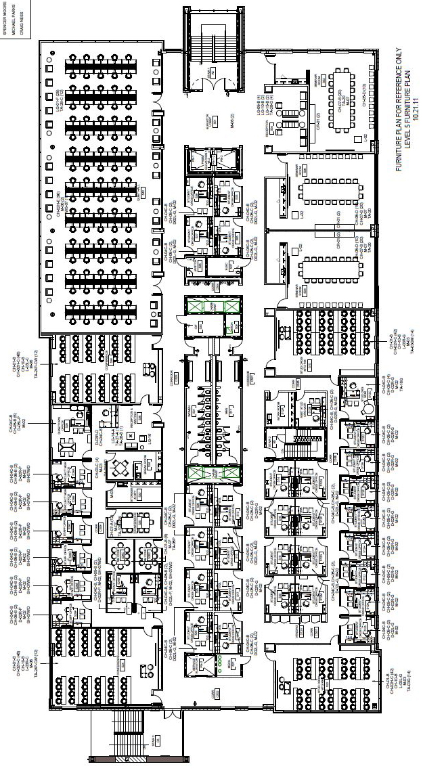

Fifth Floor (Bauer College)

Wolff Center for Entrepreneurship (two classrooms)

Student Organization Offices (30), Two Meeting Rooms

Three Seminar Rooms

“Quiet Room” -- 115 seat reading/study room

Quiet Room