**Landscape Plan for Melcher/Cemo/CBB Interface August 2012**

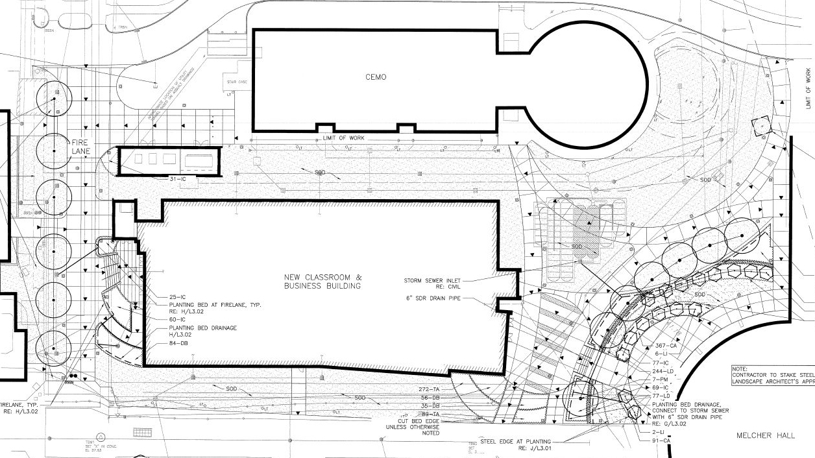

**Large Circles are “Live Oaks”; Small Circle are red Crepe Myrtles**