Coupa (HBS Case 9-813-114)

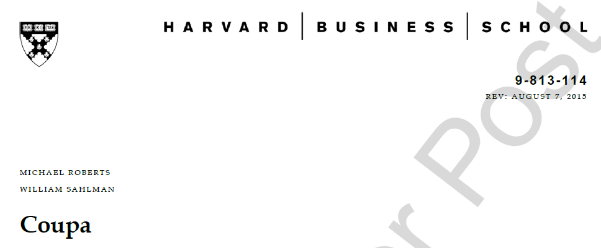

Assigned questions

- Evaluate Coupa’s management, business plan, and value proposition. Do you identify potential? What are the main risks?

- Suppose that Bernshteyn was given 10% of firm equity when joining the company as CEO. What is the current diluted ownership held by Rob? What might be the implications of this ownership level?

- What growth options does Coupa consider? How would you weight the advantages and disadvantages of organic growth through hiring vs. the acquisition of similar, smaller businesses for Coupa?

- What future EBITDAs –in years 2013, 2014, and onward – would hypothetically be generated if Coupa had one more ramped sales rep in 2012 (take into account renewals, hiring and salary costs)?

- Looking at the Coupa sales model in Exhibit 3, what is the main driver of growth? How could Coupa increase the 2014 over 2013 growth rate to 80%? Why is this a good or bad idea?

- Evaluate Coupa’s value at the end of 2014 based on its growth level and the multiples of the comparable firms provided in the case. What growth plan do you suggest?

