“Buying Status” by Choosing or Rejecting Luxury Brands and their Counterfeits

STEPHANIE GEIGER ONETO
JAMES D. HESS
BETSY D. GELB*

* Stephanie Geiger Oneto is an assistant professor of marketing, College of Business, University of Wyoming, 1000 E. University, Dept 3275, Laramie, WY 82071, soneto@uwyo.edu, (corresponding author).

James D. Hess is a professor of marketing and the Bauer Professor of Marketing Science, Bauer College of Business, University of Houston, 375H Melcher Hall, Houston, TX 77204-6021, jhess@uh.edu.

Betsy D. Gelb is a professor of marketing and the Larry J. Sachnowitz Professor of Marketing & Entrepreneurship, Bauer College of Business, University of Houston, 334 Melcher Hall, Houston, TX 77204-6021, gelb@uh.edu.

Abstract

Even in difficult economic times, many consumers consider the social implications of the goods they select and therefore take into account whether those goods carry a luxury brand label, authentic or counterfeit. While previous research has investigated influences on the authentic vs. counterfeit choice, this study adds a third possibility: rejecting both types of luxury brands to show that one has better claims to status than “buying the label.” This study tests a model of three alternative brand-type choice processes and finds support for the importance of status considerations in the selection or rejection of luxury brands.

“Who’s got money, who doesn’t, it’s always going on in my head. So, I put on my armor. I have the [hand]bag. I have the shirt. I know people can’t tell my background by looking” (New York Times 2005, p A19).
Buying to make “the right” impression in order to gain status may not always involve the constant attention described above, but it is hardly rare. Goods with designer labels that provide “armor” to the insecure offer one approach to status seeking, but that quest is a complex one. An authentic designer label surely sends a message – but at what may be an impossible price. A counterfeit of that label sends what may be viewed as the same message, or may be viewed as a different message entirely by those who value authenticity. Finally, goods lacking a luxury-brand label may be viewed by some consumers as sending a better message -- that status comes from characteristics other than the labels on one’s purchases. This complex choice process is the one investigated here.
Specifically, our study examines the choices that consumers make when considering goods, either authentic or counterfeit, with luxury-brand labels, or instead select brands clearly in neither of those categories to indicate that they have better claims to status than do those who must purchase it via status-signaling brand names. We developed and tested a theoretical model of antecedents to predict choices among these three brand-types for goods often purchased with status in mind.
By use of a nested discrete choice model we were also able to examine the decision process that consumers employ to choose among these three brand-types. Specifically, we examined (1) whether consumers first decide to “buy status” via a designer label, then select between the genuine brand and its counterfeit, or (2) whether they first select a price level, then if rejecting a high price, choose between a counterfeit or a non-luxury brand or (3) whether the decision process proceeds from “counterfeit or not” to the choice, if “not,” between an authentic luxury brand and a non-luxury brand. Understanding this sequence of decisions not only has theoretical significance but also can improve segmentation and targeting decisions for a range of goods and services that are both socially visible and branded.
In describing our research, we begin with the motivation behind many purchases: the buying of status. We then introduce the relevant constructs for brand-type choice alternatives: authentic luxury brands, their counterfeits, and non-luxury brands – those that make no exclusivity claim. Third, we describe the variables employed to predict choices among these brand-types and hypothesize relationships between these variables and consumer choices. We then present the research method used to test our hypotheses, offer results, and discuss their managerial and theoretical implications.

SEEKING STATUS

Social scientists and economists have established that status seeking is an universal and often advantageous behavior (Leibenstein 1950; Emerson 1962; Frank 1985; Driskell and Mullen 1990). Researchers have found that individuals seek status to increase their power and influence in social relationships (Berger et al. 1977; Lovaglia 1994; Ridgeway and Erikson 2000; Thye 2000), gain access to future resources (Lin 1990, 1994; Huberman et al. 2004) and demonstrate their competency and ability to others (Festinger 1954; Braun and Wicklund 1989; Wood 1989).
One way to gain status is through purchase choices. Notes the New York Times: “Luxury once denoted stuff that was costly and hard to obtain…well-upholstered and
Gatsby-esque lives played out against a backdrop of mansions and servants and…their trunks from Louis Vuitton, their trousseaux from Christian Dior, and their Dom Perignon by the case.” The same article points out, however, that “carriage trade luxury” now is sought by a new class of people who have “acquired both the ability and the hankering to purchase themselves little nothings from Vuitton, Chanel, or Dior…even in a recession” (Trebay 2009, p. ST 8). As Commuri (2009) observes, the goal of such behavior is either to ostracize others socially by using the brand as a signal of wealth or to avoid such ostracism. And as such Websites as http://www.aaareplicas.com/ make clear, thrifty signalers have imitations of luxury-labeled goods available to them at the click of a mouse.
Earlier studies in this field focused on the purchase of authentic goods vs. counterfeits (Wee et. al. 1995; Cordell 1996; Nia and Zaichkowsky 2000) by assuming a dichotomous choice primarily dictated by economic variables, while also assuming status-related motives (Cordell 1996). However, not all consumers who buy luxury brands do so to gain status; objects and brands carry a range of possible meanings (Belk 1988; McCracken 1986, 2005). For example, Wilcox, Kim, and Sen (2009) go beyond price issues to consider moral reservations concerning the purchase of counterfeits and the influence of the goals guiding a purchase: is the consumer choosing a luxury brand based on social goals, or based on goals that the authors characterize as value expressive? Similarly, Commuri (2009) identifies a segment of prestigious brand buyers in Thailand and India who are less interested in signaling than they are in simply possessing the best.
Our study goes further, including as a social motive – and one related to the pursuit of status – the choice by some consumers not to purchase luxury labels despite the financial ability to do so. We thus explore a new possibility: that consumers engage in status consumption in not only different but opposed ways. That is, they may purchase authentic luxury brands, counterfeits of those brands -- or select purchase non-luxury brands if they want to communicate that they have alternative paths to claiming status.
Luxury Brands and Their Counterfeits
Authentic luxury brands convey exclusivity via high price; for example, their designers are able to transform a $10 t-shirt into a $100 sought after treasure (Chatpaiboon 2004). Hermes once placed customers on a two-year waiting list for their most popular Birkin bag, which retailed for $6000 (Branch 2004); on EBay women engaged in bidding wars over one version of the bag, for which the winner ultimately paid over $13,000 (Rose 2003). Given that such prices place these purchases out of the financial reach of many would-be buyers and add prestige to the brand, it is unsurprising that the most sought-after labels prompt the manufacture and marketing of counterfeits.
Counterfeit goods are identical in appearance to authentic luxury goods and fraudulently display the brand name being copied (Cohen 2005). These products, which blatantly infringe trademarks, are sold at a fraction of the price of the authentic designer version—e.g. Luis Vuitton purse $1100 vs. counterfeit $115.
Non-luxury Brands

The third category, non-luxury brands, cost about the same as counterfeits of luxury brands, but knowledgeable buyers do not expect them to be perceived as costly. Such brands are therefore a natural choice for consumers who want to make clear that their choice of watch, handbag, sunglasses, or the like was not based on a wish to be associated with elitism in the conventional sense.

ELEMENTS OF THE MODEL

Our study focused on the influences affecting a consumer’s choice among the three brand-types described above and also the choice process involved. Would a luxury label be the first consideration, or price level, or authenticity? We began by developing a model of factors we expected to be influential in the actual brand choice among goods that are authentic luxury brands, counterfeit, or non-luxury brands (In our model, these three brand-types are denoted by the symbol t). At the individual level (individuals are indexed by the letter i), the factors included are 1) cultural level (CL), 2) status insecurity (SI), 3) the degree to which a consumer associates material possessions with success (M), 4) value consciousness (VC), and 5) perceived affordability of the product (AFF). Each will be discussed in turn.
Cultural Level (CL_{i})
Cultural level, also referred to as cultural capital, has been described as “institutionalized, i.e. widely shared, high status cultural signals (attitudes, preferences, formal knowledge, behaviors, goals, and credentials) used for social and cultural exclusion” (Lamont and Laureau 1988, p. 156). The exclusionary property of cultural capital – that it is difficult for others to obtain -- makes it highly coveted; those who have it reinforce the fact that they have it and others do not via their preferences and tastes for particular product categories and brands. Therefore, status boundaries are reinforced simply by expressing those preferences and tastes, referred to as one’s “habitus” (Bourdieu 1984). Consumption, along with other social domains, becomes a method by which social hierarchies are reproduced and reinforced across generations.
A person’s cultural level may influence his or her choice of brands by dictating reference groups to aspire to and determining which strategies are available and/or effective in favorably impressing those groups. Clearly, for example, it is easier for most individuals to purchase an expensive item of clothing than to complete a graduate school program or easier to appreciate a fashionable brand of shoes than to distinguish works of art. Therefore, we expect that individuals with high cultural levels, whose claims to status are more difficult to achieve, may avoid luxury branded goods in order to avoid confusion with those who rely solely on such markers for status. Furthermore, we expect these consumers to most strongly avoid counterfeits of luxury brands, not only because they give the appearance of purchasing status, but because based on their lower price they are available to anyone.
Previous research substantiates the idea that individuals who attain high cultural levels gravitate to purchases that separate them from individuals at a lower cultural level. For example, Holt (1998) found in a qualitative study that in contrast to selecting a well-known, expensive restaurant, individuals with a high cultural level preferred a restaurant with a unique atmosphere, and they preferred intangibles and unique life experiences (i.e. exotic or unusual vacations) over expensive status goods. Because individuals with high cultural capital were often raised with little or no material constraints, these individuals place a greater value on items which are authentic and/or artistic as opposed to items that signal opulence and wealth (Holt 1998).
Such reasoning supports the following hypotheses:
H1a: As cultural level increases, it is more likely that a non-luxury label is chosen over a brand in either alternative category.
H1b: As cultural level increases, the likelihood that a counterfeit luxury brand will be chosen decreases more than the likelihood of an authentic luxury brand choice decreases.

Status Insecurity (SI_{i})
While some consumers may purchase goods to signal membership in a higher status group (Veblen 1899; O’Guinn and Shrum 1997), other consumers may conspicuously consume goods simply to avoid the appearance of being low-class. Status insecurity (Wyatt et al. 2008; Wu 2001) refers to the degree to which an individual is concerned with appearing low-class or feels uncertainty about his or her social standing. According to Charles, Hurst, and Roussanov (2007), visible luxury serves to fend off the negative perception that the owner is poor, and the poorer the society or peer group, the more important such visible spending becomes. While their research focus was cross-racial differences in spending, they found that among white consumers, an increase of $10,000 in mean income leads to a 13 per cent decrease in spending on visible goods (Postrel 2008).
We therefore expected status insecurity to influence brand-type choices. Individuals who are insecure about their social status are likely to compensate by purchasing brands that convey prestige to others and avoiding those that may lead to being perceived as second-class, according to Wyatt et al. (2008). Instead, to avoid looking unsophisticated or resource-poor, they purchase authentic or counterfeit luxury brands that convey the opposite signal. However, while they prefer a brand in a luxury-label category over one with less luster, fear of being “caught out” with a fake leads them to disproportionately select authentic luxury brands if at all possible.
H2a: As status insecurity increases, it is more likely that a luxury label, authentic or counterfeit, is chosen over a non-luxury brand.
H2b: As status insecurity increases, the likelihood that an authentic luxury brand will be chosen increases more than the likelihood of choosing a counterfeit increases.

Possession-Defined Success Dimension of Materialism (M_{i})
Materialism has been defined by researchers as “a set of centrally held beliefs about the importance of possessions in one’s life,” according to Richins and Dawson (1992, p. 308). Based on the results of a qualitative study, these researchers concluded that individuals with high levels of materialism often placed greater importance on acquiring material possessions and were more likely to associate the ownership of certain products with achieving major life goals than were those with low levels of materialism. Results from their work and research by others justify expecting materialism to influence decisions across social domains that include, but are not limited to, consumption (Belk 1985; Richins and Dawson 1992; Richins 2004).
While most research focuses on materialism in general, the construct has been found to be comprised of three underlying dimensions: Possession-defined Success, Acquisition Centrality and Acquisition Happiness (Richins and Dawson 1992; Richins 2004). Because the our study focuses on factors that influence brand choice and thus precede actual ownership, two dimensions of materialism, Acquisition Centrality and Acquisition Happiness, are beyond its scope. However, we expected in developing our model that possession-defined success would help to predict brand-type choices. Researchers have found that when evaluating products and/or brands, individuals scoring high on this dimension of materialism place a greater importance on their social utility, appearance, and ability to convey status (Roberts 2000; O’Cass and McEwen 2002) than do non-materialists. Materialistic consumers overall purchase more luxury brands (Belk 1985) and are more likely to purchase goods that can be worn conspicuously (Richins 2004) than are non-materialistic consumers. Furthermore, this construct like the previous one leads to preference for an authentic luxury label category over a counterfeit because of the association of self esteem with purchase category. Therefore:
H3a: As [the success dimension of] materialism increases, it is more likely that a luxury label, authentic or counterfeit, is chosen over a non-luxury brand.
H3b: As [the success dimension of] materialism increases, the likelihood that an authentic luxury brand will be chosen increases more than the likelihood of purchasing a counterfeit.

Status Insecurity and Materialism (SI_{i} × M_{i})

The interaction of status insecurity and materialism (the degree to which success is equated with the ownership of material possessions) was also expected to influence brand-type choice. We hypothesized that someone feeling “not good enough” who equates possessions with success will be disproportionately likely to choose a label connoting status. For example, luxury-label brands, as compared to non-luxury brands, are often consumed to indicate one’s level of financial stability and ability to pay the required high prices (O’Cass and Frost 2002). As a result, for consumers who feel concern about their status, the drive to own brands that telegraph success is enhanced. Therefore,

H4a: The positive effect of greater status insecurity on the log-odds of choice of a luxury label, whether authentic or counterfeit, is larger for individuals who are more materialistic than for those who are less materialistic.
H4b: The positive effect of greater status insecurity on the log-odds of choice of a counterfeit versus an authentic luxury brand (given a luxury label is chosen) is larger for individuals who are more materialistic than for those who are less materialistic.

Value Consciousness (VC_{i})
Value Consciousness has been defined as “a concern for price paid relative to the quality received” (Lichenstein et al. 1993). Value conscious consumers take great pleasure when able to purchase items at lower prices because they feel like a “smart shopper” (Lichenstein et al. 1993). For example, consumers who are value conscious may choose to shop at outlet stores and/or purchase things on sale in order to get a better deal on desired product. These consumers have a strong desire to maximize the ratio of quality received to price paid, and also a desire to pay low prices (Burton et al. 1998). To them, brand imitations are a good alternative to the original because of their lower prices. However, while counterfeits may provide status at a lower price, they are often of lesser quality than either a non-luxury brand or authentic luxury brand. (Cohen 2005). Therefore, we expected an individual’s level of value consciousness to influence brand type choice in the following way:
H5a: As value consciousness increases, the likelihood increases that a non-luxury brand is chosen over a luxury label, either authentic or counterfeit.
H5b: As value consciousness increases, the likelihood that an authentic luxury brand will be chosen decreases more than likelihood of choosing a counterfeit decreases.

Value Consciousness and Materialism (VC_{i} × M_{i})
We expected a second interaction effect to influence brand-type choice: value consciousness and materialism. While some consumers purchase brand imitations because of value, others choose them to signal they are smart shoppers (Penz and Stottinger 2005; Tom et al. 1998), choosing a counterfeit over an authentic luxury brand to acquire the social benefits of an luxury-appearing brand with a far lower price. Some consumers of counterfeit products have described them as providing “more bang for the buck” (Gentry et al. 2001). However, other value-oriented consumers may ignore luxury labels, authentic or counterfeit, and select non-luxury goods in the belief that the prestige of a label does not enhance quality and may increase price.

Therefore, when faced with the decision among non-luxury, counterfeit, and authentic luxury goods, status-oriented value conscious consumers would be expected disproportionately to choose a counterfeit product, all things equal. On the other hand, value conscious consumers who place greater importance on quality than on prestige would be more likely to choose the non-luxury brand out of unwillingness to “buy the label.” These choices both contrast to those of less value-conscious consumers, who would be expected to be more willing to pay top dollar for the authentic luxury brand to gain both superior quality and social prestige. Therefore, it appears that the consequence of an individual’s level of value consciousness may depend on how a person weights prestige and functionality in defining value.

This reasoning leads to the following 2-way interaction hypotheses:
H6a: The positive effect of greater value consciousness on the log-odds of choice of a non-luxury label, is larger for individuals who are more materialistic.
H6b: The positive effect of greater value consciousness on the log-odds of choice of a counterfeit versus an authentic luxury brand (given that a luxury label is chosen) is larger for individuals who are more materialistic.

Affordability (AFF_{it})

While the discussion of brand-type choice has to this point emphasized individual characteristics, we also included price, as perceived by buyers, in considering the antecedents of that choice. A measure of the perceived affordability of each chosen brand-type was included as a control variable, but with the realization that low affordability -- high perceived price -- might mean “all I could manage” to those selecting a lower-priced brand-type and might signal quality and/or prestige to those choosing the authentic luxury brand (Lichenstein et al. 1993).

H7: As the perceived affordability of each brand-type increases, so does the likelihood that it will be chosen.

RESEARCH METHOD

To test the relationships hypothesized above and to better understand the brand-type selection process, we gathered data from two groups of respondents. The first group was comprised of university students; the second was recruited from the general public in a large city at two sites where the need to wait for service provided an ad hoc subject pool. See Table 1 for a complete list of descriptive statistics for the combined samples.

-----------------------------------
Insert Table 1 about here
----------------------------------
Group One
Sample and Data-Gathering Method
In the first group, 753 undergraduate business students, with an average age of 24, provided data to receive extra credit in a class. Participants, 441 males and 312 females, received gender-specific versions of an online questionnaire that asked them to first choose exactly two product categories in which they would be likely to purchase something among four possibilities: watches, wallets, sunglasses and (for women only) handbags. In each selected product category, participants saw information about three available brand-types: an authentic luxury brand, a counterfeit luxury brand, and a non-luxury brand. For example, for handbags the screen showed a Louis Vuitton $1500, Fossil $150, and Louis Vuitton counterfeit $150. Each price approximated the current market value, but prices for the counterfeit and non-luxury brands were kept identical. Participants were asked to indicate which brand they would choose if making a purchase in that product category, providing two choice observations per individual.
Then participants were asked about past brand-type purchases in general terms, for example, about previous purchases of counterfeits. They provided demographic data and responded to items measuring cultural capital, materialism, value consciousness, status insecurity, and the perceived affordability of their brand choice. A final question asked participants to name their current brand of watch, wallet, sunglasses, and (if applicable) handbag.
Group Two
Sample and Data Gathering Method
To increase the generalizability of results, the model (Figure 1) was also tested using subjects from a Department of Public Safety station parking lot and an international airport in the same city. A total of 204 participants (96 DPS station, 108 airport) completed a paper questionnaire while looking at pictures of brand-type alternatives identical to those shown to Group 1 on a computer screen. This sample was more diverse in age (mean=38 years) and education, with 56% having less than a four-year degree, 23% a bachelor’s degree and 21% a graduate degree. Table 1 shows descriptive statistics.
------------------------------
Insert Figure 1 about here
--------------------------------
Participants completed a paper version of the questionnaire used by the first sample, with the incentive of having their name entered in a drawing for two gift certificates worth approximately $150 each. They were asked to choose a brand of watch, wallet, sunglasses and handbags (if female), since there was no need to limit the choices to two categories as the computer-based questionnaire had done for Group 1. Male participants indicated their brand-type choice for each of three product categories, females for four. Table 2 shows a cross-tabulation of brand-types selected by product category.

-----------------------------
Insert Table 2 about here
-----------------------------
Measures in both samples
Cultural Level. Cultural level was measured by asking respondents to indicate which of the following cultural events, if any, they had attended in the past year: ballet, book release party, opera, theater, and classical music concert. The total number of events was then used to create a composite score. Variations of this scale have been used in several previous studies (Aschaffenburg and Maas 1997; Kamijn and Kraaykamp 1996;Lamont and Lareau 1988).
Status Insecurity. Status insecurity (alpha=.75) was measured using a previously established scale that asks for level of agreement with three statements using a 7-point Likert scale--1=Strongly Disagree/7=Strongly Agree--(Wyatt et al. 2008; Wu 2001): “People are biased against me sometimes,” “Sometimes I have to work very hard just to prove that I am just as good as anyone else” and “Sometimes others view me as second class.” Table 3 lists the scale items and factor loadings.
-------------------------------
Insert Table 3 about here
--------------------------------
Materialism. Success via possessions as a dimension of materialism (alpha=.86) was measured using a six item scale previous established by Richins and Dawson (1992) that asks participants to indicate their level of agreement with six statements by using a 7-point Likert scale (1=Strongly Disagree/7=Strongly Agree). Table 4 lists the scale items and factor loadings.

------------------------------
Insert Table 4 about here
------------------------------
Value Consciousness. Value consciousness (Lichenstein, Netemeyer and Burton 1993) was measured using seven statements assessing the relative importance of quality compared to price when making product choices (alpha=.84). Each item was measured using a 7-point scale ranging from Strongly Disagree to Strongly Agree. Table 5 lists the scale items and factor loadings.
--------------------------------
Insert Table 5 about here
--------------------------------
Affordability. Participants were asked to rate the affordability of each brand choice, given their current financial resources, on a 7-point Likert scale ranging from Extremely Unaffordable to Extremely Affordable.

Data analysis
Combining the samples
To determine the appropriateness of combining the samples, a dummy variable was created to indicate whether the observation came from the student (=1) or the more general adult population. This term was then used to create a cross-product term to represent an interaction with each of the theoretical variables of interest. The newly created interaction terms were then added into the model. The fit statistics (log-likelihood) were then used to perform a likelihood ratio test to determine if the additional interaction terms provided additional explanatory power. The observed χ²=20, does not exceed the critical value of χ²=26.30 with 16 degrees of freedom. Therefore, given that the populations are not significantly different, pooling the data to test the hypotheses was found to be appropriate.

The data were analyzed using a multinomial logit model. Use of this model is based on the assumption that individuals choose the brand-type that offers the maximum utility. In our model, the utility can come both from the functional use of the brand in private and from its use in public as a social tool for gaining status. In other words, for any brand type t, the total utility of individual i is

$U_{\text{it}}=U_{\text{it}}^{\text{func}}+U_{\text{it}}^{\text{social}}+ε_{\text{it}}\text{.}$ (1)

The first term on the right in (1) is the functional utility of brand type t and the second term represents the social benefits. Both of these utilities are potentially measurable. The final term ε_{it} represents aspects of the utility that are unobserved by the researcher but known by the individual.
Including functional utility in the model involves consideration of the perceived affordability of a consumer’s choice and the interaction of that perception with his or her value consciousness. Independent of the prestige-gaining value of a choice, affordability provides additional utility, all things equal. The importance of that utility is, in this study, value consciousness. Thus, functional utility is

$U_{\text{it}}^{\text{func}}=(c_{0t}+c_{1}{\text{AFF}}_{\text{it}}){\text{VC}}_{i}$. (2)

The utility for social benefits, described in detail in the previous section, is

$U_{\text{it}}^{\text{social}}=\left(d_{t0}+d_{t1}M_{i}\right) {\text{CL}}_{i}+\left(f_{t0}+f_{t1}M_{i}\right) {\text{SI}}_{i}+\left(g_{t0}+g_{t1}{\text{VC}}_{i}\right) M_{i}\text{.}$ (3)

Combining these gives the general model

$\begin{aligned}U_{\text{it}}^{\text{func}}+U_{\text{it}}^{\text{social}}=(c_{0t}+c_{1}{\text{AFF}}_{\text{it}}){\text{VC}}_{i}+\left(d_{0t}+d_{1t}M_{i}\right) {\text{CL}}_{i} \\ + \left(f_{0t}+f_{1t}M_{i}\right) {\text{SI}}_{i}+\left(g_{0t}+g_{1t}{\text{VC}}_{i}\right) M_{i}\text{.}\end{aligned}$ (4)

The variable labeling is spelled out in Table 6.

-----------------------------------

Insert Table 6 about here

---------------------------------

The Nested Choice Models

The standard multinomial logit model is based on the assumption that all brands are compared simultaneously. However, because this study investigates the decision process consumers engage in when choosing between brand-types, three competing nested models were tested (see Figure 2).

----------------------------------

Insert Figure 2 about here

----------------------------------

The first model describes a status focus, in which a consumer decides whether or not to purchase a luxury label, then if deciding to do so, selects between a counterfeit or authentic brand based on which one offers the greater utility. In contrast, the second model describes an economic focus, in which a consumer decides whether to purchase a bargain brand, then if deciding to do so selects between a non-luxury or counterfeit brand. The third model describes an authenticity focus, in which a consumer decides whether or not to purchase a legitimately labeled brand, as opposed to a counterfeit, then if deciding to do so chooses between the authentic luxury brand and the non-luxury brand. All of these nested choice models are contrasted to a traditional non-nested choice model.

RESULTS

Estimation of Nested Choice Model on Combined Samples

Each of the competing nested models was analyzed separately in order to determine the model that accurately describes the decision making process employed by participants in the combined sample (Train 2004). First, the necessary parameters for each variable were obtained by estimating a standard logit model, without any nesting. These initial parameters were then used as constraints and an additional scaling parameter was entered into the model. This scaling parameter (λ) is used to determine the degree to which the alternatives of each nest are correlated.
When the value of λ=1, the alternatives within a nest are completely uncorrelated and this is identical to the standard logit model but if the value of λ is between 0 and 1, the model is consistent with utility maximization for all values of the independent variables (Train 2003, p. 85). As expected, only the luxury-focused model produced a scaling coefficient that was significantly different from 1. This result supports the expectation that most consumers decide whether or not to purchase a luxury label, then if so, select either a counterfeit or authentic version of such a brand (see Table 7). In other words, in the minds of consumers, status considerations take priority over cost or authenticity.
------------------------------
Insert Table 7 about here
-------------------------------
The primacy of the choice between luxury and non-luxury labels led to additional analyses to determine how the variables of interest influenced this choice. A logit model was used to estimate the coefficients associated with choosing between the two categories of brands (1=Non-luxury, 0=Luxury Category), as well as those associated with the choice within the Luxury Category -- authentic vs. counterfeit (0=Authentic Luxury, 1=Counterfeit). Three of the variables, materialism, status insecurity, and value consciousness, were mean-centered for interpretability of the resulting coefficients (Echambadi and Hess 2007; Cronbach 1987). Table 7 shows the results from the estimation of the status-oriented choice model on the combined sample. The results from these analyses will be discussed in the order of the hypotheses. See Appendix A for the Estimation of the Non-Nested Logit Model for the Combined Samples available on the author’s webpage.
------------------------------
Insert Table 8 about here
-------------------------------
The first pair of hypotheses predicted a relationship between cultural level and brand choice. When analyzing the choice between a luxury and non-luxury category, this relationship failed to reach statistical significance (p > .05). Therefore H1a was not supported. However, cultural level did significantly influence the choice between an authentic and a counterfeit good. Specifically, as the number of cultural events an individual attended in the last year increases by 1, the probability that he or she will choose a counterfeit good decreases by 7%, (-.08, p<.05). Therefore H1b was supported.
The second pair of hypotheses focused on the influence of status insecurity. Results did show that status insecurity has a significant positive influence on the choice between the luxury and non-luxury categories (.13, p<.01). However, as the level of status insecurity increases by 1 point on a 7-point scale, an individual is 14% more likely to choose a brand-type from the non-luxury category as opposed to the luxury category of brands – a result in the opposite direction from the H2a. Also, status insecurity did not significantly influence the choice between the authentic and counterfeit good (p>.05). Therefore, H2a & H2b were not supported.
The next hypotheses predicted a relationship between materialism and luxury label choice. As predicted, Table 7 shows a significant positive relationship when analyzing the choice between an authentic and counterfeit good (.12, p<.05). As an individual’s level of materialism increases by 1 point, on a 7-point scale, his or her probability of choosing a counterfeit good over an authentic luxury good increases by 13%. Therefore, H3b was supported, but H3a was not: materialism did not significantly influence the choice between the luxury and non-luxury categories of goods.
Hypotheses 4 predicted that a significant interaction between status insecurity and materialism will help to predict the choice of a luxury label. As expected, results showed a significant negative interaction for the choice between the luxury vs. non-luxury category of goods (-.03, p<.05) and the choice between an authentic vs. counterfeit good (-.04, p<.05). Therefore, H4 was supported. See Figure 3a &b for a graphic representation of these results. The hypotheses involving interactions were stated in terms of their respective log-odds and analyzed using the computed logit interaction parameters. Had they been stated in probabilities (as opposed to log-odds) such hypotheses are more likely to be confirmed by proper statistical analysis (Hess, Hu and Blair 2009; Ai and Norton 2003).
----------------------------------
Insert Figures 3a & b about here
----------------------------------
H5a &b, predicting a direct relationship between value consciousness and product category choice, were both supported. As predicted, value consciousness was found to positively influence the choice between the luxury and non-luxury categories (.34, p<.001). Specifically, individuals are 1.4 times more likely to choose the non-luxury category over the luxury category as their level of value consciousness increases by 1 point. In addition, value consciousness had a significant positive relationship on the choice between the counterfeit and authentic brand-type. As an individual’s level of value consciousness increases by 1 point, on a seven point scale, he or she is 1.4 times more likely to choose the counterfeit over the authentic brand. Therefore H5a &b were supported.
Hypotheses 6a & b predicted a significant interaction between value consciousness and materialism, but this interaction failed to reach significance as a predictor of the choice between a counterfeit and authentic brand-type (p>.05). A statistically significant positive interaction of value consciousness and materialism did, however, predict the choice between the luxury and non-luxury categories of goods (.10, p<.000). Therefore H6a was supported, but 6b was not. See Figure 4 for a graphical representation of this interaction.
Several control variables were also included in the analysis. A significant positive effect of age was found to predict the choice within the luxury category, between a counterfeit and authentic good, whether luxury labeled or not (.02, p<.001). As an individual’s age increased by one year, the likelihood that he or she would choose a counterfeit over an authentic brand-type increased by 2%. Not surprisingly, affordability was also found to influence the choice of brand-type (.15, p<.000). As a brand-type’s perceived affordability increased by 1 point, on a seven-point scale, the likelihood that it would be chosen increased by 16%. Finally, participants who had purchased a counterfeit in the past were significantly more likely to choose a counterfeit brand-type as compared to an authentic luxury brand-type (.53, p<.001).
Support from Actual Ownership
To test the external validity of the results from the study, each respondent’s choices were compared to his or her actual ownership of the products of interest. Supplementing the purchase simulation, brand-type choice was also measured by asking each participant to list the brands he or she was currently wearing or carrying. These brands were then coded, according to Nia and Zaichkowsky (2000), as being one of three brand types: 1) luxury, 2) non-luxury, or 3) counterfeit. To compare these brand choices to those made during the simulated choice process, all of the data were combined and assigned a coding scheme of: 0=real, 1=simulation. Cross-product interaction terms were then created by multiplying each of the first-order variables in the experimental model with the newly created dummy variable.
The model was then estimated both with and without the new interaction variables, resulting in a model with sixteen additional parameters. The same technique was used to analyze this mixed logit model as was used in the experimental analysis. The comparative fit statistics were used to determine whether the inclusion of the additional interaction terms resulted in a better fitting model.
Using a likelihood ratio test, a χ²=19.8 with 16 degrees of freedom was calculated. The difference between the log-likelihood statistic for each of the model was calculated and multiplied by 2 ((LLR-LLF)χ2) to compute the necessary -2LL statistic, where LLR is the log-likelihood restricted model where interaction terms are set to zero and LLF is the log-likelihood free model. This value did not exceed the critical χ² value of 26.30, suggesting that the choices made in the simulation do not significantly differ from the brand-type choices the respondents had made in actual retail settings, providing additional support for the results of the study.

DISCUSSION

The overall conclusion to be drawn from this study is support for the basic idea that status-seeking influences brand-type choices, but points different consumers in different and even opposite directions. Our analyses generated several meaningful findings for researchers.
As expected, cultural level was found to significantly influence choice behavior. In general, individuals who participated in a higher number of cultural events preferred authentic luxury labels, over the counterfeit counterparts, a finding consistent with the conclusions of Holt (1998). He notes that because luxury objects are increasingly available across all social classes, class distinctions now focus on consumption practices (e.g., lifestyles) rather than consumption objects (e.g., materialism). Consumers with high cultural capital favor goods considered unique, such as works of art, as opposed to goods available to the masses.
That finding suggests to marketing managers a need to distinguish subsets of “upscale” consumers in their segmentation and targeting planning. Ability to pay more may in predictable populations correlate negatively with interest in buying luxury labels, an issue that may be relevant to a wide range of marketers, from restaurants to cruise lines to residential communities. It is also prudent to consider for any target segment the other variables found to be significant in this study: materialism and value consciousness (each quite probably influenced by family-of-origin upbringing).
It should be noted, however, that Han, Nunes and Dreze (2009) found an influence for the prominence of the brand name on luxury products when they asked buyers at different levels of social standing to assess their value. Consumers they categorized as “patricians” based on their residential Zip Code recognized what the authors called subtle signals in luxury brands, whereas those the authors refer to as “parvenus and poseurs” attributed more value to blatant brand signals. Thus segmentation and targeting decisions become even more complex: for brands with subtle indicators of their luxury status, it may be a safe choice to target who are those reluctant to “buy the label” to proclaim status, but who may do so for the “value expressive,” quality-focused goals identified by Wilcox, Kim, and Sen (2009).
The influence of status insecurity on brand-type choice also has tactical implications for marketers fighting counterfeit versions of their brand. Contrary to what was expected, Figure 3b shows materialism and status insecurity interacting to predict choice, but its principal and unexpected message is that for the sample as a whole, increasing SI raises the probability of a non-luxury brand choice. Therefore, we wondered whether income constraints might be discouraging the less materialistic from using possessions to compete for status and whether in fact they might have fewer resources with which to do so than the sample as a whole. We therefore examined the relationship between status insecurity and perceived affordability of the goods of interest and found a significant negative relationship (p < .05). That relationship seems credible: one basis for concern about one’s status surely can be a perceived lack of resources. The significant interaction shown in Figure 3b simply shows materialism mitigating the main effect, which we might describe as “opting out” of the buy-for-status mindset, deeming it unaffordable.
Another explanation for the surprising influence of status insecurity may involve the perceived social risk of buying luxury goods, particularly those that are counterfeit. Because counterfeits are so prevalent in today’s society, perhaps those who are insecure about their status were influenced by unwillingness to risk being associated with a lower class--specifically those unable to afford the “real” thing. Therefore, status insecure individuals may avoid luxury brands altogether because observers could assume that their authentic handbag is actually a counterfeit.
Beyond the managerial implications, our most consequential finding from a theoretical perspective is the analysis suggesting that consumers engage in a status-focused hierarchical decision process when choosing among brands, giving the luxury label – pro or con – priority over either affordability or authenticity when the brand choice involves product categories with strong symbolic meaning. Such results point to a more powerful influence for status considerations than may have previously been assumed, although a high prestige label may either attract or repel.
Limitations and Future Research
This study shares with many others the limitation that consumers made their brand choices from pictures, online (Group 1) or on paper (Group 2), in environments that differ from a typical retail setting. Of course, many consumers do purchase via the Internet and through catalogs. Nevertheless, it is admittedly artificial to view one’s alternatives in a DPS station parking lot or an airport waiting area.
Taking that limitation into account, our results nevertheless prompt consideration of several areas for future research. One is their social welfare implications. As status-oriented consumers select authentic luxury brands, what are the consequences in terms of excessive credit card debt or bankruptcy? As they instead select counterfeits, does the “everybody’s doing it” rationale promote disrespect for law and intellectual property rights? Such information is relevant to concern with the “dark side” of consumer behavior (Mick 1996; Belk 1995) and surely to the dark economic picture that began in the fall of 2008. According to one observer, some luxury brands continued to conduct business as usual as economic strains increased, and the message of their ads remained clear: “If you need to ask how much our stuff costs, you can’t afford it” (Rosen, p. W11).
Although our study focuses only on accessories, another future research area would be to test this model on counterfeit product categories that are copied for their functional utility as well as luxury label (i.e. computer software, electronics, and perfume). While the relative importance of functional utility and status utility might shift, it would be useful to investigate choices regarding authentic vs. counterfeited versions of such products as personal digital assistants.
The basic conclusion, however, is that while consumers often make an initial decision based on brand’s image as opposed to its price and/or quality, an luxury image attracts some buyers and repels others. Buyers, it appears, are not just purchasing goods; they are purchasing a broader range than previously realized of the impressions they wish to make.
Figure 1: Social Antecedents of Brand Choice

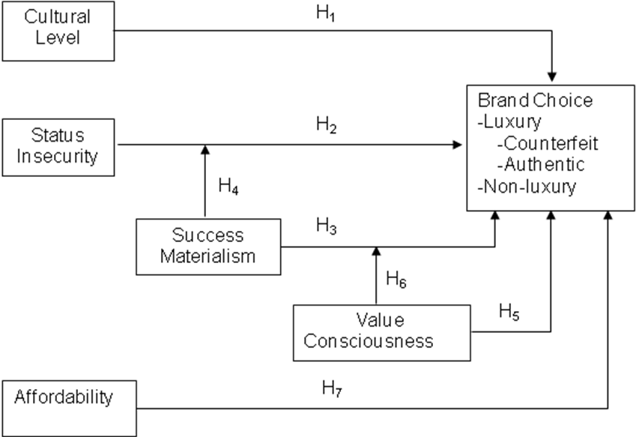

Figure 2: Alternative Nested Models

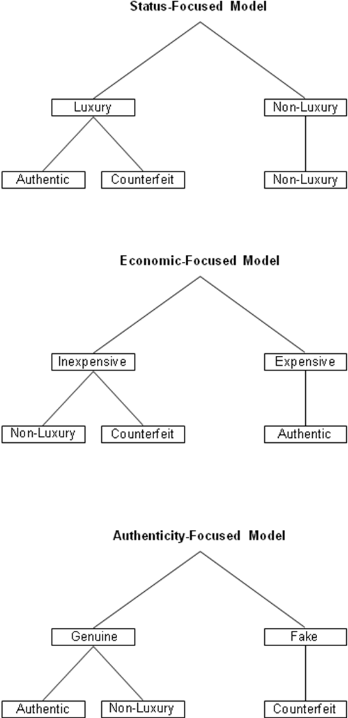

Figure 3a: Interaction of Status Insecurity and Materialism on Choice within Luxury Category (Authentic vs. Counterfeit Brand-Types)

Figure 3b: Interaction of Status Insecurity and Materialism on Choice between Luxury and Non-luxury Categories

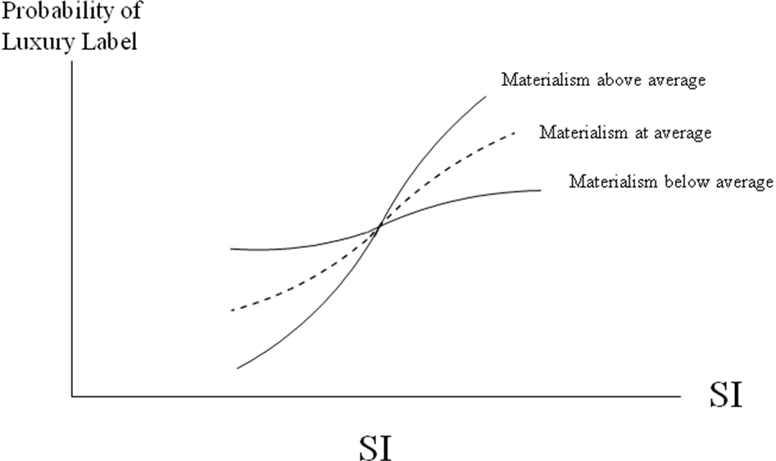
Figure 4: Interaction of Value Consciousness and Materialism on Choice between Luxury and Non-luxury Categories

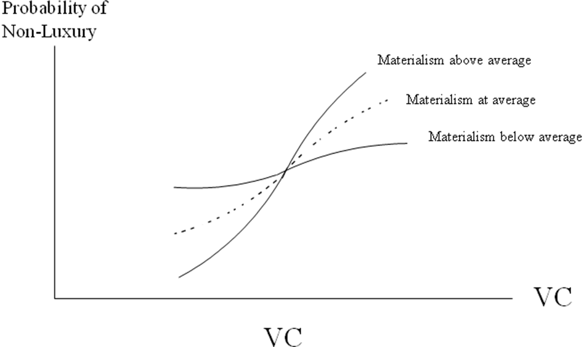

Table 1: Descriptive Statistics for Combined Samples
 |  | %
Male |  | 42.9
Female |  | 57.1
Race
Caucasian |  | 33.4
African-American |  | 32.0
Hispanic |  | 22.0
Asian |  | 7.6
Other |  | 4.9
Independent Variables
Materialism |  | 3.7
Value Consciousness |  | 5.2
Status Insecurity |  | 3.5
Cultural Events¹ |  | 1.4
N=957
¹Number of 5 cultural events respondents attended in past year.

Table 2: Percentage of Brand-Type Reported by Product Category
 |  | Watch | Wallet | Sun | Purse | Total
Luxury |  | 23.4 | 22.6 | 23.5 | 22.3 | 23.0
Non-luxury |  | 51.2 | 50.8 | 52.2 | 48.4 | 50.6
Counterfeit |  | 25.4 | 26.6 | 24.3 | 29.3 | 26.4
N=956

Table 3: Status Insecurity Scale Items and Factor Loadings
 |  | Factor Loadings
Sometimes others view me as second class |  | .87
People are biased against me sometimes |  | .85
Sometimes I have to work very hard just to prove that I am just as good as anyone else |  | .82

Table 4: Materialism (Success Dimension) Scale Items and Factor Loading
 |  | Factor Loadings
I don’t pay much attention to the material objects other people own.* |  | .85
The things I own say a lot about how well I’m doing in life. |  | .79
I like to own things that impress people. |  | .78
I don’t place much emphasis on the amount of material objects people own as a sign of success.* |  | .77
Some of the most important achievements in life include acquiring material possessions. |  | .77
I admire people who own expensive homes, cars, and clothes. |  | .68
* These items were reversed coded

Table 5: Value Consciousness Scale Items and Factor Loadings
 |  | Factor Loadings
I generally shop around for lower prices on products, but they still must meet certain quality requirements before I buy them. |  | .86
When shopping, I compare the prices of different brands to be sure I get the best value for the money. |  | .85
I always check prices at different stores to be sure I get the best value for the money. |  | .76
I am very concerned about low prices, but I am equally concerned with quality. |  | .71
When I shop, I usually compare the “price per ounce” information for brands I normally buy. |  | .67
When purchasing a product, I always try to maximize the quality I get for the money I spend. |  | .65
When I buy products, I like to be sure that I am getting my money’s worth. |  | .65

Table 6: Explanation of Variables used in Logit Model

Variable | Meaning
AFF_{it} | Affordability by individual i of brand type $t∈${authentic luxury, counterfeit, non-luxury}
VC_{i} | Value Consciousness of individual i
M_{i} | Materialism of individual i
CL_{i} | Cultural Level of individual i
SI_{i} | Status Insecurity of individual i

Table 7: Estimation of Competing Nested Logit Models
Model |  |  |  |  |  |  | Scaling Parameter (λ) |  |  |  | S.E. |  |  | T-stat |  |  |  | Sig. |  |  |  | LL
Status Focus |  |  |  |  |  | .55 |  |  |  | .15 |  |  | 3.59 |  |  |  |  | *** |  |  | -2066.52
Economic Focus |  |  |  |  |  | .99 |  |  |  | 2.25 |  |  | .44 |  |  |  |  |  |  |  | -2091.56
Authenticity Focus |  |  |  |  |  | 2.55 |  |  |  | .67 |  |  | 3.8 |  |  |  |  | *** |  |  | -2043.56
N=2174
*** P<.001
Table 8: Results from Estimation of Nested Logit Model: Choice between
the Luxury Category Goods (Authentic & Counterfeit) and Non-luxury Category
 |  | Estimates | t-Stat |  | Sig. | Odds Ratio
Choice within Luxury Category
Cultural Level | CF-A¹ | -.08 | -2.18 |  | * | .93
Status Insecurity² | CF-A | -.05 | -1.16 |  |  | .96
Materialism² | CF-A | .12 | 2.58 |  | ** | 1.13
Value Consciousness² | CF-A | .34 | 3.88 |  | *** | 1.40
VC x Mat | CF-A | .02 | .97 |  |  | 1.02
SI x Mat | CF-A | -.04 | -2.11 |  | * | .96
Constant | CF-A | -1.23 | -3.83 |  | *** | .33
Control Variables
Affordability |  | .15 | 4.08 |  | *** | 1.16
Aff x VC |  | -.02 | -1.53 |  |  | .98
Age | CF-A | .02 | 3.27 |  | *** | 1.02
Purchased a Fake | CF-A | .53 | 3.39 |  | *** | 1.71
Choice between Luxury and Non-Luxury Categories
Cultural Level | NL-L³ | .00 | .11 |  |  | 1.00
Status Insecurity | NL-L | .13 | 2.83 |  | ** | 1.14
Materialism | NL-L | -.02 | -.11 |  |  | .98
Value Consciousness | NL-L | .31 | 5.01 |  | *** | 1.37
VC x Mat | NL-L | .10 | 3.48 |  | *** | 1.10
SI x Mat | NL-L | -.04 | -1.71 |  |  | .96
Constant | NL-L | -.05 | -.25 |  |  | .95
Control Variables
Age | NL-L | .01 | 1.31 |  |  | 1.01
Purchased a Fake | NL-L | -.00 | -.04 |  |  | 1.00
λ |  | .56 | 3.73 |  | *** | 1.73
LL | -2063
N=2174
***p<.001, **p<.01, *p<.05
¹ 1=Counterfeit, 0-Authentic Luxury
² Mean-centered
³ 1=Non-luxury Category, 0=Luxury Category (Authentic and Counterfeit)

References
Ai, Chunrong and Edward C. Norton (2003), “Interaction Terms in Logit and Probit Models,” Economics Letters, 80, 123-129.

Aschaffenburg, Karen and Ineke Maas (1997), “Cultural and Educational Careers,” American Sociological Review, 62(4), 573-587.

Belk, Russell W. (1988), “Possessions and the Extended Self,” Journal of Consumer Research, 15(September), 139-168.

_____(1985), “Materialism: Trait Aspects of Living in the Material World,” Journal of Consumer Research, 12(December), 265-280.

Bell, S., Morris Holbrook and Michael Solomon (1991), “Combining Esthetic and Social Value to Explain Preferences for Product Styles with Incorporation of Personality and Ensemble Effects”, in ‘To Have Possessions: A Handbook on Ownership and Property’ Journal of Social Behaviour and Personality, 6(6), 243-247.

Berger, Joseph, Rosenholtz and Morris Zelditch (1977), “Status Organizing Processes,” Annual Review of Sociology, 6, 479-508.

Bourdieu, Pierre (1984), Distinction: A Social Critique of the Judgment of Taste, Cambridge, MA: Harvard University Press.

Braun, Ottmar L. and Robert A. Wicklund (1989), “Psychological Antecedents of Conspicuous Consumption, Journal of Economic Psychology, 10(2), 161-187.

Charles, Kerwin Kofi, Erik Hurst and Nikolai Roussanov (2007), “Conspicuous Consumption
and Race,” NBER Working Paper Series no. 13392; Cambridge: National Bureau of Economic Research, accessed January 7, 2009, at http://www.nber.org/papers/w13392

Chatpaiboon, Pasinee (2004), “Designer Knockoffs,” BT Magazine, Fall

Accessed online: http://businesstoday.org/magazine/issues/1/6.php

Cohen, Randy (2005), “Acceptable Knockoffs,” New York Times Magazine, May 22, 24

Commuri, Suraj (2009), “The Impact of Counterfeiting on Genuine-Item consumers’ Brand Relationships,” Journal of Marketing, 73 (May), 86-98.

Cordell, Victor, Nittaya Wongtada, and Robert L. Dieschnick (1996): “Counterfeit Purchase Intentions: The Role of Lawfulness Attitudes and Product Traits as Determinants,” Journal of Business Research, 35 (January), 41-53.

Cronbach, L.J. 1987. “Statistical Tests for Moderator Variables.” Psychological Bulletin 87: 51- 57.

Driskell, James and Brian Mullen (1990), “Status, Expectations and Behavior: A Meta-Analytic Review and Test of the Theory,” Personality and Social Psychology Bulletin, 16(3), 541-553.

Eastman, Jacqueline, Ronald Goldman and Leisa Reinecke Flynn (1999), “Status Consumption in Consumer Behavior: Scale Development and Validation,” Journal of Marketing Theory and Practice, Summer, 41-52.

Emerson, Richard (1962), “Power-Dependence Relations,” American Sociological Review, 27, 31-40.

Echambadi, Raj and James D. Hess (2007), “Mean-Centering Does Not Alleviate Collinearity Problems in Moderated Multiple Regression Models,” Marketing Science, 26(3), 438-445.

Festinger, Leon (1954), “A Theory of Social Comparison Processes,” Human Relations, 7, 117-140.

Frank, Robert (1985), “The Demand for Unobservable and Other Nonpositional Goods,” American Economic Review, 75(1), 101-116.

Gentry, James W., Sanjay Putrevu, Clifford Shultz, and Suraj Commuri (2001),"How Now Ralph Lauren? The Separation of Brand and Product in a Counterfeit Culture," Association for Consumer Research, Salt Lake City, 2000.

Han, Young Jee, Joseph C. Nunes, and Xavier Dreze (2009), “First Impressions; Status Signaling Using Brand Prominence,” paper presented at the spring Doctoral Symposium, University of Houston.

Hess, James D., Ye Hu, and Edware Blair (2009), “On Testing Moderation Effects in Experiments Using Binary Logistic Regression, (Working Paper).

Holt, Doug (1998), “Does Cultural Capital Structure American Consumption?” Journal of Consumer Research, 25(June), 1-25.

Kamijn, Matthis and Gerbert Kraaykamp (1996), “Race, Cultural Capital, and Schooling: An Analysis of Trends in the United States,” Sociology of Education, 69, 22-34.

Kingston, Paul W. (2001), “The Unfulfilled Promise of Cultural Capital Theory,” Sociology of Education, 74, 88-99.

Lamont, Michele and Annette Lareau (1998), “Cultural Capital: Allusions, Gaps and Glissandos in Recent Theoretical Developments,” Sociological Theory, 6, 153-168.

Leibenstein, Harvey (1950), “Bandwagon, Snob and Veblen Effects in the Theory of Consumers’ Demand,” Quarterly Journal of Economics, 64(May), 183-207.

Lichenstein, Donald, Nancy M. Ridgway and Richard G. Netemeyer (1993), “Price Perceptions and Consumer Shopping Behavior: A Field Study,” Journal of Marketing Research, 30(May), 234-245.

Lin, Nan (1990), “Social Resources and Social Mobility: A Structural Theory of Status Attainment,” Pp 247-271 in Social Mobility and Social Structure, R. Breiger (ed.). Cambridge, UK: Cambridge University Press.

_____(1994), “Action, Social Resources and the Emergence of Social Structures,” Pp. 67-85 in Advances in Group Processes vol. 11. B. Markovsky, E. Lawler, J. O’Brien, K. Heimer (eds.). Greenwich, Conn: JAI Press.

Lovaglia, Michael (1994), “Relating Power to Status,” Advances in Group Processes, 11, 87-111.

McCracken, Grant (1986), “Culture and Consumption: A Theoretical Account of the Structure and Movement of the Cultural Meanings of Consumer Goods,” Journal of Consumer Research, 13(June), 71-84.

_____ (1988), Culture and Consumption. Bloomington: Indiana University Press.

______(2005), Culture and Consumption II, Bloomington: Indiana University Press.

Mick, David Glen (1996), “Are Studies of Dark Side Variables Confounded by Socially Desirable Responding? The Case of Materialism,” Journal of Consumer Behavior, 23(September), 106-119.

Nia, Arghavan and Judith Lynne Zaichkowsky (2000), “Do Counterfeits Devalue the Ownership of Luxury Brands?” Journal of Product and Brand Management, 9(7), 485-497.

O’Cass, Aron and Hmily McEwen (2004), “Exploring Consumer Status and Conspicuous Consumption,” Journal of Consumer Behavior, 4(1), 25-39.

______ and Hmily Frost (2002) “Status Brands: Examining the effects of non-product-related brand associations on status and conspicuous consumption,” Journal of Product and Brand Management, 11(2), 67-88.

O’ Guinn, Thomas C. and L. J. Shrum (1997), “The Role of Television in the Construction of Consumer Reality,” Journal of Consumer Research, 23(March), 278-294.

O’Shaughnessy, John (1992), Explaining Buyer Behavior, Oxford University Press: New York, NY.

Penz, Elfriede and Barbara Stottinger (2005), “Forget the “Real” Thing-Take the Copy! An Exploratory Model for the Volitional Purchase of Counterfeit Products,” Advances in Consumer Research, 32, 568-575.

Postrel, Virginia (2008), “Inconspicuous Consumption,” The Atlantic (July-August), 148ff.

Richins, Marsha L. and Scott Dawson (1992), “A Consumer Values Orientation for Materialism and Its Measurement: Scale Development and Validation,” Journal of Consumer Research, 19(December), 303-316.

_____(2004), “Material Values Scale Short Form,” Journal of Consumer Research, 31(June), 209-219.

Ridgeway, Cecilia, Elizabeth Boyle, Kathy Kuipers and Dawn Robinson (1998), “How Status Forms Beliefs? The Role of Resources and Interactional Experience,” American Sociological Review, 63(3), 331-350.

____and Kristan Erickson (2000), “Creating and Spreading Status Beliefs,” American Journal of Sociology, 106, 579-615.

Roberts, James (2000), “Consuming in a Consumer Culture: College Students, Materialism, Status Consumption, and Compulsive Buying,” Marketing Management Journal, Fall/Winter, 76-91.

Rose, Jamiee (2003), “Knockoffs—who is it?” The Arizona Republic, January 15.

Available online: http://www.azcentral.com/style/articles/0116knockoffs.html

Rosen, Christine (2008), “The Bare Necessities: Marketing Luxury Goods in a Bad Economy,” Wall Street Journal, December 19, W11.

Thye, Shane (2000), “A Status Value Theory of Power in Exchange Relations,” American Sociological Review, 65(3), 407-432.

Tom, Gail, Barbara Garibaldi, Yvette Zeng and Julie Pilcher (1998), “Consumer Demand for Counterfeit Goods,” Psychology and Marketing, 15(5), 405-421.

Train, Kenneth (2004), Discrete Choice Methods with Simulation, Cambridge: Cambridge University Press.

Trebay, Guy (2009), “When Cartier Was Just for the Likes of Liz,” New York Times, April 26,

ST 8.

Veblen, Thornstein (1899), The Theory of the Leisure Class, New York: Mentor Book.

Wee, Chow-Hou, Soo-Jiuan Tan and Kim-Hong Cheok (1995), “Non-price determinants of intention to purchase counterfeit goods,” International Marketing Review, 12(6), 19-46.

Wilcox, Keith, Hyeong Min Kim, and Sankar Sen (2009), “Why Do Consumers Buy Counterfeit Luxury Brands?,” Journal of Marketing Research, 46(2), 247-259.

Wood, Joanne V. (1989) “Theory and Research Concerning Social Comparisons of Personal Attributes,” Psychological Bulletin, 106(2), 231-248.

Wu, June (2001), “The impact of status insecurity on credit card spending.” (working paper) University of Houston.

Wyatt, Rosalind, Betsy D. Gelb and Stephanie Geiger-Oneto (2008) “How Advertising Reinforces Minority Consumers’ Preference for National Brands,” Journal of Current Issues and Research in Advertising, 30(1), 61-70.

